November 14, 2022

# Preface

## Software information and conventions

This training manual was created using the **knitr** package (Xie 2015a) and the **bookdown** package (Xie 2020a). The following is the R session information:

xfun::session_info()

## R version 4.2.0 (2022-04-22)  
## Platform: x86_64-apple-darwin17.0 (64-bit)  
## Running under: macOS Catalina 10.15.7  
##   
## Locale: en_US.UTF-8 / en_US.UTF-8 / en_US.UTF-8 / C / en_US.UTF-8 / en_US.UTF-8  
##   
## Package version:  
## abind_1.4-5 acs_2.1.4 afrilearndata_0.0.0.9003  
## agridat_1.21 askpass_1.1 assertthat_0.2.1   
## backports_1.4.1 base64enc_0.1-3 bit_4.0.4   
## bit64_4.0.5 bitops_1.0-7 blob_1.2.3   
## bookdown_0.29 boot_1.3.28 brew_1.0.8   
## brio_1.1.3 broom_1.0.1 bslib_0.4.1   
## cachem_1.0.6 callr_3.7.3 car_3.1-1   
## carData_3.0-5 cellranger_1.1.0 checkmate_2.1.0   
## choroplethr_3.7.1 choroplethrMaps_1.0.1 class_7.3-20   
## classInt_0.4-8 cli_3.4.1 clipr_0.8.0   
## cluster_2.1.4 codetools_0.2-18 colorspace_2.0-3   
## colourpicker_1.2.0 commonmark_1.8.1 compiler_4.2.0   
## corrplot_0.92 cowplot_1.1.1 cpp11_0.4.3   
## crayon_1.5.2 crosstalk_1.2.0 curl_4.3.3   
## data.table_1.14.4 DBI_1.1.3 dbplyr_2.2.1   
## deldir_1.0-6 desc_1.4.2 dichromat_2.0-0.1   
## diffobj_0.3.5 digest_0.6.30 dplyr_1.0.10   
## dtplyr_1.2.2 e1071_1.7-12 ellipsis_0.3.2   
## evaluate_0.17 fansi_1.0.3 farver_2.1.1   
## fastmap_1.1.0 fontawesome_0.4.0 forcats_0.5.2   
## foreign_0.8-83 Formula_1.2-4 fs_1.5.2   
## gargle_1.2.1 generics_0.1.3 geojsonsf_2.0.3   
## geometries_0.2.0 ggExtra_0.10.0 ggmap_3.0.1   
## ggplot2_3.4.0 ggpubr_0.4.0 ggrepel_0.9.1   
## ggsci_2.9 ggsignif_0.6.4 ggspatial_1.1.6   
## ggthemes_4.2.4 glue_1.6.2 googledrive_2.0.0   
## googlesheets4_1.0.1 graphics_4.2.0 grDevices_4.2.0   
## grid_4.2.0 gridExtra_2.3 gtable_0.3.1   
## haven_2.5.1 highr_0.9 Hmisc_4.7-1   
## hms_1.1.2 htmlTable_2.4.1 htmltools_0.5.3   
## htmlwidgets_1.5.4 httpuv_1.6.6 httr_1.4.4   
## ids_1.0.1 interp_1.1-3 isoband_0.2.6   
## jpeg_0.1-9 jquerylib_0.1.4 jsonify_1.2.1   
## jsonlite_1.8.3 kableExtra_1.3.4 KernSmooth_2.23-20   
## knitr_1.40 labeling_0.4.2 later_1.3.0   
## lattice_0.20-45 latticeExtra_0.6-30 lazyeval_0.2.2   
## leafem_0.2.0 leaflet_2.1.1 leaflet.providers_1.9.0   
## leafpop_0.1.0 leafsync_0.1.0 lifecycle_1.0.3   
## lme4_1.1.31 lubridate_1.8.0 lwgeom_0.2-9   
## magick_2.7.3 magrittr_2.0.3 maptools_1.1-5   
## mapview_2.11.0 markdown_1.3 MASS_7.3.58.1   
## Matrix_1.5-1 MatrixModels_0.5.1 memoise_2.0.1   
## methods_4.2.0 mgcv_1.8-41 mime_0.12   
## miniUI_0.1.1.1 minqa_1.2.5 modelr_0.1.9   
## munsell_0.5.0 nasaweather_0.1 ndjson_0.9.0   
## nlme_3.1-160 nloptr_2.0.3 nnet_7.3-18   
## numDeriv_2016.8.1.1 openssl_2.0.4 parallel_4.2.0   
## pbkrtest_0.5.1 pillar_1.8.1 pkgconfig_2.0.3   
## pkgload_1.3.1 plyr_1.8.7 png_0.1-7   
## polynom_1.4.1 praise_1.0.0 prettymapr_0.2.4   
## prettyunits_1.1.1 processx_3.8.0 progress_1.2.2   
## promises_1.2.0.1 proxy_0.4-27 ps_1.7.2   
## purrr_0.3.5 quantreg_5.94 R6_2.5.1   
## ragg_1.2.4 rapidjsonr_1.2.0 rappdirs_0.3.3   
## raster_3.6-3 RColorBrewer_1.1-3 Rcpp_1.0.9   
## RcppEigen_0.3.3.9.2 RCurl_1.98-1.9 readr_2.1.3   
## readxl_1.4.1 rematch_1.0.1 rematch2_2.1.2   
## reprex_2.0.2 reshape2_1.4.4 rgdal_1.5-32   
## RgoogleMaps_1.4.5.3 rjson_0.2.21 rlang_1.0.6   
## rmarkdown_2.17 rnaturalearth_0.1.0 rnaturalearthdata_0.1.0   
## rnaturalearthhires_0.2.0 rosm_0.2.6 rpart_4.1.19   
## rprojroot_2.0.3 rstatix_0.7.0 rstudioapi_0.14   
## rticles_0.24 rvest_1.0.3 s2_1.1.0   
## sass_0.4.2 satellite_1.0.4 scales_1.2.1   
## selectr_0.4.2 servr_0.25 sf_1.0-8   
## sfheaders_0.4.0 shiny_1.7.3 shinyjs_2.1.0   
## sourcetools_0.1.7 sp_1.5-0 SparseM_1.81   
## splines_4.2.0 stars_0.5-6 stats_4.2.0   
## stats4_4.2.0 streamR_0.4.5 stringi_1.7.8   
## stringr_1.4.1 survival_3.4-0 svglite_2.1.0   
## sys_3.4.1 systemfonts_1.0.4 terra_1.6-17   
## testthat_3.1.5 textshaping_0.3.6 tibble_3.1.8   
## tidycensus_1.2.3 tidyr_1.2.1 tidyselect_1.2.0   
## tidyverse_1.3.2 tigris_1.6.1 tinytex_0.42   
## tmap_3.3-3 tmaptools_3.1-1 tools_4.2.0   
## tzdb_0.3.0 units_0.8-0 utf8_1.2.2   
## utils_4.2.0 uuid_1.1-0 vctrs_0.5.0   
## viridis_0.6.2 viridisLite_0.4.1 visreg_2.7.0   
## vroom_1.6.0 waldo_0.4.0 WDI_2.7.8   
## webshot_0.5.4 widgetframe_0.3.1 withr_2.5.0   
## wk_0.7.0 xfun_0.34 XML_3.99-0.12   
## xml2_1.3.3 xtable_1.8-4 yaml_2.3.6

# 1 Data Organization with Spreadsheet

* Any research project’s cornerstone is good data organization. Because most researchers keep their data in spreadsheets, many research initiatives begin there.
* In spreadsheets, we organize data in the ways that we wish to work with it as humans, while computers demand that data be organized in specific ways. We must organize our data in the way that computers require it in order to employ tools that make computation more efficient, such as programming languages like R or Python. Since most research projects begin here, we’d like to begin here as well!
* However, you will not learn about data analysis with spreadsheets in this lesson. As a researcher, you’ll spend a lot of time organizing data so you can do good analysis afterwards. It isn’t the most enjoyable task, but it is important. This session will teach you how to think about data organization and some data wrangling best practices. This method allows you to properly prepare existing data and organize new data collection, resulting in less data wrangling.

## 1.1 Spreadsheet Programs

* Good data organization is the foundation of your research project. Most researchers have data or do data entry in spreadsheets. Spreadsheet programs are very useful graphical interfaces for designing data tables and handling very basic data quality control functions.
* Spreadsheet programs encompass a lot of the things we need to be able to do as researchers. We can use them for:
  + Data entry
  + Organizing data
  + Subsetting and sorting data
  + Statistics
  + Plotting

## 1.2 Formatting data tables

* The most common mistake is using spreadsheet tools as lab notebooks, relying on context, margin notes, and data and field spatial layout to convey information. We can (usually) interpret these things as humans, but computers don’t see information in the same way, and unless we explain everything to the computer (which can be difficult! ), it won’t be able to see how our data fits together.
* We can handle and analyze data much more effectively and quickly with the help of computers, but we must first prepare our data so that the computer can interpret it (and computers are very literal).

**Why aren’t we teaching data analysis in spreadsheets**:

* Data analysis in spreadsheets normally requires a significant amount of human labor. You normally have to redo everything by hand if you want to alter a parameter or run an analysis with a different dataset. (We know you can make macros; nevertheless, see the next point.)

### 1.2.1 Problems with Spreadsheets

Spreadsheets are good for data entry, but we use them for much more than that. Use them to create data tables for publications, generate statistics and make figures. **Spreadsheets can be used with caution if you want to replicate your steps in another person’s work**.

### 1.2.2 Use of Spreadsheets for Data Entery and Cleaning

* However, there are times when you’ll want to use a spreadsheet tool to make “quick and dirty” calculations or figures, and data cleaning will make it easier to do so. Data cleaning also improves the format of your data before it is imported into a statistical analysis program. We’ll show you how to use various spreadsheet tools to double-check your data quality and get preliminary summary statistics.
* In this lesson, we will assume that you are most likely using Excel as your primary spreadsheet program - there are others (gnumeric, Calc from OpenOffice), and their functionality is similar, but Excel seems to be the program most used by everyone.

### 1.2.3 Keeping track of your analyses

It’s very simple to end up with a spreadsheet that looks nothing like the one you started with when dealing with spreadsheets for data cleaning or analytics. If a reviewer or instructor requests a new analysis, you should be able to recreate your analyses or figure out what you performed.

* Make a new file containing the data you’ve cleaned or examined. If you change the original dataset, you’ll lose track of where you started!
* Keep a record of the steps you did to clean up or analyze your data. These stages should be tracked just like any other phase in an experiment. This should be done in a plain text file located in the same folder as the data file.

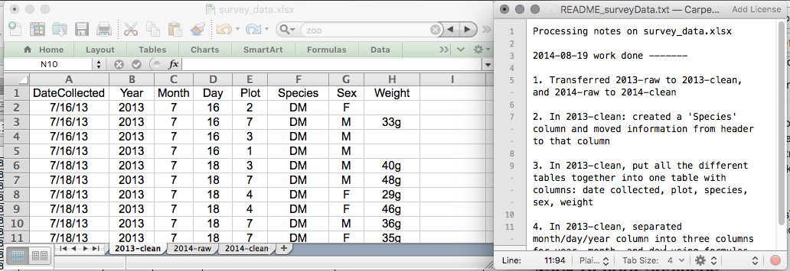

Keeping track of your analyses

### 1.2.4 Structuring data in spreadsheets

The cardinal rules of using spreadsheet programs for data:

1. Put all your variables in columns - the thing you’re measuring, like ‘weight’ or ‘temperature’.
2. Put each observation in its own row.
3. Don’t combine multiple pieces of information in one cell. Sometimes it just seems like one thing, but think if that’s the only way you’ll want to be able to use or sort that data.
4. Leave the raw data raw - don’t change it!
5. Export the cleaned data to a text-based format like CSV (comma-separated values) format. This ensures that anyone can use the data, and is required by most data repositories.

**Exercise**:

What is the issue with the following data entry according to spreadsheet data structure rules above?

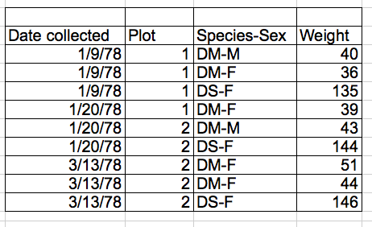

multiple-info example

### 1.2.5 Columns for variables and rows for observations

The rule of thumb, when setting up a datasheet, is columns = variables, rows = observations, cells = data (values).

So, instead we should have:

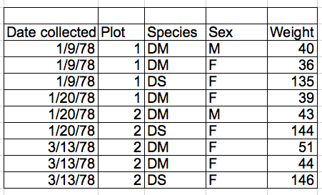

single-info example

## 1.3 Common Spreadsheet Errors

* Don’t create multiple data tables within a single spreadsheet. This creates false associations between things for the computer, and makes it harder to sort and sort your data in the right order. 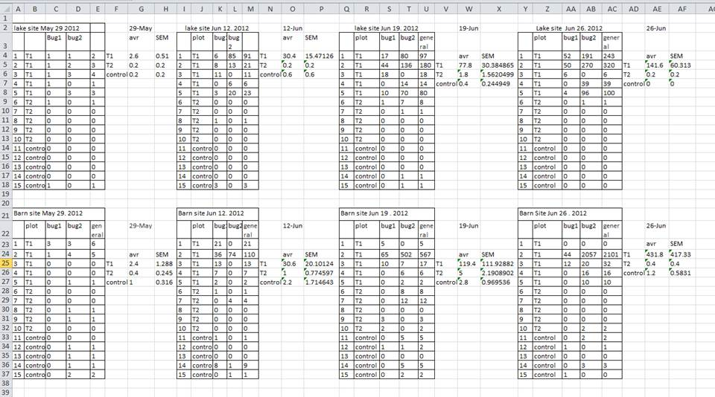 In the table below, each row in A-F represents four distinct samples. This means that the columns A-AF do not all refer to the same sample.

### 1.3.1 Using multiple tabs

* When you create extra tabs, you fail to allow the computer to see connections in the data that are there (you have to introduce spreadsheet application-specific functions or scripting).

### 1.3.2 Not filling in zeros

There’s a difference between a zero and a blank cell in a spreadsheet. To the computer, a zero is actually data. By not entering the value of an observation, you are telling your computer to represent that data as unknown(otherwise known as a null value). This can cause problems with subsequent calculations or analyses.

### 1.3.3 Using problematic null values

There are a few reasons why null values get represented differently within a dataset. Sometimes confusing null values are automatically recorded from the measuring device. It’s a problem if unknown or missing data is recorded as -999, 999, or 0.

Many statistical applications won’t detect them as missing (null) values. The tools you select to evaluate your data will determine how these values are interpreted. It is critical to utilize a null indicator that is clearly defined and consistent. As a result, Blanks (for most applications) and NA (for R) are excellent options.

## 1.4 Date as data

* It is much safer to store dates with [MONTH, DAY and YEAR] in separate columns
* Excel is unable to parse dates from before 1899-12-31, and will thus leave these untouched.
* If you’re mixing historic data from before and after this date, Excel will translate only the post-1900 dates into its internal format
* Ideally, data should be as unambiguous as possible.

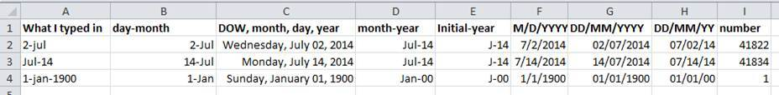

Many formats, many ambiguities

# 2 Data Cleaning with OpenRefine

Cleaning data is required before it can be analyzed. To provide consistent data, data cleaning identifies mistakes and corrects formatting. This procedure must be done with extreme caution since without clean data, analysis results may be inaccurate and non-reproducible.

OpenRefine is a robust free and open source tool for dealing with untidy data, such as cleaning it and converting it to a different format.

This course will show you how to use OpenRefine to successfully clean and format data while keeping track of any changes you make. Many users say that using this program saves them months of time compared to doing these modifications by hand.

## 2.1 Layout

Once you have imported your data, it is important to familiarize yourself with OpenRefine’s layout.

1. In the top right corner there are three buttons:
2. “Open…” returns you to the home screen where you can select projects.
3. “Export” opens a dropdown menu of options to export your data.
4. “Help” opens the OpenRefine User Documentation in a new tab in your browser.

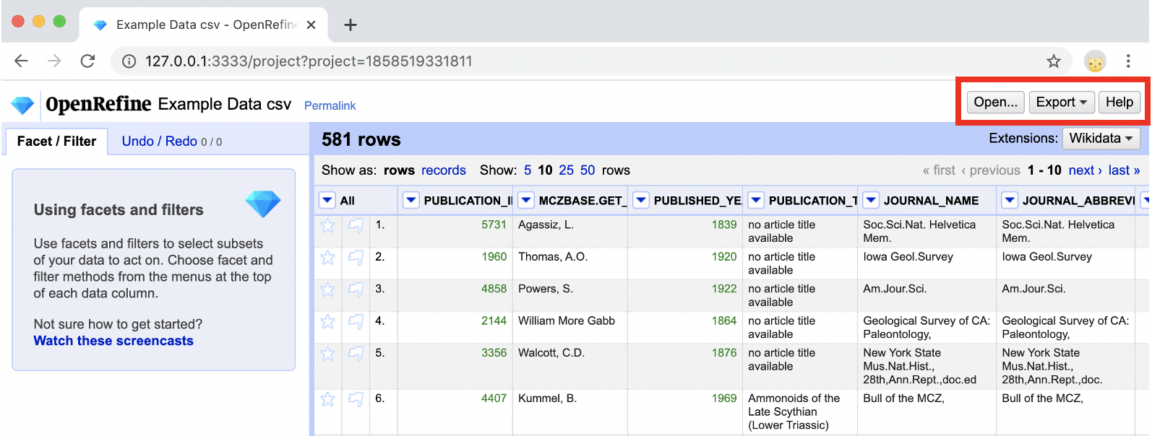

1. Below the bolded header stating how many rows/records there are two options:
2. “Show as” allows you to change the grid view between rows and records. For more information on the difference between rows and records, see the explanation of Records and Rows below.
3. “Show” allows you to change the number of rows/records visible in the grid view.

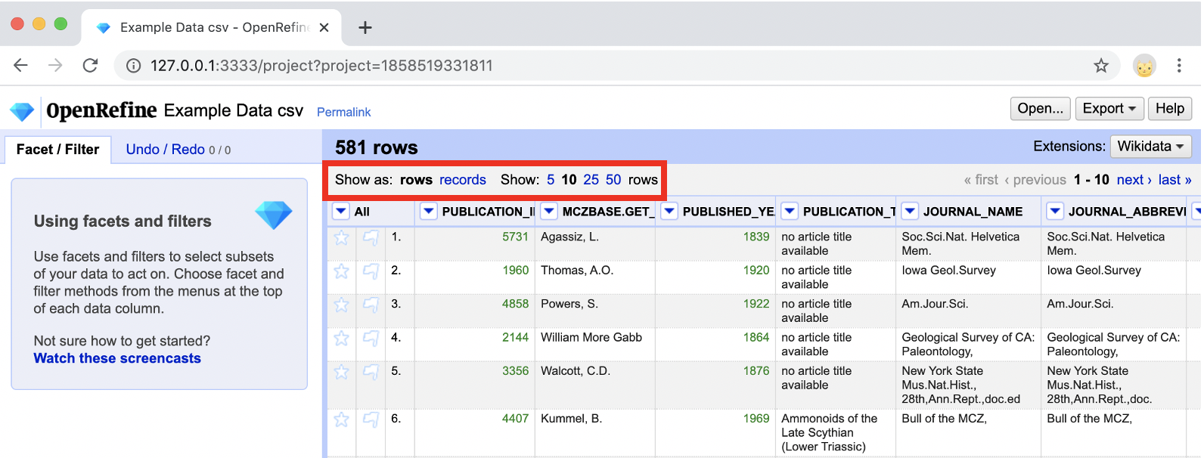

1. In the center of the page is your data in the grid view, which looks similar to Excel. Features of the grid view include:
2. Column headings with dropdown arrows for chosing functions
3. Row/Record numbers and alternate row/record shading
4. Selectable flags and stars

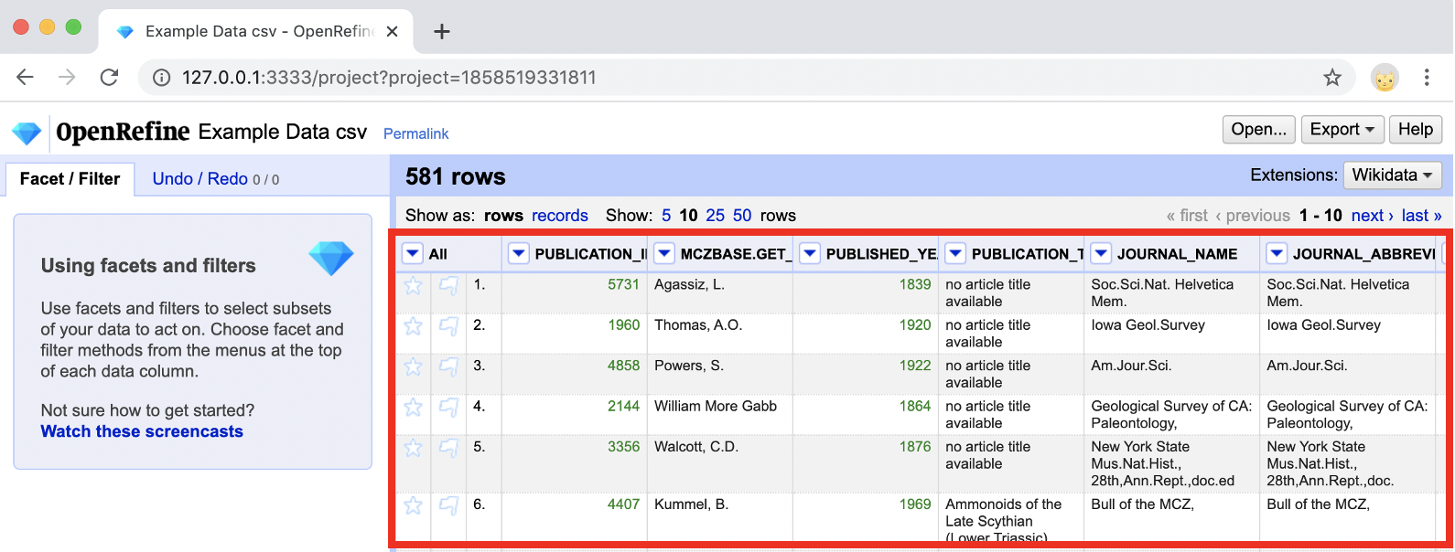

1. On the left, there is a pane with two tabs:
2. b”Facet/Filter” allows you to work on selected sections of your data, including faceting, clustering, and filtering.
3. “Undo/Redo” tracks and stores your history, allows you to undo or redo transformations, and export a JSON file of your transformations.

## 2.2 Records and Rows

There are two settings for the grid view in OpenRefine: rows or records.

The difference between rows and records is that “rows” display your data in individual lines, each numbered separately, while “records” display your data in multi-line groupings depending on the relationships between the data in those lines. For example:

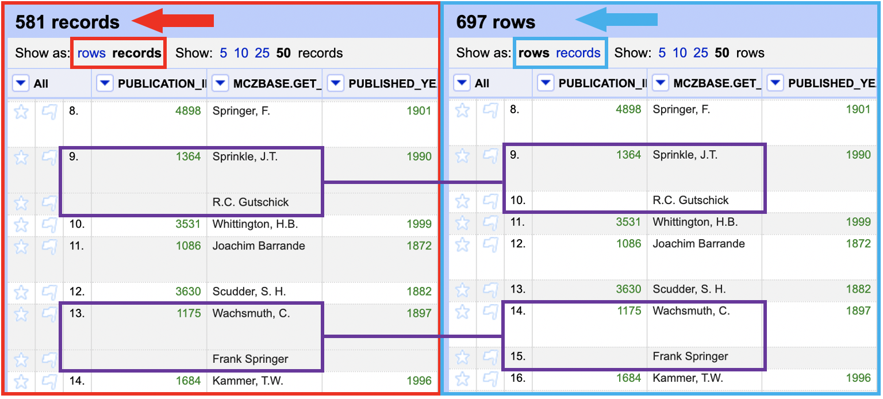

This data has been transformed using “split multi-valued cells” on the author field to separate different authors into their own lines. On the left, the data is displayed as “records,” showing the different lines with the multiple authors grouped together. On the right, the data is displayed as “rows,” showing each of the multiple authors as a separate line.

NOTE: Take caution when permanently renumbering rows or records and be aware of what setting you are viewing your data under.

## 2.3 Changing the Grid View

You can adjust the grid display in numerous ways to make it easier to compare, analyse, and associate data columns. Some adjustments can be permanent or non-permanent, and they can help you organize your data better overall.

### 2.3.1 Permanent Changes

Rearranging columns, eliminating columns, and/or renaming columns are all permanent modifications to the grid view.

Although the instructions in Reordering Columns can be used to reorder and remove columns, this method produces the same effects for modest, rapid changes.

1. Go to the column you would like to rearrange or remove and click the arrow button on the column header.
2. Select the “Edit columns” option and choose the option that best fits from the dropdown:
3. Remove this column
4. Move column to beginning
5. Move column to end
6. Move column left
7. Move column right

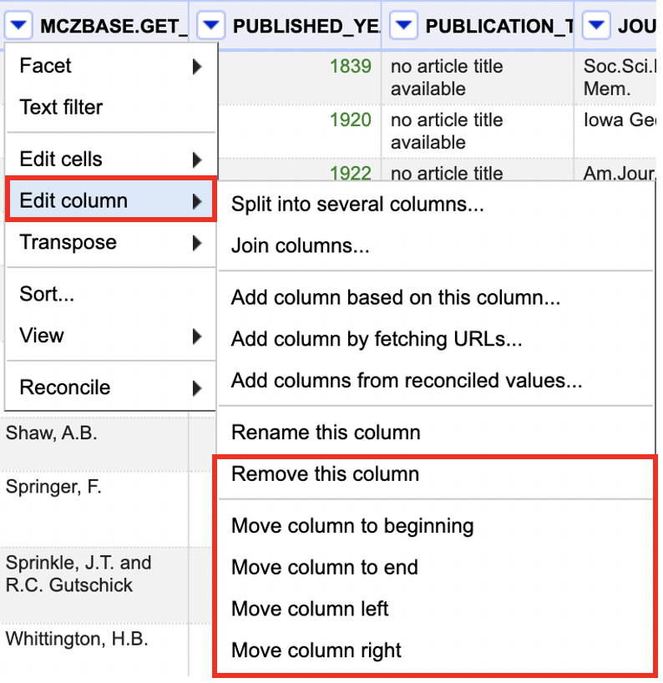

Changes to the column name can be done in a few simple steps:

1. Go to the column you would like to rename and click the arrow button on the column header.
2. Select the “Edit columns” option and click on “Rename this column.”
3. Change the column name in the pop-up window and click “OK.”

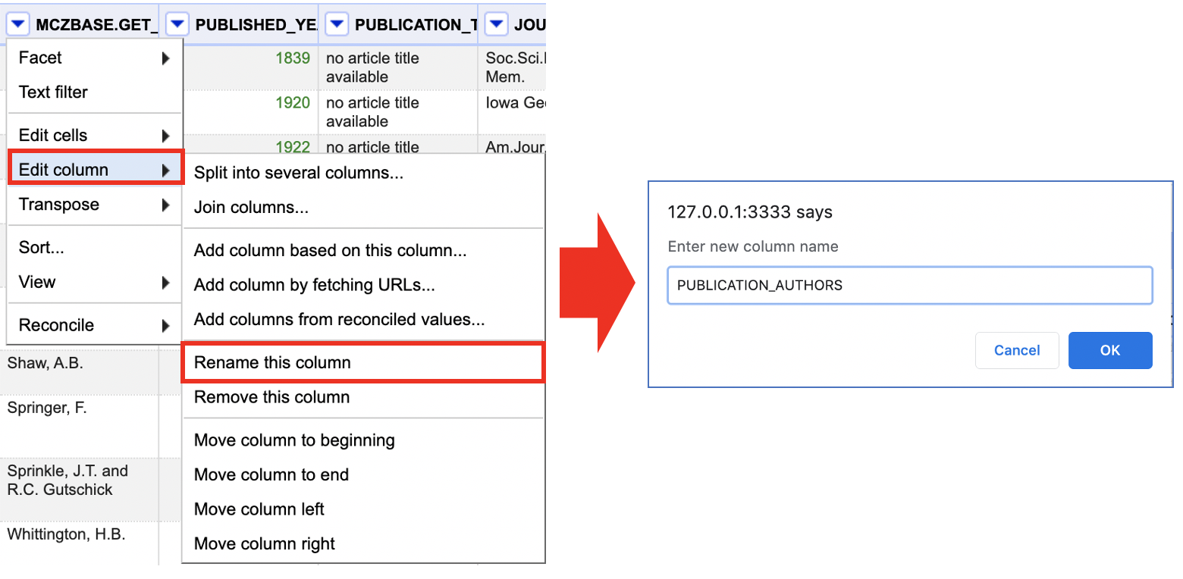

NOTE: In your tracked history, changes to column order or name, as well as the removal of columns, are logged as transformations. Follow the instructions in History and Undo/Redo to undo moving a column.

### 2.3.2 Non-Permanent Changes

Collapsing columns in one of four ways is a non-permanent alteration to the grid view: collapsing the current column, all other columns, all columns to the left of the current column, or all columns to the right of the current column.

1. Go to the column you would like to change and click the arrow button on the column header.
2. Select the “View” option and pick the best option from the dropdown:
3. Collapse this column
4. Collapse all other columns
5. Collapse all columns to left (see second image below)
6. Collapse all columns to right

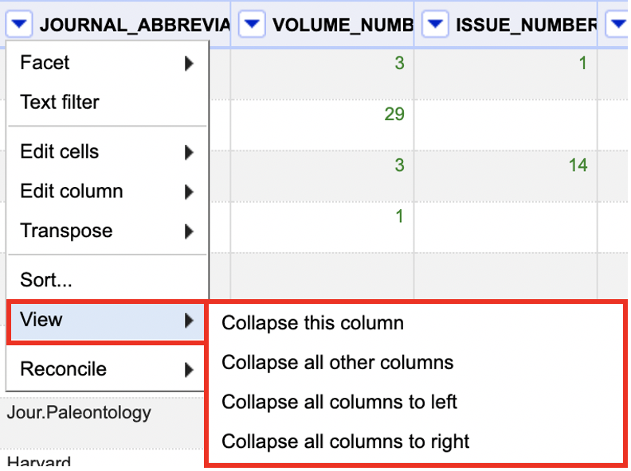

1. The collapsed column(s) are replaced by a narrow placeholder.
2. To reopen collapsed columns, click on the placeholder.

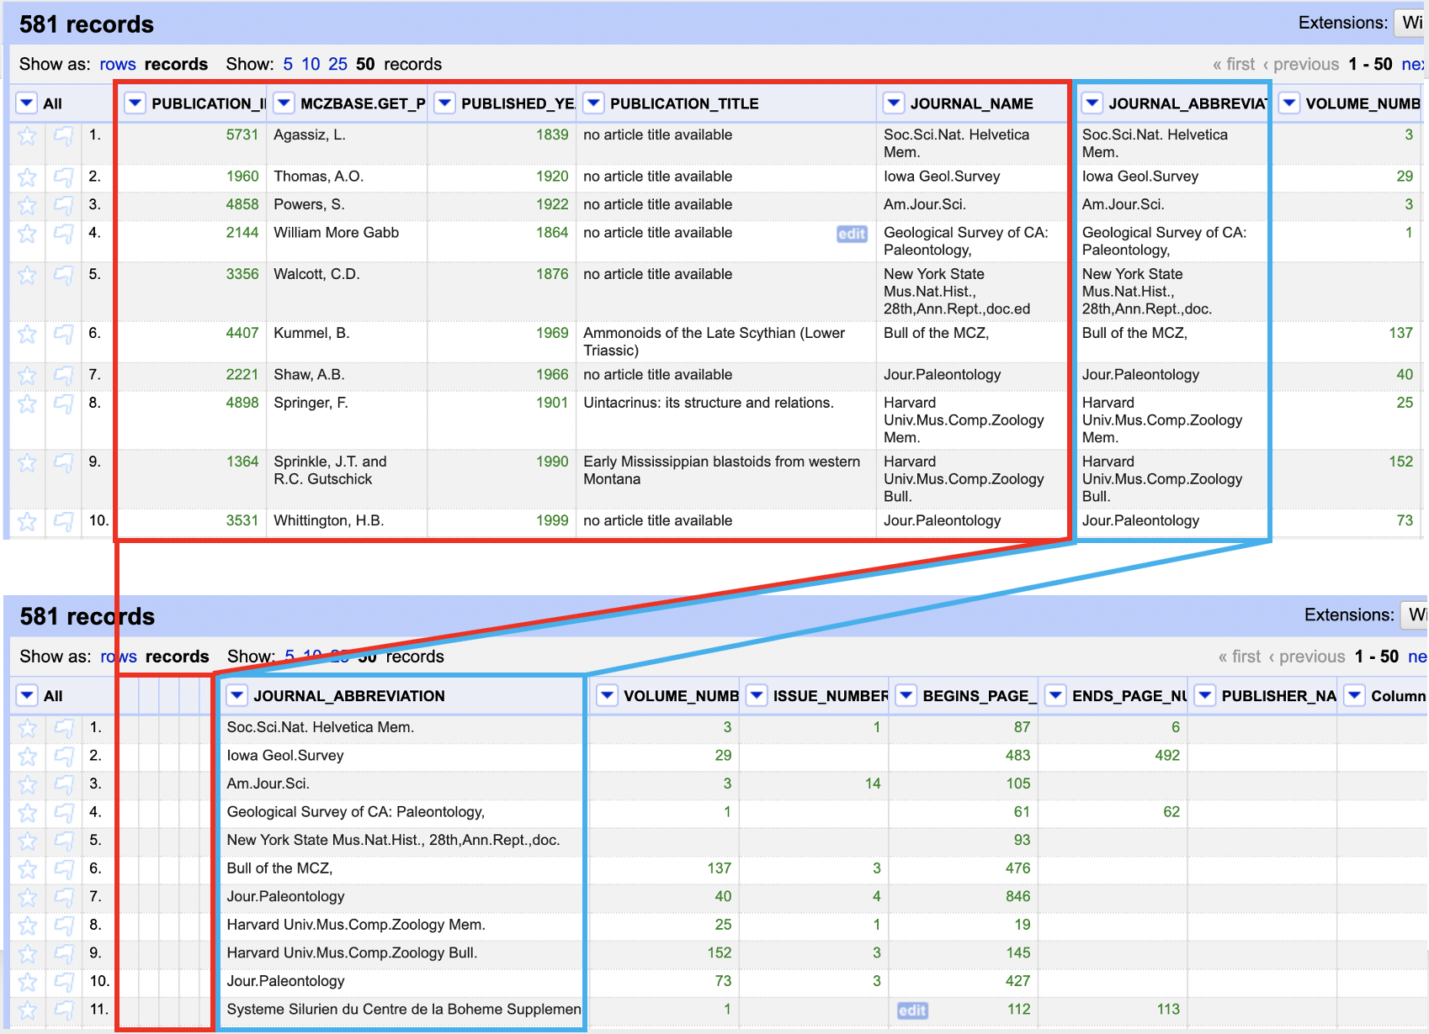

NOTE: Collapsing columns does not permanently delete columns from your data, it only hides the selected columns from view. To permanently delete columns, follow the instructions in Reordering Columns.

## 2.4 Data Mining and Discovery

OpenRefine includes a number of tools that allow you to quickly search, organize, and contextualize your data without having to go through it manually. Facets and filters based on data type (text, numeric, or date) can be used to sort, arrange, and contextualize your data for better discovery and analysis while maintaining the data’s original structure.

* Reordering columns Reorder your columns for better contextualization or to prepare for further transformations.
* Sorting Data Arrange your data according to defined order within one or more columns.
* Text Based Discovery Search, narrow, and isolate data based on textual information.
* Number and Date Based Discovery Search, narrow, and isolate data based on numeric and date information.

### 2.4.1 Reordering Columns

OpenRefine allows you to reorder your columns for better contextualization or to prepare for further transformations of your data. To reorder columns:

1. Go to the first column, labeled “All,” and click the arrow button on the column header.
2. Select the option “Edit columns” and then choose “Re-order/remove columns.”
3. In the pop-up window, click and drag the column titles into the order in which you would like them to be displayed or drag them to the far right to remove the columns.

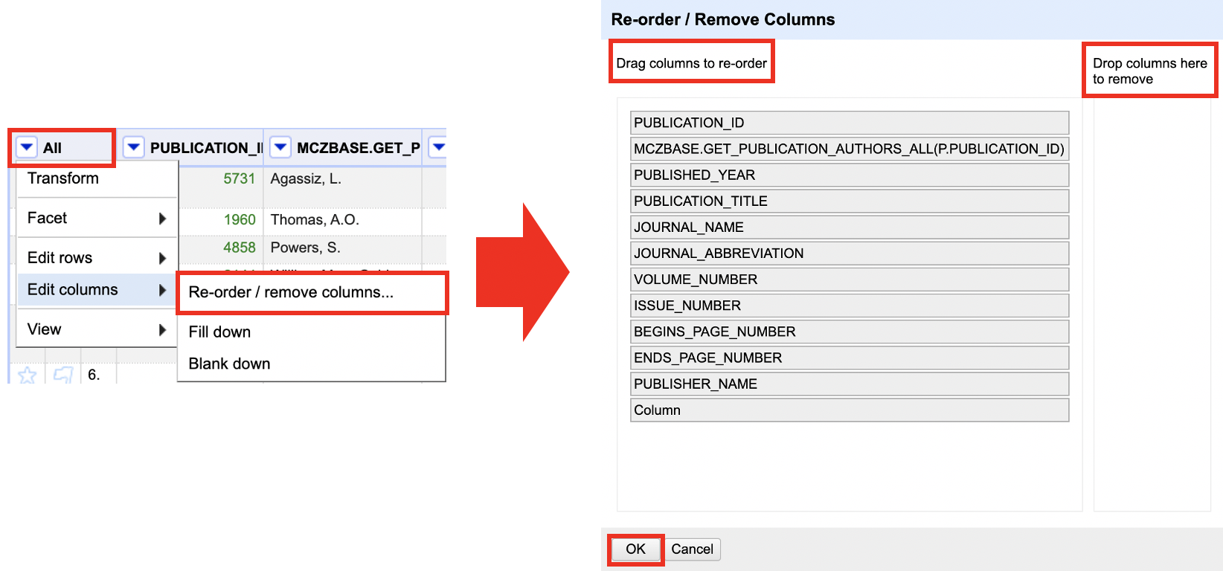

Helpful Tips:

Reordering columns can be useful when preparing to combine column data or to rearrange columns after splitting column data

### 2.4.2 Sorting Data

OpenRefine has a “Sort” feature that works similarly to Excel’s sorting. This function allows you to arrange your data in one or more columns in a certain order. #### Sorting by One Column 1.

1. Go to the column you would like to sort by and click the arrow button on the column header.
2. Select the “Sort” option.
3. In the pop-up window, select the criteria and order you wish to sort by and select “Ok.”
4. The order of rows/records will change in the grid view according to your selections



Helpful Tips:

* The “Sort” function does not permanently change the order of your rows/records, only the order you view them in. This can be checked by looking at the row/record numbers at the left of the grid view.
* The order of your rows/records can be permanently changed by selecting “Sort” at the top of the grid view and choosing “Reorder rows permanently.”
* The “Sort” function can be removed by selecting “Sort” at the top of the grid view and choosing “Remove sort.”

#### 2.4.2.1 Sorting by Multiple Columns

1. Follow steps 1-4 above for your first sort.
2. Do not remove the first sort, but choose your second column and repeat steps 1-2.
3. In the pop-up window DO NOT select the “Sort by this column alone” option and select “Ok.”
4. The order of rows/columns will change in the grid view according to your first sort and then within that, according to the second sort

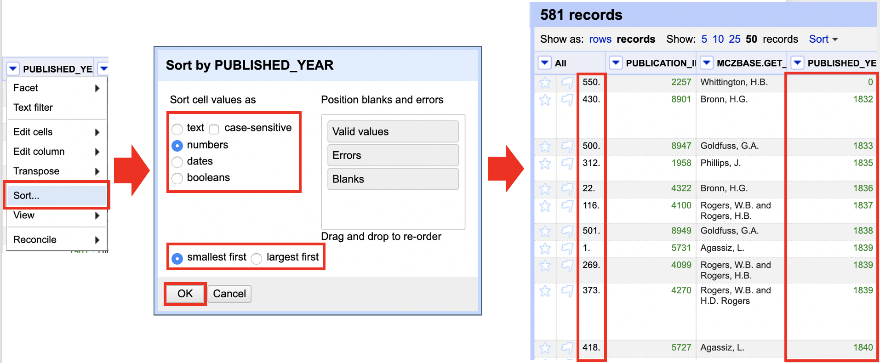 Helpful Tips:

* If you have applied multiple sorts, you can remove each one individually or as a group. This can be done by selecting “Sort” at the top of the grid view, hovering over the sort title you wish to remove, and selecting “Remove sort.”

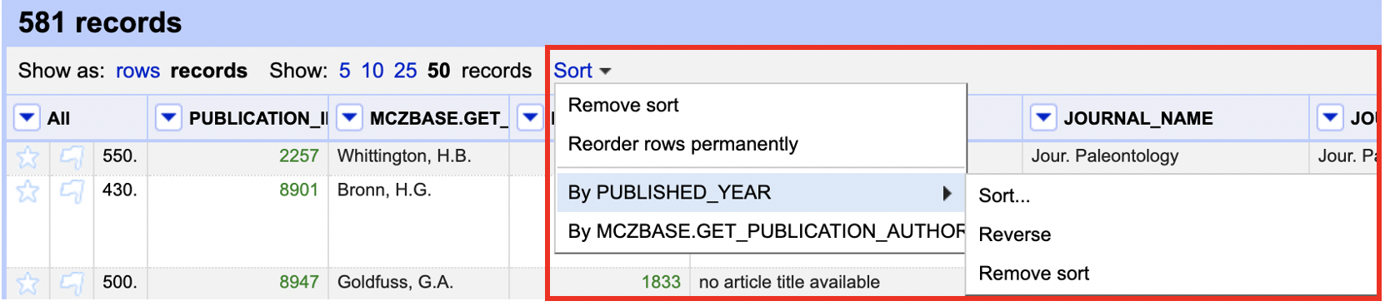

### 2.4.3 Text Based Discovery

#### 2.4.3.1 Text Facet

* Faceting allows you to quickly view unique values in a column, make edits to those values, and narrow your display to show results containing a specific facet.
* To display facets:
  1. Go to the column you would like to analyze and click the arrow button on the column header.
  2. Choose “Facet” from the drop-down menu, and then select “Text facet.”
  3. A facet window will appear in the pane to the left side of the grid view.



#### 2.4.3.2 Text Filter

* The text filter option works like the “Find” function in Excel, allowing you to search a column for values containing a specific string.
* To display the text filter function:
  1. Go to the column you would like to search and click the arrow button on the column header.
  2. Choose “Text filter.”
  3. A window with a search box will appear in the pane to the left side of the grid view.

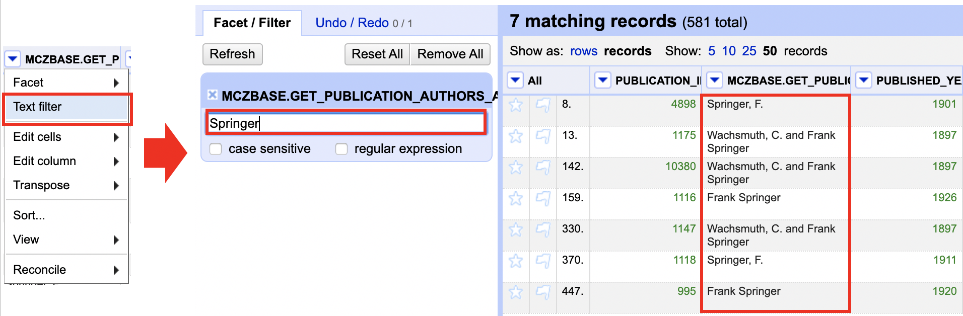

### 2.4.4 Number and Data Based Discovery

#### 2.4.4.1 Changing the Cell Format

* When you import a project into OpenRefine, the cells will automatically be given a format: text, number, or date. To change this format:

1. Go to the column you would like to change the format of and click the arrow button on the column header.
2. Choose “Edit cells” and then select “Common transformations.”
3. Under “Common transformation,” choose the desired format.

**Helpful Tips:**

-Columns with values in green are either in date or number format. This makes it easier to identify what types of facets and filters you can use.

#### 2.4.4.2 Numeric Facet

* The Numeric Facet allows you to sort columns with numeric values and to use a sliding scale to adjust the range of number values displayed in the grid view. To display this facet:

1.Go to the column you would like to facet and click the arrow button on the column header. 2. Choose “Facet” and then select “Numeric facet.” 3. A window with a sliding scale will appear in the pane to the left side of the grid view.

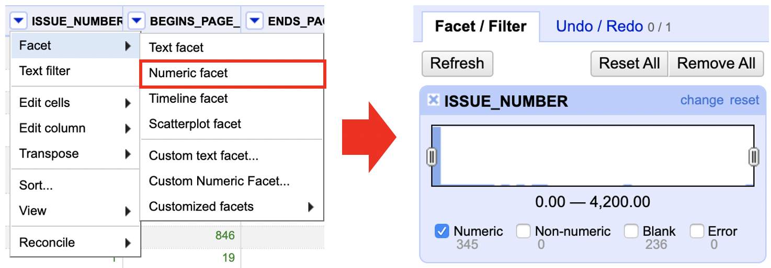

**Helpful Tips:**

* The “Numeric Facet” function is useful for narrowing data to exclude outlying numeric values.
* This function can also be used to isolate high or low values.

#### 2.4.4.3 Timeline Facet

* The Timeline Facet allows you to sort columns with date values and to use a sliding scale to adjust the range of date values to displayed in the grid view. To display this facet:

1. Go to the column you would like to facet and click the arrow button on the column header.
2. If the data is not read as “dates”, it needs to covert this column to dates. See the explanation of Common transformations.
3. Choose “Facet” and then select “Timeline facet.”
4. A window with a sliding scale will appear in the pane to the left side of the grid view.

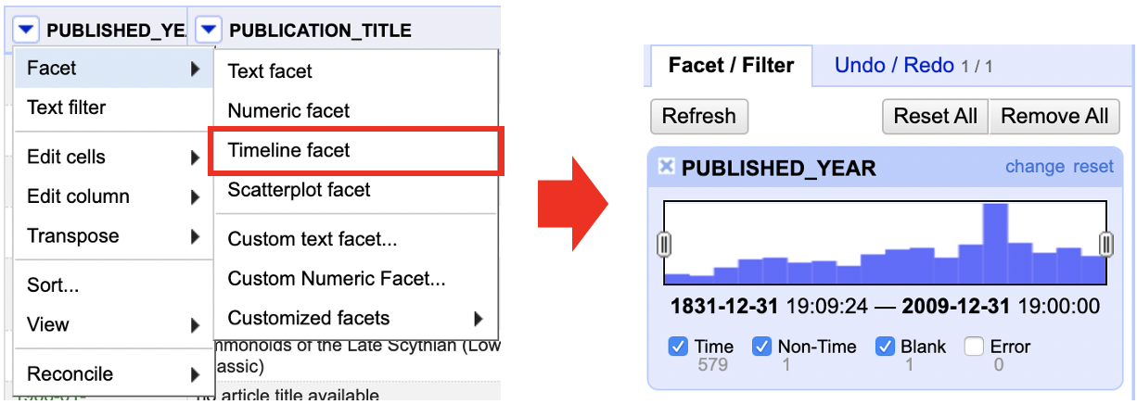

**Helpful Tips:**

The “Timeline facet” function is useful for narrowing data to exclude outlying date values. This function can also be used to isolate specific dates, times, or date ranges.

## 2.5 Data Preparation and Normalization

### 2.5.1 Common Transformations

OpenRefine has a number of functions for performing typical data transformations. Many of these changes are for data cleansing and may be done with regular expressions as well. To locate these transformations:

1. Go to the column you would like to make edits to and click the arrow button on the column header.
2. Select the “Edit cells” and then “Common transforms” options.

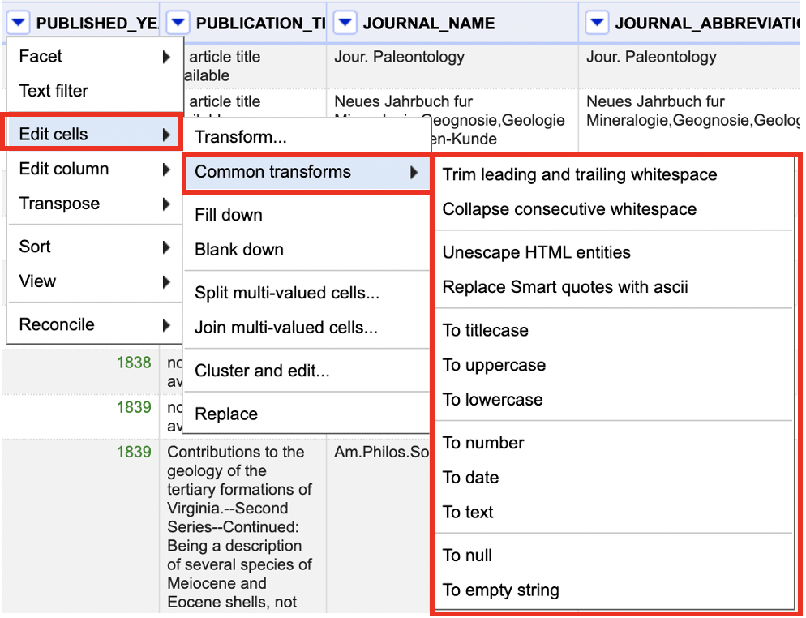

### 2.5.2 Removing Duplicates

Your data may contain duplicate information that should be removed from the dataset.

NOTE: For optimal results, make sure you’re in ROW mode.

1. Sort the column with duplicates using the sort function. See the Sorting Data section for sorting instructions.
2. Choose “Sort” and then “reorder rows permanently” after you’ve sorted the column.
3. Select the duplicates column and click the arrow button in the column header.
4. Select “Edit cells” followed by “Blank down.”
5. If two rows succeeding each other have the identical information, “Blank down” will detect it. If they do, the cell values in the second row will be eliminated and the second row will be “blanked out.”

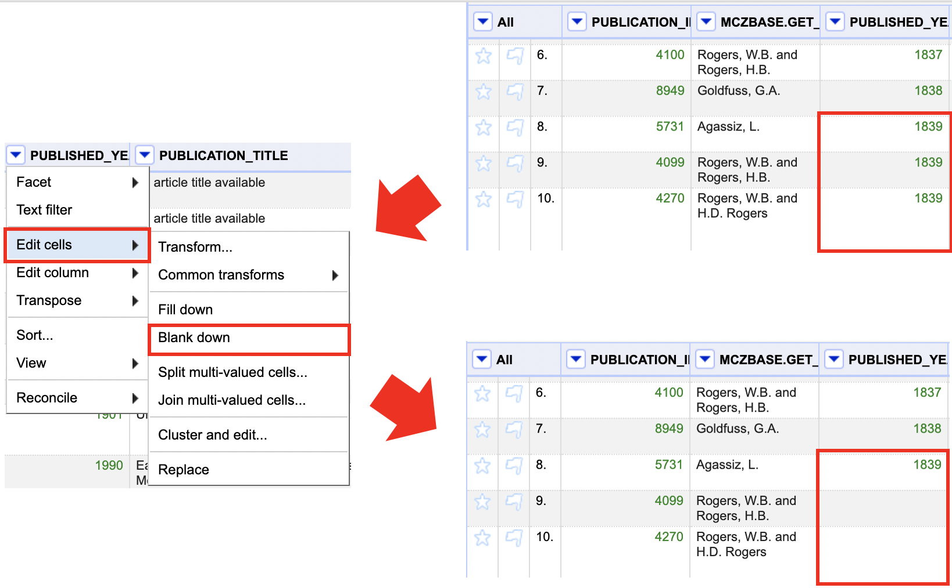

1. After you have used the “Blank down” function, use the “Facet by blank” to identify rows with blank cell values for that column.
2. From the facet window, select the “true” option.
3. Go to the column labeled “All” and click on the arrow button, then select “Edit rows” and choose “Remove all matching rows.”
4. All rows with the identified duplicates will be removed. To restore the full data view, simply reset the facets

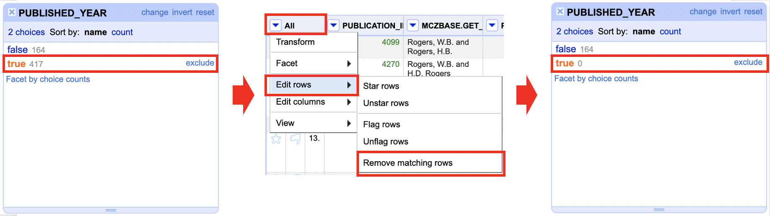

Helpful Tips:

* It is important to make sure that all cells in the column you are applying this transformation to have values. If there are cells that were originally blank before applying the “Blank down” function, they will be deleted along with the duplicate rows.
* It is important to be aware that the entire row of values will be deleted along with the duplicate value in a given column. Be careful and check before deleting rows or applying the “Blank down” function to make sure that data meant to be kept is not accidentally deleted.

### 2.5.3 Splitting Cell Values

You can come across columns that have a lot of data clumped together. OpenRefine has numerous options for separating these pieces of data into more meaningful divisions, such creating new columns or creating a multi-row record.

#### 2.5.3.1 Creating a New Row Based on a Separator

NOTE: Before starting this process, make sure to reset all facets on the column you want to work with.

1. Click the arrow button on the column header next to the column you want to split.
2. Choose “Split multi-valued cells” from the “Edit cells” menu.
3. Type the separator (usually a semicolon, comma, or other special character) in the pop-up window and click “OK.”
4. Cells having separator values will be divided into different rows according to those separators.

Note: The new rows will be part of the same record as before. See the Layout section for further information on rows and records.

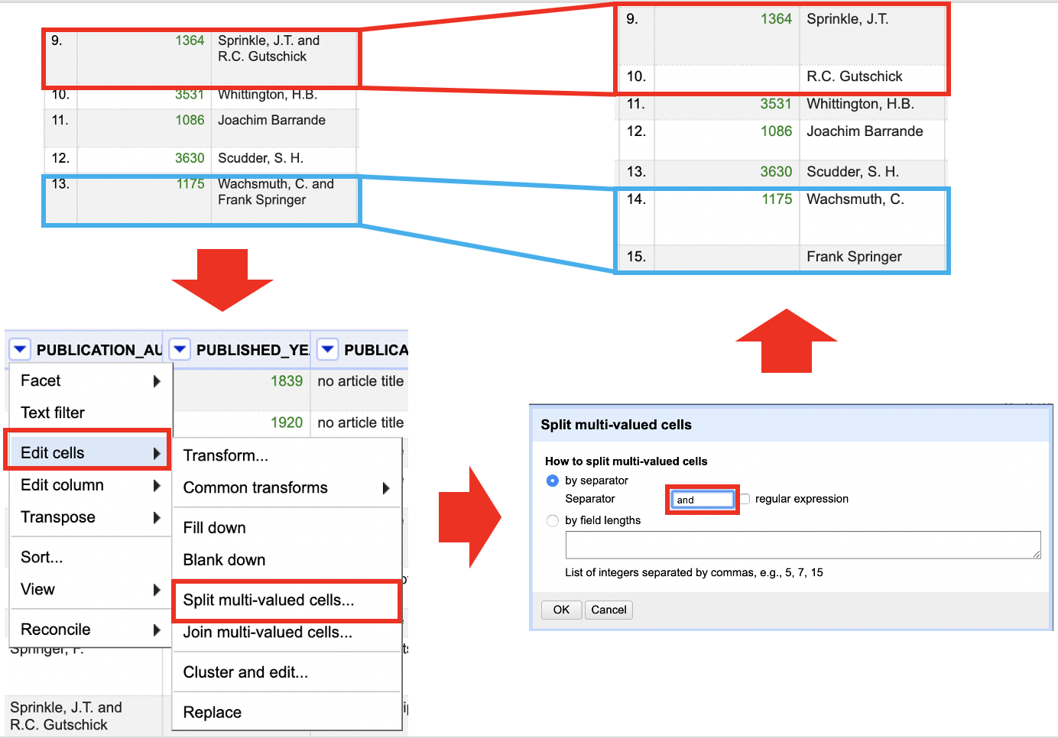

#### 2.5.3.2 Creating a New Column Based on a Separator or Field Length

1. Go to the column you would like to split and click the arrow button on the column header.
2. Select the “Edit column” option and choose “Split into several columns.”
3. In the pop-up window, select the method by which you would like to split the column:
4. “By separator” allows you to input the separator value (often a semi-colon, comma, or other special character) as well as to limit the number of additional columns are created.
5. “By field lengths” allows you to input a string of integers to indicate where in the original column value you would like OpenRefine to split the values. For example: i. A column contains dates in the YYYY/MM/DD format. You wish to divide this into three columns (Year, Month, Day). Under “by field lengths,” use the list “4, 1, 2, 1, 2” indicating “year, slash, month, slash, day.” The result will be five columns, two with only slashes which you can remove, and three with the Year, Month, and Day respectively.
6. When you have selected and identified all your criteria, select “OK.”

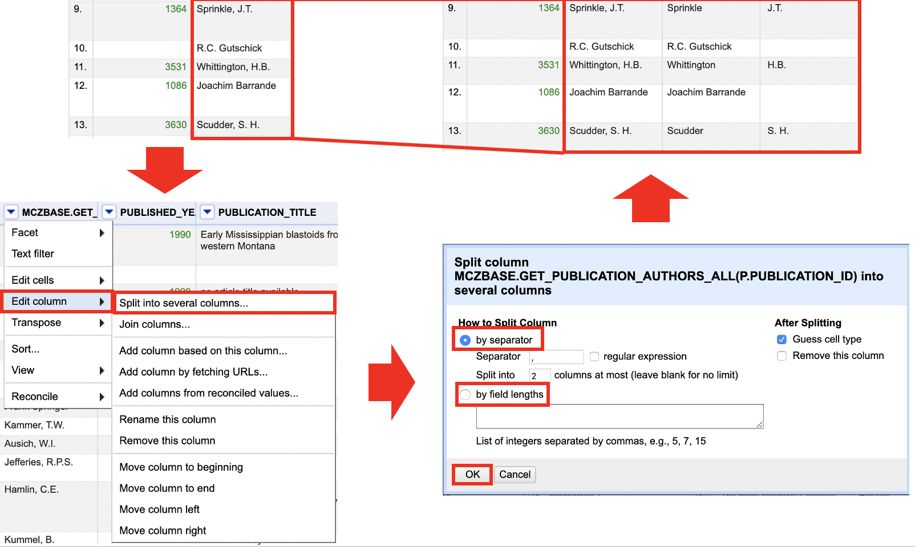

Helpful Tips:

* The new columns will be named after the original column from which they were built. You can change the column titles by going to the column header, clicking the arrow button, selecting “Edit column,” and then selecting “Rename this column.”
* This transformation is useful for splitting data into manageable chunks for analysis. Information such as addresses, dates, and people could be included.

### 2.5.4 Combining cell Values

In OpenRefine 3.3, you can merge data from different columns. You can use this technique to combine the contents of two columns, add a certain string or characters to the values of a column, or do both. There are various methods for combining data from different columns. Introduce two fundamental functions for combining data:

* Joining columns
* Concatenation

### 2.5.5 Data Shaping

OpenRefine has functions that allow you to reshape your data by transposing information between rows and columns in order to see it in a new way.

#### 2.5.5.1 Rows into Columns

To transpose rows into columns:

1. Go to the column with the data you would like to separate into different columns.
2. Click the arrow button in the column header and select “Transpose.”
3. Select “Transpose cells in rows into columns

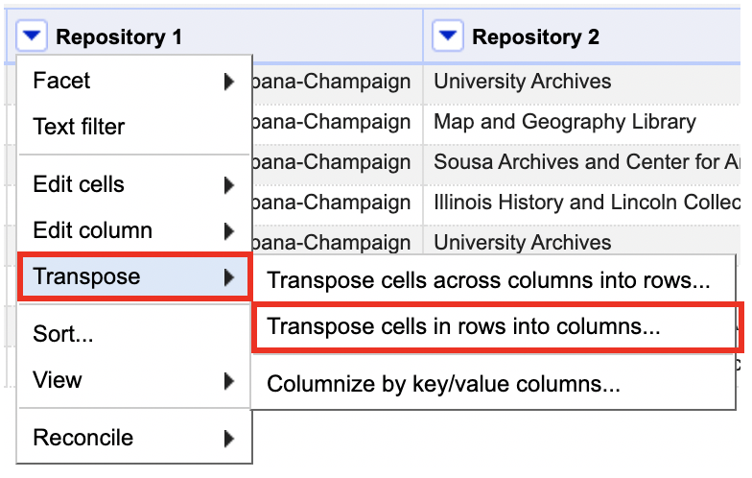

1. In the pop-up window, enter the number of rows you would like to transpose and click OK. NOTE: If you enter “2,” OpenRefine will create two columns, pulling cell values from rows in sets of two. For example: (Row 1, Column A) and (Row 2, Column A) will become (Row 1, Column A) and (Row 1, Column B) respectively.

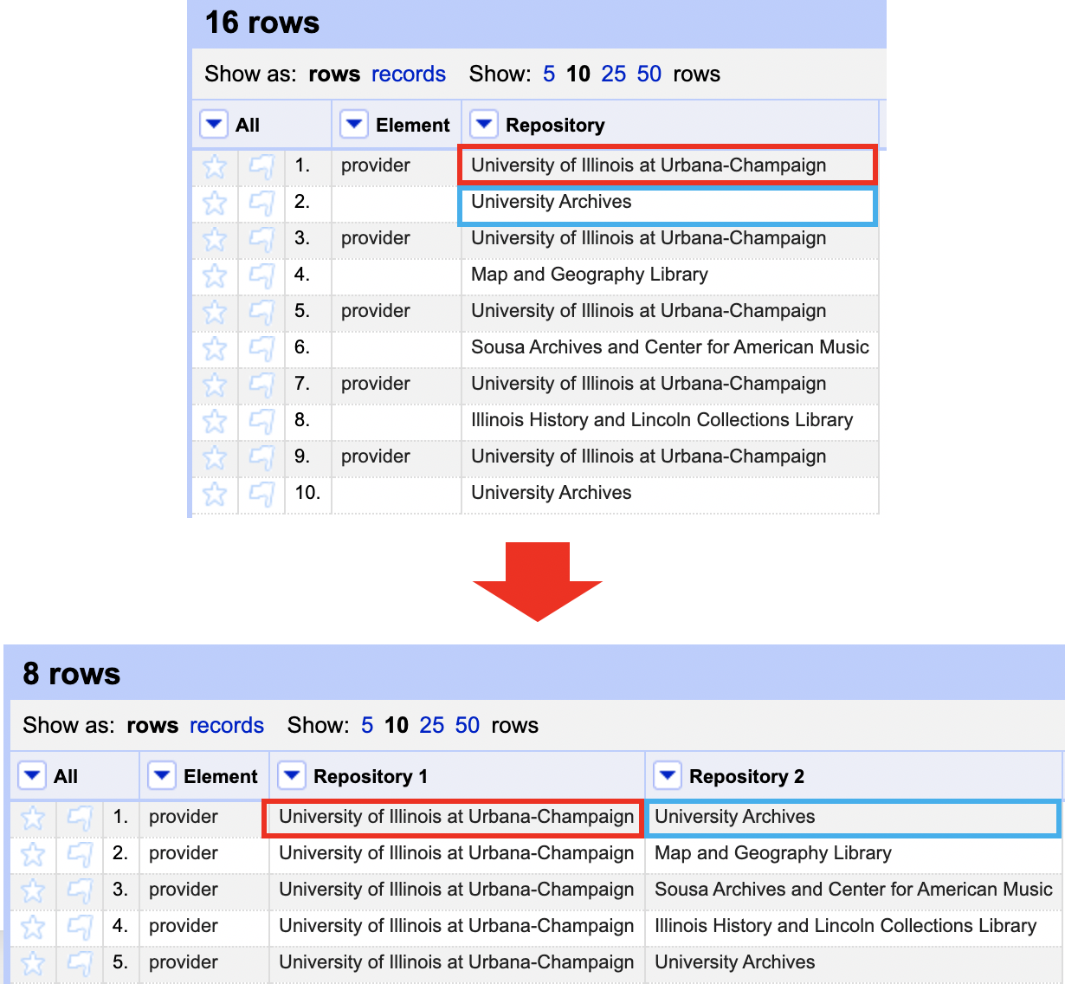 5. Click “Transpose.”

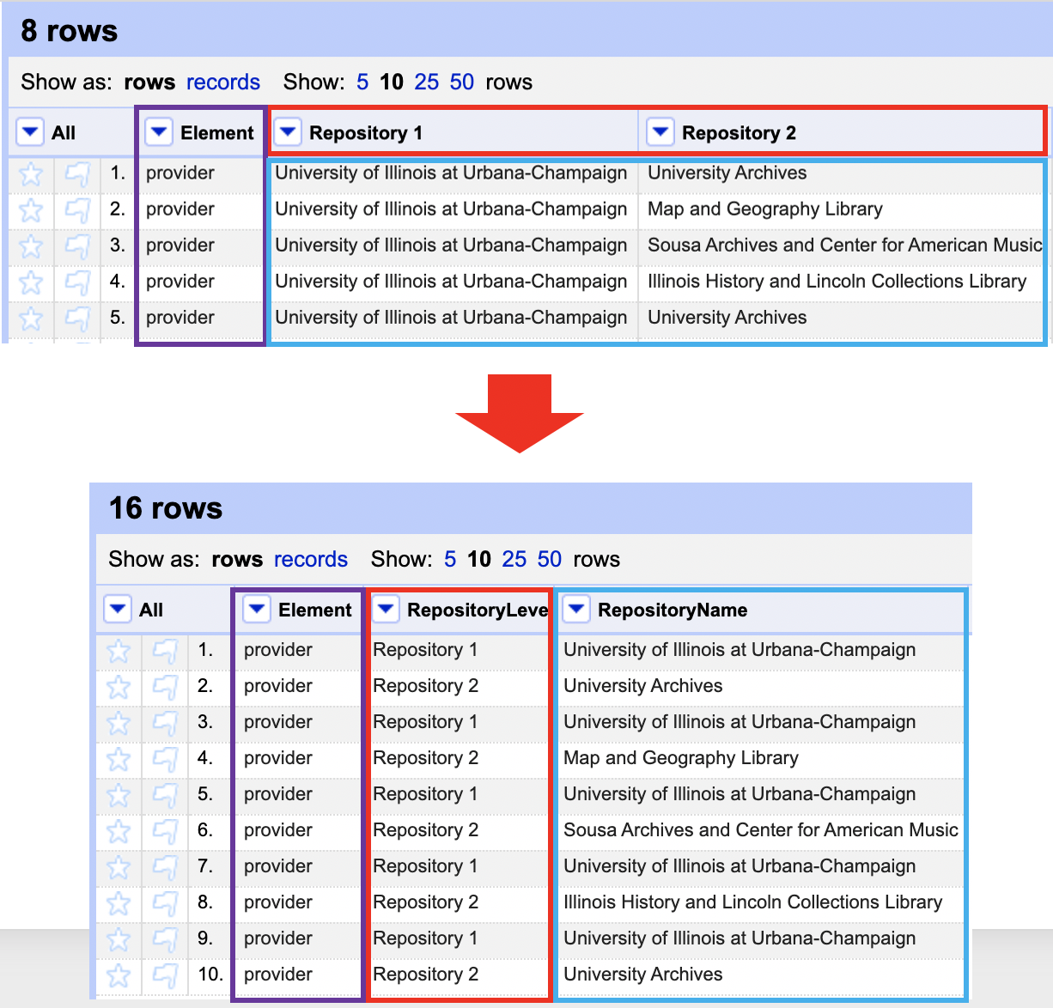 Helpful Tips:

* If there are specific columns you would like to transpose into rows, consider moving them next to each other by following the instructions for Reordering Columns.
* Since transposing columns to rows does not preserve record associations (see Records and Rows), make sure you have a unique identifier column not being included in the transformation. This way, when you select “Fill down in other columns.” the unique identifier can be used to associate related data.
* All transformations of columns into rows are tracked in the Undo/Redo tab, so you can experiment with transposing columns into rows until you are comfortable with the result.

### 2.5.6 Clustering

# 3 Data Analysis with R

## 3.1 What is R? What is RStudio?

The term R is used to refer to both the programming language and the software that interprets the scripts written using it.

RStudio is a popular tool for not just writing R scripts but also interacting with the R software. RStudio requires R to function properly, thus both must be installed on your machine.

## 3.2 Why learn R?

### 3.2.1 R does not involve lots of pointing and clicking, and that’s a good thing

The learning curve may be longer than with other tools, but the outcomes of your research with R are based on a sequence of written commands rather than a series of pointing and clicking, which is a positive thing! So, if you want to redo your analysis because you gathered more data, you don’t need to remember which buttons you clicked in which order to get your results; all you have to do is rerun your script.

Working using scripts clarifies the steps you took in your investigation, and the code you write can be reviewed by another person who can provide input and point out errors.

Working with scripts challenges you to think more deeply about what you’re doing and makes it easier to learn and comprehend the approaches you utilize.

### 3.2.2 R code is great for reproducibility

When someone else (including your future self) can get the same results from the same dataset using the same analysis, it’s called reproducibility.

To generate manuscripts from your code, R interfaces with different technologies. The figures and statistical tests in your publication are automatically updated if you acquire more data or correct a mistake in your dataset.

Knowing R will offer you an advantage with these requirements, as an increasing number of journals and funding agencies seek repeatable analyses.

### 3.2.3 R is interdisciplinary and extensible

R provides a framework that allows you to integrate statistical methodologies from various scientific disciplines to best suit the analytical framework you need to examine your data, with over 10,000+ packages that can be installed to increase its capabilities. R, for example, contains packages for image analysis, geographic information systems (GIS), time series, population genetics, and much more.

### 3.2.4 R works on data of all shapes and sizes

The abilities you learn with R scale quickly as your dataset grows in size. It won’t make a difference to you if your dataset comprises hundreds or millions of lines.

R was created with data analysis in mind. It includes specific data structures and data types that simplify the handling of missing data and statistical elements.

R can connect to spreadsheets, databases, and a variety of other data formats, both locally and remotely.

### 3.2.5 R produces high-quality graphics

R’s plotting capabilities are limitless, allowing you to tweak every part of your graph to best convey the message from your data.

### 3.2.6 R has a large and welcoming community

R is used by thousands of people every day. Many of them are prepared to help you through mailing lists and websites such as Stack Overflow, or on the RStudio community.

### 3.2.7 Not only is R free, but it is also open-source and cross-platform

Anyone can look at the source code to learn more about R. Because of this transparency, there are less chances for errors, and you (or someone else) can report and repair faults if you find them.

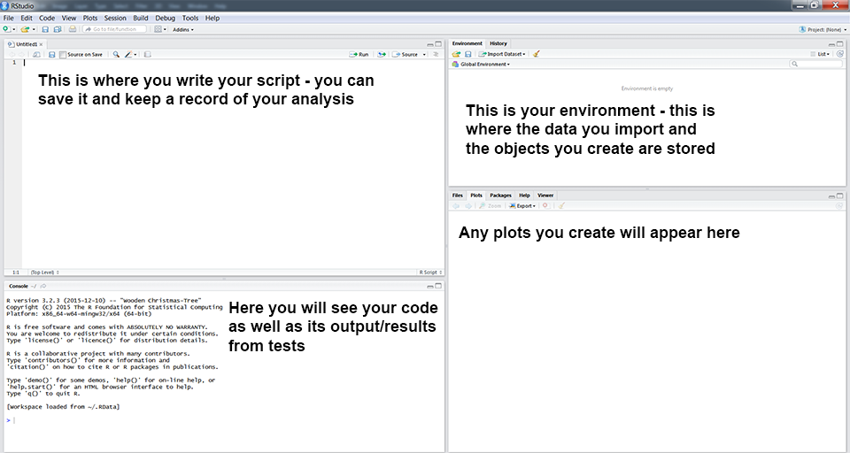

Rstudio Panels

### 3.2.8 Knowing your way around RStudio

Let’s begin by learning about RStudio, an Integrated Development Environment (IDE) for R programming.

The Affero General Public License (AGPL) v3 covers the RStudio IDE open-source project. A commercial license and priority email assistance from RStudio, Inc. are also available for the RStudio IDE.

We’ll use the RStudio IDE to write code, navigate our computer’s files, analyze the variables we’ll create, and visualize the plots we’ll make. Other features of RStudio that we will not cover during the course include version management, package development, and writing Shiny apps.

## 3.3 Introduction to R

You can get output from R simply by typing math in the console:

5 + 6

## [1] 11

10 /3

## [1] 3.333333

However, we must give values to objects in order to accomplish useful and interesting things. To make an object, we must first give it a name, then use the assignment operator. <-, and the value we want to give it:

weight_kg <- 65

<- is the assignment operator. It assigns values on the right to objects on the left. So, after executing x <- 3, the value of x is 3. The arrow can be read as **3 goes into x**. For historical reasons, you can also use = for assignments, but not in every context. Because of the slight differences in syntax, it is good practice to always use <- for assignments.

In RStudio, typing Alt + - (push Alt at the same time as the - key) will write <- in a single keystroke in a PC, while typing Option + - (push Option at the same time as the - key) does the same in a Mac.

When assigning a value to an object, R does not print anything. You can force R to print the value by using parentheses or by typing the object name:

weight_kg <- 65 # doesn't print anything  
(weight_kg <- 65) # but putting parenthesis around the call prints the value of `weight_kg`

## [1] 65

weight_kg # and so does typing the name of the object

## [1] 65

Now that R has weight_kg in memory, we can do arithmetic with it. For instance, we may want to convert this weight into pounds (weight in pounds is 2.2 times the weight in kg):

weight_lb <- weight_kg * 2.2

### 3.3.1 Comments

The comment character in R is #, and anything in a script to the right of a # is disregarded by *R*. Leaving notes and clarifications in your scripts is beneficial. To remark or uncomment a paragraph in RStudio, select the lines you want to comment and hit Ctrl + Shift + C on your keyboard at the same time. If you only want to comment out one line, place the cursor wherever on it (no need to select the entire line), then click Ctrl + Shift + C.

**Exercise**

What are the values after each statement in the following?

mass <- 65.5 # mass?  
age <- 55 # age?  
mass <- mass * 2.0 # mass?  
age <- age - 20 # age?  
mass_index <- mass/age # mass_index?

### 3.3.2 Functions and their arguments

Functions are “canned scripts” that automate more complex sets of commands, such as operations assignments and the like. Many functions are predefined or can be accessed by installing R packages (more on that later). A function typically takes one or more arguments as input. Most (but not all) functions return a value. The function sqrt() is an excellent example. The input (argument) must be an integer, and the output (return value) is the square root of that number. Calling a function (‘running it’) is the process of executing it. A function call might look like this:

ten <- sqrt(weight_kg)

The **sqrt()** method is given the value of weight kg, which calculates the square root and returns the value, which is then assigned to the object ten. Because it just accepts one argument, this function is incredibly basic.

Let’s try a function that can take multiple arguments: round()

round(3.14159)

## [1] 3

We used round() with only one argument, 3.14159, and it returned 3. Because the default is to round to the nearest full number, this is the case. We can see how to gain extra digits by gathering knowledge about the round function. To find out what arguments it requires, we can use args(round) or search up the documentation for this method with ?round.

args(round)

## function (x, digits = 0)   
## NULL

We see that if we want a different number of digits, we can type digits = 3 or however many we want.

round(3.14159, digits = 3)

## [1] 3.142

# or  
round(3.14159, 3)

## [1] 3.142

### 3.3.3 Data Structure

R has several core data structures, and we’ll take a look at each. * Vectors * Factors * Lists * Matrices/arrays * Data frames

#### 3.3.3.1 Vectors

Vectors form the basis of R data structures. It is the most frequent and fundamental data type in R, and it is the workhorse of the language. A vector is made up of a collection of values that can be numbers or characters. The c() function can be used to assign a set of values to a vector. For instance, we may make a vector of animal weights and assign it to a new object called weight_g:

weight_g <- c(70, 80, 75, 22)  
weight_g

## [1] 70 80 75 22

A vector can also contain characters:

animals <- c("rat","mouse", "dog")  
animals

## [1] "rat" "mouse" "dog"

The quotation marks surrounding “mouse,” “rat,” and other words are crucial. Without the quotations, R will presume that objects named **rat, mouse, and dog** have been created. There will be an error message since these objects do not exist in R’s memory.

There are numerous functions for inspecting the content of a vector. length() returns the number of elements in a given vector:

length(weight_g)

## [1] 4

length(animals)

## [1] 3

An important feature of a vector, is that all of the elements are the same type of data. The function class() indicates the class (the type of element) of an object:

class(animals)

## [1] "character"

class(weight_g)

## [1] "numeric"

The function **str()** provides an overview of the structure of an object and its elements. It is a useful function when working with large and complex objects:

str(weight_g)

## num [1:4] 70 80 75 22

str(animals)

## chr [1:3] "rat" "mouse" "dog"

You can use the c() function to add other elements to your vector:

weight_g <- c(weight_g, 10) # add to the end of the vector  
weight_g <- c(20, weight_g) # add to the beginning of the vector  
weight_g

## [1] 20 70 80 75 22 10

Elements of an atomic vector are the same type. Example types include:

* character
* numeric (double)
* integer
* logical

### 3.3.4 Subsetting vectors

We must specify one or more indices in square brackets if we want to extract one or more values from a vector. Consider the following:

animals <- c("mouse", "rat", "dog", "cat")  
animals[2]

## [1] "rat"

animals <- c("mouse", "rat", "dog", "cat")  
animals[c(3,1)]

## [1] "dog" "mouse"

We can also repeat the indices to create an object with more elements than the original one:

animals <- c("mouse", "rat", "dog", "cat")  
animals[c(3,1, 2, 1, 3, 1,4)]

## [1] "dog" "mouse" "rat" "mouse" "dog" "mouse" "cat"

R indices start at 1. Programming languages like Fortran, MATLAB, Julia, and R start counting at 1, because that’s what human beings typically do. Languages in the C family (including C++, Java, Perl, and Python) count from 0 because that’s simpler for computers to do.

### 3.3.5 Conditional subsetting

Another common way of subsetting is by using a logical vector. TRUE will select the element with the same index, while FALSE will not:

weight_g <- c(20, 10, 39, 54, 65)  
weight_g[c(TRUE, FALSE, FALSE, TRUE, TRUE)]

## [1] 20 54 65

weight_g > 40

## [1] FALSE FALSE FALSE TRUE TRUE

weight_g[weight_g > 40]

## [1] 54 65

You can combine multiple tests using & (both conditions are true, AND) or | (at least one of the conditions is true, OR):

weight_g[weight_g < 20 | weight_g > 60]

## [1] 10 65

weight_g[weight_g < 20 & weight_g == 60]

## numeric(0)

### 3.3.6 Missing Data

As R was designed to analyze datasets, it includes the concept of missing data (which is uncommon in other programming languages). Missing data are represented in vectors as NA.

When doing operations on numbers, most functions will return NA if the data you are working with include missing values. This feature makes it harder to overlook the cases where you are dealing with missing data. You can add the argument na.rm = TRUE to calculate the result while ignoring the missing values.

heights <- c(2, 4, 4, NA, 6)  
mean(heights)

## [1] NA

heights <- c(2, 4, 4, NA, 6)  
mean(heights)

## [1] NA

min(heights)

## [1] NA

max(heights, na.rm = TRUE)

## [1] 6

If your data include missing values, you may want to become familiar with the functions is.na(), na.omit(), and complete.cases(). See below for examples.

# Extract those elements which are not missing values.  
heights[!is.na(heights)]

## [1] 2 4 4 6

# Returns the object with incomplete cases removed. The returned object is an atomic vector of type `"numeric"` (or `"double"`).  
na.omit(heights)

## [1] 2 4 4 6  
## attr(,"na.action")  
## [1] 4  
## attr(,"class")  
## [1] "omit"

# Extract those elements which are complete cases. The returned object is an atomic vector of type `"numeric"` (or `"double"`).  
heights[complete.cases(heights)]

## [1] 2 4 4 6

#### 3.3.6.1 Factors

An important type of vector is a factor. Factors are used to represent categorical data structures. Although not exactly precise, one can think of factors as integers with labels. For example, the underlying representation of a variable for sex is 1:2 with labels “Male” and “Female”. They are a special class with attributes, or metadata, that contains the information about the levels.

x = factor(c("Male","Female","Female","Male","Male"))  
x

## [1] Male Female Female Male Male   
## Levels: Female Male

attributes(x)

## $levels  
## [1] "Female" "Male"   
##   
## $class  
## [1] "factor"

The underlying representation is numeric, but it is important to remember that factors are categorical. Thus, they can’t be used as numbers would be, as the following demonstrates.

x_num = as.numeric(x) # convert to a numeric object  
sum(x_num)

## [1] 8

Error in Summary.factor(c(1L, 1L, 1L, 1L, 1L, 1L, 1L, 1L, 1L, 1L, 2L, :   
 ‘sum’ not meaningful for factors  
 Error in base::try(heights, silent = TRUE) : object 'heights' not found

#### 3.3.6.2 Logicals

Logical scalar/vectors are those that take on one of two values: TRUE or FALSE. They are especially useful in flagging whether to run certain parts of code, and indexing certain parts of data structures (e.g. taking rows that correspond to TRUE). We’ll talk about the latter usage later.

Here is a logical vector.

my_logic= c(TRUE, FALSE, TRUE, FALSE, TRUE, TRUE)  
my_logic

## [1] TRUE FALSE TRUE FALSE TRUE TRUE

Note also that logicals are also treated as binary 0:1, and so, for example, taking the mean will provide the proportion of TRUE values.

!my_logic

## [1] FALSE TRUE FALSE TRUE FALSE FALSE

as.numeric(my_logic)

## [1] 1 0 1 0 1 1

mean(my_logic)

## [1] 0.6666667

#### 3.3.6.3 Numeric and Integer

The most common type of data structure you’ll deal with are integer and numeric vectors.

ints <- -3:3 # integer sequences are easily constructed with the colon operator  
class(ints)

## [1] "integer"

set.seed(42) # fix the random numbers seed  
x <- rnorm(5) # 5 random values from the standard normal distribution  
x

## [1] 1.3709584 -0.5646982 0.3631284 0.6328626 0.4042683

typeof(x)

## [1] "double"

class(x)

## [1] "numeric"

The main difference between the two is that integers regard whole numbers only and are otherwise smaller in size in memory, but practically speaking you typically won’t distinguish them for most of your data science needs.

#### 3.3.6.4 Dates

The common data structure you’ll deal with is a date variable. Typically dates require special treatment and to work as intended, but they can be stored as character strings or factors if desired. The following shows some of the base R functionality for this.

Sys.Date()

## [1] "2022-11-14"

x = as.Date(c(Sys.Date(), '2022-05-25', Sys.Date()+2))  
x

## [1] "2022-11-14" "2022-05-25" "2022-11-16"

In almost every case however, a package like lubridate will make processing them much easier. The following shows how to strip out certain aspects of a date using it.

library(lubridate)  
month(Sys.Date())

## [1] 11

library(lubridate)  
day(Sys.Date())

## [1] 14

library(lubridate)  
wday(Sys.Date()) # week start day ( 1-Monday, 7-sunday)

## [1] 2

quarter(Sys.Date())

## [1] 4

as_date('2022-01-01') + 100

## [1] "2022-04-11"

In general though, dates are treated as numeric variables, with consistent (but arbitrary) starting point. If you use these in analysis, you’ll probably want to make zero a useful value (e.g. the starting date)

as.numeric(Sys.Date())

## [1] 19310

### 3.3.7 Matrices

With multiple dimensions, we are dealing with arrays. Matrices are two dimensional (2-d) arrays, and extremely commonly used for scientific computing. The vectors making up a matrix must all be of the same type. For example, all values in a matrix might be numeric, or all character strings.

#### 3.3.7.1 Creating a matrix

Creating a matrix can be done in a variety of ways.

# create vectors  
x <- 1:4  
y <- 5:8  
z <- 9:12  
  
rbind(x, y, z) # row bind

## [,1] [,2] [,3] [,4]  
## x 1 2 3 4  
## y 5 6 7 8  
## z 9 10 11 12

cbind(x, y, z) # row bind

## x y z  
## [1,] 1 5 9  
## [2,] 2 6 10  
## [3,] 3 7 11  
## [4,] 4 8 12

matrix(  
 c(x, y, z),  
 nrow = 3,  
 ncol = 4,  
 byrow = TRUE  
)

## [,1] [,2] [,3] [,4]  
## [1,] 1 2 3 4  
## [2,] 5 6 7 8  
## [3,] 9 10 11 12

matrix(  
 c(x, y, z),  
 nrow = 3,  
 ncol = 4,  
 byrow = FALSE  
)

## [,1] [,2] [,3] [,4]  
## [1,] 1 4 7 10  
## [2,] 2 5 8 11  
## [3,] 3 6 9 12

### 3.3.8 Data Frames

Data frames are a very commonly used data structure, and are essentially a representation of data in a table format with rows and columns. Elements of a data frame can be different types, and this is because the data.frame class is actually just a list. As such, everything about lists applies to them. But they can also be indexed by row or column as well, just like matrices. There are other very common types of object classes associated with packages that are both a data.frame and some other type of structure (e.g. tibbles in the tidyverse).

Usually your data frame will come directly from import or manipulation of other R objects (e.g. matrices). However, you should know how to create one from scratch.

#### 3.3.8.1 Creating a data frame

The following will create a data frame with two columns, a and b.

a <- c(1, 5, 2)  
b <- c(3, 8, 1)  
df <- data.frame(a,b)  
df

## a b  
## 1 1 3  
## 2 5 8  
## 3 2 1

Much to the disdain of the tidyverse, we can add row names also

rownames(df) <- paste0('row',1:3)  
df

## a b  
## row1 1 3  
## row2 5 8  
## row3 2 1

Everything about lists applies to data.frames, so we can add, select, and remove elements of a data frame just like lists. However we’ll visit this more in depth later, and see that we’ll have much more flexibility with data frames than we would lists for common data analysis and visualization.

## 3.4 Starting with data

We can read and load the data table from csv format:

library(tidyverse)  
df <- read_csv("data/combined.csv")

This statement doesn’t produce any output because, as you might recall, assignments don’t display anything. If we want to check that our data has been loaded, we can see the contents of the data frame by typing its name: df

Wow… that was a lot of output. At least it means the data loaded properly. Let’s check the top (the first 6 lines) of this data frame using the function head():

head(df)

## # A tibble: 6 × 13  
## record_id month day year plot_id speci…¹ sex hindf…² weight genus species  
## <dbl> <dbl> <dbl> <dbl> <dbl> <chr> <chr> <dbl> <dbl> <chr> <chr>   
## 1 1 7 16 1977 2 NL M 32 NA Neot… albigu…  
## 2 72 8 19 1977 2 NL M 31 NA Neot… albigu…  
## 3 224 9 13 1977 2 NL <NA> NA NA Neot… albigu…  
## 4 266 10 16 1977 2 NL <NA> NA NA Neot… albigu…  
## 5 349 11 12 1977 2 NL <NA> NA NA Neot… albigu…  
## 6 363 11 12 1977 2 NL <NA> NA NA Neot… albigu…  
## # … with 2 more variables: taxa <chr>, plot_type <chr>, and abbreviated  
## # variable names ¹​species_id, ²​hindfoot_length

str(df)

## spc_tbl_ [34,786 × 13] (S3: spec_tbl_df/tbl_df/tbl/data.frame)  
## $ record_id : num [1:34786] 1 72 224 266 349 363 435 506 588 661 ...  
## $ month : num [1:34786] 7 8 9 10 11 11 12 1 2 3 ...  
## $ day : num [1:34786] 16 19 13 16 12 12 10 8 18 11 ...  
## $ year : num [1:34786] 1977 1977 1977 1977 1977 ...  
## $ plot_id : num [1:34786] 2 2 2 2 2 2 2 2 2 2 ...  
## $ species_id : chr [1:34786] "NL" "NL" "NL" "NL" ...  
## $ sex : chr [1:34786] "M" "M" NA NA ...  
## $ hindfoot_length: num [1:34786] 32 31 NA NA NA NA NA NA NA NA ...  
## $ weight : num [1:34786] NA NA NA NA NA NA NA NA 218 NA ...  
## $ genus : chr [1:34786] "Neotoma" "Neotoma" "Neotoma" "Neotoma" ...  
## $ species : chr [1:34786] "albigula" "albigula" "albigula" "albigula" ...  
## $ taxa : chr [1:34786] "Rodent" "Rodent" "Rodent" "Rodent" ...  
## $ plot_type : chr [1:34786] "Control" "Control" "Control" "Control" ...  
## - attr(*, "spec")=  
## .. cols(  
## .. record_id = col_double(),  
## .. month = col_double(),  
## .. day = col_double(),  
## .. year = col_double(),  
## .. plot_id = col_double(),  
## .. species_id = col_character(),  
## .. sex = col_character(),  
## .. hindfoot_length = col_double(),  
## .. weight = col_double(),  
## .. genus = col_character(),  
## .. species = col_character(),  
## .. taxa = col_character(),  
## .. plot_type = col_character()  
## .. )  
## - attr(*, "problems")=<externalptr>

### 3.4.1 Inspecting Data Frame Objects

We already saw how the functions head() and str() can be useful to check the content and the structure of a data frame. Here is a non-exhaustive list of functions to get a sense of the content/structure of the data. Let’s try them out!

* Size:
  + dim(df) - returns a vector with the number of rows in the first element, and the number of columns as the second element (the dimensions of the object)
  + nrow(df) - returns the number of rows
  + ncol(df) - returns the number of columns
* Content:
  + head(df) - shows the first 6 rows
  + tail(df) - shows the last 6 rows
* Names:
  + names(df) - returns the column names (synonym of colnames() for data.frame objects)
  + rownames(df) - returns the row names Summary:
  + str(df) - structure of the object and information about the class, length and content of each column
  + summary(df) - summary statistics for each column

Note: most of these functions are “generic”, they can be used on other types of objects besides data.frame.

## 3.5 Indexing and subsetting data frames

Our survey data frame has rows and columns (it has 2 dimensions), if we want to extract some specific data from it, we need to specify the “coordinates” we want from it. Row numbers come first, followed by column numbers. However, note that different ways of specifying these coordinates lead to results with different classes.

# first element in the first column of the data frame (as a vector)  
df[1, 1]

## # A tibble: 1 × 1  
## record_id  
## <dbl>  
## 1 1

# first element in the 6th column (as a vector)  
df[1, 6]

## # A tibble: 1 × 1  
## species_id  
## <chr>   
## 1 NL

# first column of the data frame (as a vector)  
df[, 1]

## # A tibble: 34,786 × 1  
## record_id  
## <dbl>  
## 1 1  
## 2 72  
## 3 224  
## 4 266  
## 5 349  
## 6 363  
## 7 435  
## 8 506  
## 9 588  
## 10 661  
## # … with 34,776 more rows

# first column of the data frame (as a data.frame)  
df[1]

## # A tibble: 34,786 × 1  
## record_id  
## <dbl>  
## 1 1  
## 2 72  
## 3 224  
## 4 266  
## 5 349  
## 6 363  
## 7 435  
## 8 506  
## 9 588  
## 10 661  
## # … with 34,776 more rows

# first three elements in the 7th column (as a vector)  
df[1:3, 7]

## # A tibble: 3 × 1  
## sex   
## <chr>  
## 1 M   
## 2 M   
## 3 <NA>

# the 3rd row of the data frame (as a data.frame)  
df[3, ]

## # A tibble: 1 × 13  
## record_id month day year plot_id speci…¹ sex hindf…² weight genus species  
## <dbl> <dbl> <dbl> <dbl> <dbl> <chr> <chr> <dbl> <dbl> <chr> <chr>   
## 1 224 9 13 1977 2 NL <NA> NA NA Neot… albigu…  
## # … with 2 more variables: taxa <chr>, plot_type <chr>, and abbreviated  
## # variable names ¹​species_id, ²​hindfoot_length

# equivalent to head_df <- head(df)  
head_df <- df[1:6, ]

: is a special function that creates numeric vectors of integers in increasing or decreasing order, test 1:10 and 10:1 for instance.

You can also exclude certain indices of a data frame using the “-” sign:

df[, -1] # The whole data frame, except the first column

## # A tibble: 34,786 × 12  
## month day year plot_id species_id sex hindf…¹ weight genus species taxa   
## <dbl> <dbl> <dbl> <dbl> <chr> <chr> <dbl> <dbl> <chr> <chr> <chr>  
## 1 7 16 1977 2 NL M 32 NA Neot… albigu… Rode…  
## 2 8 19 1977 2 NL M 31 NA Neot… albigu… Rode…  
## 3 9 13 1977 2 NL <NA> NA NA Neot… albigu… Rode…  
## 4 10 16 1977 2 NL <NA> NA NA Neot… albigu… Rode…  
## 5 11 12 1977 2 NL <NA> NA NA Neot… albigu… Rode…  
## 6 11 12 1977 2 NL <NA> NA NA Neot… albigu… Rode…  
## 7 12 10 1977 2 NL <NA> NA NA Neot… albigu… Rode…  
## 8 1 8 1978 2 NL <NA> NA NA Neot… albigu… Rode…  
## 9 2 18 1978 2 NL M NA 218 Neot… albigu… Rode…  
## 10 3 11 1978 2 NL <NA> NA NA Neot… albigu… Rode…  
## # … with 34,776 more rows, 1 more variable: plot_type <chr>, and abbreviated  
## # variable name ¹​hindfoot_length

df[-c(7:34786), ] # Equivalent to head(df)

## # A tibble: 6 × 13  
## record_id month day year plot_id speci…¹ sex hindf…² weight genus species  
## <dbl> <dbl> <dbl> <dbl> <dbl> <chr> <chr> <dbl> <dbl> <chr> <chr>   
## 1 1 7 16 1977 2 NL M 32 NA Neot… albigu…  
## 2 72 8 19 1977 2 NL M 31 NA Neot… albigu…  
## 3 224 9 13 1977 2 NL <NA> NA NA Neot… albigu…  
## 4 266 10 16 1977 2 NL <NA> NA NA Neot… albigu…  
## 5 349 11 12 1977 2 NL <NA> NA NA Neot… albigu…  
## 6 363 11 12 1977 2 NL <NA> NA NA Neot… albigu…  
## # … with 2 more variables: taxa <chr>, plot_type <chr>, and abbreviated  
## # variable names ¹​species_id, ²​hindfoot_length

Data frames can be subset by calling indices (as shown previously), but also by calling their column names directly:

df["species_id"] # Result is a data.frame  
df[, "species_id"] # Result is a vector  
df[["species_id"]] # Result is a vector  
df$species_id # Result is a vector

In RStudio, you can use the autocompletion feature to get the full and correct names of the columns.

## 3.6 Factors

When we did str(df) we saw that several of the columns consist of integers. The columns genus, species, sex, plot_type, … however, are of a special class called factor. Factors are very useful and actually contribute to making R particularly well suited to working with data. So we are going to spend a little time introducing them.

Factors represent categorical data. They are stored as integers associated with labels and they can be ordered or unordered. While factors look (and often behave) like character vectors, they are actually treated as integer vectors by R. So you need to be very careful when treating them as strings.

Once created, factors can only contain a pre-defined set of values, known as *levels*. By default, R always sorts levels in alphabetical order. For instance, if you have a factor with 2 levels:

sex <- factor(c("male", "female", "female", "male"))

R will assign 1 to the level "female" and 2 to the level "male" (because f comes before m, even though the first element in this vector is "male"). You can see this by using the function levels() and you can find the number of levels using nlevels():

levels(sex)

## [1] "female" "male"

nlevels(sex)

## [1] 2

Sometimes, the order of the factors does not matter, other times you might want to specify the order because it is meaningful (e.g., “low”, “medium”, “high”), it improves your visualization, or it is required by a particular type of analysis. Here, one way to reorder our levels in the sex vector would be:

sex # current order

## [1] male female female male   
## Levels: female male

sex <- factor(sex, levels = c("male", "female"))  
sex # after re-ordering

## [1] male female female male   
## Levels: male female

In R’s memory, these factors are represented by integers (1, 2, 3), but are more informative than integers because factors are self describing: "female", "male" is more descriptive than 1, 2. Which one is “male”? You wouldn’t be able to tell just from the integer data. Factors, on the other hand, have this information built in. It is particularly helpful when there are many levels (like the species names in our example dataset).

### 3.6.1 Converting factors

If you need to convert a factor to a character vector, you use as.character(x).

as.character(sex)

## [1] "male" "female" "female" "male"

In some cases, you may have to convert factors where the levels appear as numbers (such as concentration levels or years) to a numeric vector. For instance, in one part of your analysis the years might need to be encoded as factors (e.g., comparing average weights across years) but in another part of your analysis they may need to be stored as numeric values (e.g., doing math operations on the years). This conversion from factor to numeric is a little trickier. The as.numeric() function returns the index values of the factor, not its levels, so it will result in an entirely new (and unwanted in this case) set of numbers. One method to avoid this is to convert factors to characters, and then to numbers.

Another method is to use the levels() function. Compare:

year_fct <- factor(c(1990, 1983, 1977, 1998, 1990))  
as.numeric(year_fct) # Wrong! And there is no warning...

## [1] 3 2 1 4 3

as.numeric(as.character(year_fct)) # Works...

## [1] 1990 1983 1977 1998 1990

as.numeric(levels(year_fct))[year_fct] # The recommended way.

## [1] 1990 1983 1977 1998 1990

Notice that in the levels() approach, three important steps occur:

* We obtain all the factor levels using levels(year_fct)
* We convert these levels to numeric values using as.numeric(levels(year_fct))
* We then access these numeric values using the underlying integers of the vector year_fct inside the square brackets

### 3.6.2 Renaming factors

In addition to males and females, there are about 1700 individuals for which the sex information hasn’t been recorded. Additionally, for these individuals, there is no label to indicate that the information is missing or undetermined. Let’s rename this label to something more meaningful. Before doing that, we’re going to pull out the data on sex and work with that data, so we’re not modifying the working copy of the data frame:

sex <- df$sex  
head(sex)

## [1] "M" "M" NA NA NA NA

levels(sex)

## NULL

levels(sex)[1] <- "undetermined"  
levels(sex)

## [1] "undetermined"

head(sex)

## [1] "M" "M" NA NA NA NA

### 3.6.3 Using stringsAsFactors=FALSE

By default, when building or importing a data frame, the columns that contain characters (i.e. text) are coerced (= converted) into factors. Depending on what you want to do with the data, you may want to keep these columns as character. To do so, read.csv() and read.table() have an argument called stringsAsFactors which can be set to FALSE.

In most cases, it is preferable to set stringsAsFactors = FALSE when importing data and to convert as a factor only the columns that require this data type.

## Compare the difference between our data read as `factor` vs `character`.  
df <- read.csv("data/combined.csv", stringsAsFactors = TRUE)  
str(df)  
df <- read.csv("data/combined.csv", stringsAsFactors = FALSE)  
str(df)  
## Convert the column "plot_type" into a factor  
df$plot_type <- factor(df$plot_type)

## 3.7 Formatting Dates

One of the most common issues that new (and experienced!) R users have is converting date and time information into a variable that is appropriate and usable during analyses. As a reminder from earlier in this lesson, the best practice for dealing with date data is to ensure that each component of your date is stored as a separate variable. Using str(), We can confirm that our data frame has a separate column for day, month, and year, and that each contains integer values.

str(df)

We are going to use the ymd() function from the package **lubridate** (which belongs to the **tidyverse**; learn more [here](https://www.tidyverse.org/)). . **lubridate** gets installed as part as the **tidyverse** installation. When you load the **tidyverse** (library(tidyverse)), the core packages (the packages used in most data analyses) get loaded. **lubridate** however does not belong to the core tidyverse, so you have to load it explicitly with library(lubridate)

Start by loading the required package:

library(lubridate)

ymd() takes a vector representing year, month, and day, and converts it to a Date vector. Date is a class of data recognized by R as being a date and can be manipulated as such. The argument that the function requires is flexible, but, as a best practice, is a character vector formatted as “YYYY-MM-DD”.

Let’s create a date object and inspect the structure:

my_date <- ymd("2015-01-01")  
str(my_date)

## Date[1:1], format: "2015-01-01"

Now let’s paste the year, month, and day separately - we get the same result:

# sep indicates the character to use to separate each component  
my_date <- ymd(paste("2015", "1", "1", sep = "-"))   
str(my_date)

## Date[1:1], format: "2015-01-01"

Now we apply this function to the surveys dataset. Create a character vector from the year, month, and day columns of df using paste():

date <- paste(df$year, df$month, df$day, sep = "-")  
head(date)

## [1] "1977-7-16" "1977-8-19" "1977-9-13" "1977-10-16" "1977-11-12"  
## [6] "1977-11-12"

This character vector can be used as the argument for ymd():

date2 <- ymd(paste(df$year, df$month, df$day, sep = "-"))

The resulting Date vector can be added to df as a new column called date:

df$date <- ymd(paste(df$year, df$month, df$day, sep = "-"))  
str(df) # notice the new column, with 'date' as the class

## spc_tbl_ [34,786 × 14] (S3: spec_tbl_df/tbl_df/tbl/data.frame)  
## $ record_id : num [1:34786] 1 72 224 266 349 363 435 506 588 661 ...  
## $ month : num [1:34786] 7 8 9 10 11 11 12 1 2 3 ...  
## $ day : num [1:34786] 16 19 13 16 12 12 10 8 18 11 ...  
## $ year : num [1:34786] 1977 1977 1977 1977 1977 ...  
## $ plot_id : num [1:34786] 2 2 2 2 2 2 2 2 2 2 ...  
## $ species_id : chr [1:34786] "NL" "NL" "NL" "NL" ...  
## $ sex : chr [1:34786] "M" "M" NA NA ...  
## $ hindfoot_length: num [1:34786] 32 31 NA NA NA NA NA NA NA NA ...  
## $ weight : num [1:34786] NA NA NA NA NA NA NA NA 218 NA ...  
## $ genus : chr [1:34786] "Neotoma" "Neotoma" "Neotoma" "Neotoma" ...  
## $ species : chr [1:34786] "albigula" "albigula" "albigula" "albigula" ...  
## $ taxa : chr [1:34786] "Rodent" "Rodent" "Rodent" "Rodent" ...  
## $ plot_type : chr [1:34786] "Control" "Control" "Control" "Control" ...  
## $ date : Date[1:34786], format: "1977-07-16" "1977-08-19" ...  
## - attr(*, "spec")=  
## .. cols(  
## .. record_id = col_double(),  
## .. month = col_double(),  
## .. day = col_double(),  
## .. year = col_double(),  
## .. plot_id = col_double(),  
## .. species_id = col_character(),  
## .. sex = col_character(),  
## .. hindfoot_length = col_double(),  
## .. weight = col_double(),  
## .. genus = col_character(),  
## .. species = col_character(),  
## .. taxa = col_character(),  
## .. plot_type = col_character()  
## .. )  
## - attr(*, "problems")=<externalptr>

Let’s make sure everything worked correctly. One way to inspect the new column is to use summary():

summary(df$date)

## Min. 1st Qu. Median Mean 3rd Qu. Max.   
## "1977-07-16" "1984-03-12" "1990-07-22" "1990-12-15" "1997-07-29" "2002-12-31"   
## NA's   
## "129"

Something went wrong: some dates have missing values. Let’s investigate where they are coming from.

We can use the functions we saw previously to deal with missing data to identify the rows in our data frame that are failing. If we combine them with what we learned about subsetting data frames earlier, we can extract the columns “year,”month”, “day” from the records that have NA in our new column date. We will also use head() so we don’t clutter the output:

missing_dates <- df[is.na(df$date), c("year", "month", "day")]  
  
head(missing_dates)

## # A tibble: 6 × 3  
## year month day  
## <dbl> <dbl> <dbl>  
## 1 2000 9 31  
## 2 2000 4 31  
## 3 2000 4 31  
## 4 2000 4 31  
## 5 2000 4 31  
## 6 2000 9 31

## 3.8 manipulating and analyzing data with tidyverse

### 3.8.1 Data Manipulation using **dplyr** and **tidyr**

Bracket subsetting is handy, but it can be cumbersome and difficult to read, especially for complicated operations. Enter **dplyr**. **dplyr** is a package for making tabular data manipulation easier. It pairs nicely with **tidyr** which enables you to swiftly convert between different data formats for plotting and analysis.

Packages in R are basically sets of additional functions that let you do more stuff. The functions we’ve been using so far, like str() or data.frame(), come built into R; packages give you access to more of them. Before you use a package for the first time you need to install it on your machine, and then you should import it in every subsequent R session when you need it. You should already have installed the **tidyverse** package. This is an “umbrella-package” that installs several packages useful for data analysis which work together well such as **tidyr**, **dplyr**, **ggplot2**, **tibble**, etc.

The **tidyverse** package tries to address 3 common issues that arise when doing data analysis with some of the functions that come with R:

1. The results from a base R function sometimes depend on the type of data.
2. Using R expressions in a non standard way, which can be confusing for new learners.
3. Hidden arguments, having default operations that new learners are not aware of.

We have seen in our previous lesson that when building or importing a data frame, the columns that contain characters (i.e., text) are coerced (=converted) into the factor data type. We had to set **stringsAsFactors** to **FALSE** to avoid this hidden argument to convert our data type.

This time we will use the **tidyverse** package to read the data and avoid having to set **stringsAsFactors** to **FALSE**

To load the package type:

## load the tidyverse packages, incl. dplyr  
library("tidyverse")

#### 3.8.1.1 What are **dplyr** and **tidyr**?

The package **dplyr** provides easy tools for the most common data manipulation tasks. It is built to work directly with data frames, with many common tasks optimized by being written in a compiled language (C++). An additional feature is the ability to work directly with data stored in an external database. The benefits of doing this are that the data can be managed natively in a relational database, queries can be conducted on that database, and only the results of the query are returned.

This addresses a common problem with R in that all operations are conducted in-memory and thus the amount of data you can work with is limited by available memory. The database connections essentially remove that limitation in that you can connect to a database of many hundreds of GB, conduct queries on it directly, and pull back into R only what you need for analysis.

The package **tidyr** addresses the common problem of wanting to reshape your data for plotting and use by different R functions. Sometimes we want data sets where we have one row per measurement. Sometimes we want a data frame where each measurement type has its own column, and rows are instead more aggregated groups - like plots or aquaria. Moving back and forth between these formats is nontrivial, and **tidyr** gives you tools for this and more sophisticated data manipulation.

To learn more about **dplyr** and **tidyr** after the workshop, you may want to check out this [handy data transformation with **dplyr** cheatsheet](https://github.com/rstudio/cheatsheets/raw/master/data-transformation.pdf) and this [one about **tidyr**](https://github.com/rstudio/cheatsheets/raw/master/data-import.pdf).

We’ll read in our data using the read_csv() function, from the tidyverse package **readr**, instead of read.csv().

df <- read_csv("data/combined.csv")  
  
## inspect the data  
str(df)

Notice that the class of the data is now tbl_df

This is referred to as a “tibble”. Tibbles tweak some of the behaviors of the data frame objects we introduced in the previous episode. The data structure is very similar to a data frame. For our purposes the only differences are that:

1. In addition to displaying the data type of each column under its name, it only prints the first few rows of data and only as many columns as fit on one screen.
2. Columns of class character are never converted into factors.

We’re going to learn some of the most common **dplyr** functions:

* select(): subset columns
* filter(): subset rows on conditions
* mutate(): create new columns by using information from other columns
* group_by() and summarize(): create summary statisitcs on grouped data
* arrange(): sort results
* count(): count discrete values

#### 3.8.1.2 Selecting columns and filtering rows

To select columns of a data frame, use select(). The first argument to this function is the data frame (df), and the subsequent arguments are the columns to keep.

library(dplyr)  
dplyr::select(df, plot_id, species_id, weight)

## # A tibble: 34,786 × 3  
## plot_id species_id weight  
## <dbl> <chr> <dbl>  
## 1 2 NL NA  
## 2 2 NL NA  
## 3 2 NL NA  
## 4 2 NL NA  
## 5 2 NL NA  
## 6 2 NL NA  
## 7 2 NL NA  
## 8 2 NL NA  
## 9 2 NL 218  
## 10 2 NL NA  
## # … with 34,776 more rows

To select all columns *except* certain ones, put a “-” in front of the variable to exclude it.

dplyr::select(df, -record_id, -species_id)

## # A tibble: 34,786 × 11  
## month day year plot_id sex hindfoot…¹ weight genus species taxa plot_…²  
## <dbl> <dbl> <dbl> <dbl> <chr> <dbl> <dbl> <chr> <chr> <chr> <chr>   
## 1 7 16 1977 2 M 32 NA Neot… albigu… Rode… Control  
## 2 8 19 1977 2 M 31 NA Neot… albigu… Rode… Control  
## 3 9 13 1977 2 <NA> NA NA Neot… albigu… Rode… Control  
## 4 10 16 1977 2 <NA> NA NA Neot… albigu… Rode… Control  
## 5 11 12 1977 2 <NA> NA NA Neot… albigu… Rode… Control  
## 6 11 12 1977 2 <NA> NA NA Neot… albigu… Rode… Control  
## 7 12 10 1977 2 <NA> NA NA Neot… albigu… Rode… Control  
## 8 1 8 1978 2 <NA> NA NA Neot… albigu… Rode… Control  
## 9 2 18 1978 2 M NA 218 Neot… albigu… Rode… Control  
## 10 3 11 1978 2 <NA> NA NA Neot… albigu… Rode… Control  
## # … with 34,776 more rows, and abbreviated variable names ¹​hindfoot_length,  
## # ²​plot_type

This will select all the variables in df except record_id and species_id.

To choose rows based on a specific criteria, use filter():

dplyr::filter(df, year == 1995)

## # A tibble: 1,180 × 13  
## record…¹ month day year plot_id speci…² sex hindf…³ weight genus species  
## <dbl> <dbl> <dbl> <dbl> <dbl> <chr> <chr> <dbl> <dbl> <chr> <chr>   
## 1 22314 6 7 1995 2 NL M 34 NA Neot… albigu…  
## 2 22728 9 23 1995 2 NL F 32 165 Neot… albigu…  
## 3 22899 10 28 1995 2 NL F 32 171 Neot… albigu…  
## 4 23032 12 2 1995 2 NL F 33 NA Neot… albigu…  
## 5 22003 1 11 1995 2 DM M 37 41 Dipo… merria…  
## 6 22042 2 4 1995 2 DM F 36 45 Dipo… merria…  
## 7 22044 2 4 1995 2 DM M 37 46 Dipo… merria…  
## 8 22105 3 4 1995 2 DM F 37 49 Dipo… merria…  
## 9 22109 3 4 1995 2 DM M 37 46 Dipo… merria…  
## 10 22168 4 1 1995 2 DM M 36 48 Dipo… merria…  
## # … with 1,170 more rows, 2 more variables: taxa <chr>, plot_type <chr>, and  
## # abbreviated variable names ¹​record_id, ²​species_id, ³​hindfoot_length

#### 3.8.1.3 Pipes

What if you want to select and filter at the same time? There are three ways to do this: use intermediate steps, nested functions, or pipes.

With intermediate steps, you create a temporary data frame and use that as input to the next function, like this:

df2 <- dplyr::filter(df, weight < 5)  
df2_sml <- dplyr::select(df2, species_id, sex, weight)

This is readable, but can clutter up your workspace with lots of objects that you have to name individually. With multiple steps, that can be hard to keep track of.

You can also nest functions (i.e. one function inside of another), like this:

df_sml <- dplyr::select(filter(df, weight < 5), species_id, sex, weight)

This is handy, but can be difficult to read if too many functions are nested, as R evaluates the expression from the inside out (in this case, filtering, then selecting).

The last option, *pipes*, are a recent addition to R. Pipes let you take the output of one function and send it directly to the next, which is useful when you need to do many things to the same dataset. Pipes in R look like %>% and are made available via the **magrittr** package, installed automatically with **dplyr**. If you use RStudio, you can type the pipe with Ctrl + Shift + M if you have a PC or Cmd + Shift + M if you have a Mac.

df %>%  
 dplyr::filter(weight < 5) %>%  
 dplyr::select(species_id, sex, weight)

## # A tibble: 17 × 3  
## species_id sex weight  
## <chr> <chr> <dbl>  
## 1 PF F 4  
## 2 PF F 4  
## 3 PF M 4  
## 4 RM F 4  
## 5 RM M 4  
## 6 PF <NA> 4  
## 7 PP M 4  
## 8 RM M 4  
## 9 RM M 4  
## 10 RM M 4  
## 11 PF M 4  
## 12 PF F 4  
## 13 RM M 4  
## 14 RM M 4  
## 15 RM F 4  
## 16 RM M 4  
## 17 RM M 4

In the above code, we use the pipe to send the df dataset first through filter() to keep rows where weight is less than 5, then through select() to keep only the species_id, sex, and weight columns. Since %>% takes the object on its left and passes it as the first argument to the function on its right, we don’t need to explicitly include the data frame as an argument to the filter() and select() functions any more.

Some may find it helpful to read the pipe like the word “then”. For instance, in the above example, we took the data frame df, *then* we filtered for rows with weight < 5, *then* we selected columns species_id, sex, and weight. The **dplyr** functions by themselves are somewhat simple, but by combining them into linear workflows with the pipe, we can accomplish more complex manipulations of data frames.

If we want to create a new object with this smaller version of the data, we can assign it a new name:

df_sml <- df %>%  
 dplyr::filter(weight < 5) %>%  
 dplyr::select(species_id, sex, weight)  
  
df_sml

## # A tibble: 17 × 3  
## species_id sex weight  
## <chr> <chr> <dbl>  
## 1 PF F 4  
## 2 PF F 4  
## 3 PF M 4  
## 4 RM F 4  
## 5 RM M 4  
## 6 PF <NA> 4  
## 7 PP M 4  
## 8 RM M 4  
## 9 RM M 4  
## 10 RM M 4  
## 11 PF M 4  
## 12 PF F 4  
## 13 RM M 4  
## 14 RM M 4  
## 15 RM F 4  
## 16 RM M 4  
## 17 RM M 4

Note that the final data frame is the leftmost part of this expression.

##### 3.8.1.3.1 Mutate

Frequently you’ll want to create new columns based on the values in existing columns, for example to do unit conversions, or to find the ratio of values in two columns. For this we’ll use mutate().

To create a new column of weight in kg:

df %>%  
 mutate(weight_kg = weight / 1000)

## # A tibble: 34,786 × 14  
## record…¹ month day year plot_id speci…² sex hindf…³ weight genus species  
## <dbl> <dbl> <dbl> <dbl> <dbl> <chr> <chr> <dbl> <dbl> <chr> <chr>   
## 1 1 7 16 1977 2 NL M 32 NA Neot… albigu…  
## 2 72 8 19 1977 2 NL M 31 NA Neot… albigu…  
## 3 224 9 13 1977 2 NL <NA> NA NA Neot… albigu…  
## 4 266 10 16 1977 2 NL <NA> NA NA Neot… albigu…  
## 5 349 11 12 1977 2 NL <NA> NA NA Neot… albigu…  
## 6 363 11 12 1977 2 NL <NA> NA NA Neot… albigu…  
## 7 435 12 10 1977 2 NL <NA> NA NA Neot… albigu…  
## 8 506 1 8 1978 2 NL <NA> NA NA Neot… albigu…  
## 9 588 2 18 1978 2 NL M NA 218 Neot… albigu…  
## 10 661 3 11 1978 2 NL <NA> NA NA Neot… albigu…  
## # … with 34,776 more rows, 3 more variables: taxa <chr>, plot_type <chr>,  
## # weight_kg <dbl>, and abbreviated variable names ¹​record_id, ²​species_id,  
## # ³​hindfoot_length

You can also create a second new column based on the first new column within the same call of mutate():

df %>%  
 mutate(weight_kg = weight / 1000,  
 weight_kg2 = weight_kg * 2)

## # A tibble: 34,786 × 15  
## record…¹ month day year plot_id speci…² sex hindf…³ weight genus species  
## <dbl> <dbl> <dbl> <dbl> <dbl> <chr> <chr> <dbl> <dbl> <chr> <chr>   
## 1 1 7 16 1977 2 NL M 32 NA Neot… albigu…  
## 2 72 8 19 1977 2 NL M 31 NA Neot… albigu…  
## 3 224 9 13 1977 2 NL <NA> NA NA Neot… albigu…  
## 4 266 10 16 1977 2 NL <NA> NA NA Neot… albigu…  
## 5 349 11 12 1977 2 NL <NA> NA NA Neot… albigu…  
## 6 363 11 12 1977 2 NL <NA> NA NA Neot… albigu…  
## 7 435 12 10 1977 2 NL <NA> NA NA Neot… albigu…  
## 8 506 1 8 1978 2 NL <NA> NA NA Neot… albigu…  
## 9 588 2 18 1978 2 NL M NA 218 Neot… albigu…  
## 10 661 3 11 1978 2 NL <NA> NA NA Neot… albigu…  
## # … with 34,776 more rows, 4 more variables: taxa <chr>, plot_type <chr>,  
## # weight_kg <dbl>, weight_kg2 <dbl>, and abbreviated variable names  
## # ¹​record_id, ²​species_id, ³​hindfoot_length

If this runs off your screen and you just want to see the first few rows, you can use a pipe to view the head() of the data. (Pipes work with non-**dplyr** functions, too, as long as the **dplyr** or magrittr package is loaded).

df %>%  
 mutate(weight_kg = weight / 1000) %>%  
 head()

## # A tibble: 6 × 14  
## record_id month day year plot_id speci…¹ sex hindf…² weight genus species  
## <dbl> <dbl> <dbl> <dbl> <dbl> <chr> <chr> <dbl> <dbl> <chr> <chr>   
## 1 1 7 16 1977 2 NL M 32 NA Neot… albigu…  
## 2 72 8 19 1977 2 NL M 31 NA Neot… albigu…  
## 3 224 9 13 1977 2 NL <NA> NA NA Neot… albigu…  
## 4 266 10 16 1977 2 NL <NA> NA NA Neot… albigu…  
## 5 349 11 12 1977 2 NL <NA> NA NA Neot… albigu…  
## 6 363 11 12 1977 2 NL <NA> NA NA Neot… albigu…  
## # … with 3 more variables: taxa <chr>, plot_type <chr>, weight_kg <dbl>, and  
## # abbreviated variable names ¹​species_id, ²​hindfoot_length

The first few rows of the output are full of NAs, so if we wanted to remove those we could insert a filter() in the chain:

df %>%  
 filter(!is.na(weight)) %>%  
 mutate(weight_kg = weight / 1000) %>%  
 head()

## # A tibble: 6 × 14  
## record_id month day year plot_id speci…¹ sex hindf…² weight genus species  
## <dbl> <dbl> <dbl> <dbl> <dbl> <chr> <chr> <dbl> <dbl> <chr> <chr>   
## 1 588 2 18 1978 2 NL M NA 218 Neot… albigu…  
## 2 845 5 6 1978 2 NL M 32 204 Neot… albigu…  
## 3 990 6 9 1978 2 NL M NA 200 Neot… albigu…  
## 4 1164 8 5 1978 2 NL M 34 199 Neot… albigu…  
## 5 1261 9 4 1978 2 NL M 32 197 Neot… albigu…  
## 6 1453 11 5 1978 2 NL M NA 218 Neot… albigu…  
## # … with 3 more variables: taxa <chr>, plot_type <chr>, weight_kg <dbl>, and  
## # abbreviated variable names ¹​species_id, ²​hindfoot_length

is.na() is a function that determines whether something is an NA. The ! symbol negates the result, so we’re asking for every row where weight *is not* an NA.

##### 3.8.1.3.2 Split-apply-combine data analysis and the summarize() function

Many data analysis tasks can be approached using the *split-apply-combine* paradigm: split the data into groups, apply some analysis to each group, and then combine the results. **dplyr** makes this very easy through the use of the group_by() function.

###### 3.8.1.3.2.1 The summarize() function

group_by() is often used together with summarize(), which collapses each group into a single-row summary of that group. group_by() takes as arguments the column names that contain the **categorical** variables for which you want to calculate the summary statistics. So to compute the mean weight by sex:

df %>%  
 group_by(sex) %>%  
 summarize(mean_weight = mean(weight, na.rm = TRUE))

## # A tibble: 3 × 2  
## sex mean_weight  
## <chr> <dbl>  
## 1 F 42.2  
## 2 M 43.0  
## 3 <NA> 64.7

You may also have noticed that the output from these calls doesn’t run off the screen anymore. It’s one of the advantages of tbl_df over data frame.

You can also group by multiple columns:

df %>%  
 group_by(sex, species_id) %>%  
 summarize(mean_weight = mean(weight, na.rm = TRUE))

## # A tibble: 92 × 3  
## # Groups: sex [3]  
## sex species_id mean_weight  
## <chr> <chr> <dbl>  
## 1 F BA 9.16  
## 2 F DM 41.6   
## 3 F DO 48.5   
## 4 F DS 118.   
## 5 F NL 154.   
## 6 F OL 31.1   
## 7 F OT 24.8   
## 8 F OX 21   
## 9 F PB 30.2   
## 10 F PE 22.8   
## # … with 82 more rows

When grouping both by sex and species_id, the last few rows are for animals that escaped before their sex and body weights could be determined. You may notice that the last column does not contain NA but NaN (which refers to “Not a Number”). To avoid this, we can remove the missing values for weight before we attempt to calculate the summary statistics on weight. Because the missing values are removed first, we can omit na.rm = TRUE when computing the mean:

df %>%  
 filter(!is.na(weight)) %>%  
 group_by(sex, species_id) %>%  
 summarize(mean_weight = mean(weight))

## # A tibble: 64 × 3  
## # Groups: sex [3]  
## sex species_id mean_weight  
## <chr> <chr> <dbl>  
## 1 F BA 9.16  
## 2 F DM 41.6   
## 3 F DO 48.5   
## 4 F DS 118.   
## 5 F NL 154.   
## 6 F OL 31.1   
## 7 F OT 24.8   
## 8 F OX 21   
## 9 F PB 30.2   
## 10 F PE 22.8   
## # … with 54 more rows

Here, again, the output from these calls doesn’t run off the screen anymore. If you want to display more data, you can use the print() function at the end of your chain with the argument n specifying the number of rows to display:

df %>%  
 filter(!is.na(weight)) %>%  
 group_by(sex, species_id) %>%  
 summarize(mean_weight = mean(weight)) %>%  
 print(n = 15)

## # A tibble: 64 × 3  
## # Groups: sex [3]  
## sex species_id mean_weight  
## <chr> <chr> <dbl>  
## 1 F BA 9.16  
## 2 F DM 41.6   
## 3 F DO 48.5   
## 4 F DS 118.   
## 5 F NL 154.   
## 6 F OL 31.1   
## 7 F OT 24.8   
## 8 F OX 21   
## 9 F PB 30.2   
## 10 F PE 22.8   
## 11 F PF 7.97  
## 12 F PH 30.8   
## 13 F PL 19.3   
## 14 F PM 22.1   
## 15 F PP 17.2   
## # … with 49 more rows

Once the data are grouped, you can also summarize multiple variables at the same time (and not necessarily on the same variable). For instance, we could add a column indicating the minimum weight for each species for each sex:

df %>%  
 filter(!is.na(weight)) %>%  
 group_by(sex, species_id) %>%  
 summarize(mean_weight = mean(weight),  
 min_weight = min(weight))

## # A tibble: 64 × 4  
## # Groups: sex [3]  
## sex species_id mean_weight min_weight  
## <chr> <chr> <dbl> <dbl>  
## 1 F BA 9.16 6  
## 2 F DM 41.6 10  
## 3 F DO 48.5 12  
## 4 F DS 118. 45  
## 5 F NL 154. 32  
## 6 F OL 31.1 10  
## 7 F OT 24.8 5  
## 8 F OX 21 20  
## 9 F PB 30.2 12  
## 10 F PE 22.8 11  
## # … with 54 more rows

It is sometimes useful to rearrange the result of a query to inspect the values. For instance, we can sort on min_weight to put the lighter species first:

df %>%  
 filter(!is.na(weight)) %>%  
 group_by(sex, species_id) %>%  
 summarize(mean_weight = mean(weight),  
 min_weight = min(weight)) %>%  
 arrange(min_weight)

## # A tibble: 64 × 4  
## # Groups: sex [3]  
## sex species_id mean_weight min_weight  
## <chr> <chr> <dbl> <dbl>  
## 1 F PF 7.97 4  
## 2 F RM 11.1 4  
## 3 M PF 7.89 4  
## 4 M PP 17.2 4  
## 5 M RM 10.1 4  
## 6 <NA> PF 6 4  
## 7 F OT 24.8 5  
## 8 F PP 17.2 5  
## 9 F BA 9.16 6  
## 10 M BA 7.36 6  
## # … with 54 more rows

To sort in descending order, we need to add the desc() function. If we want to sort the results by decreasing order of mean weight:

df %>%  
 filter(!is.na(weight)) %>%  
 group_by(sex, species_id) %>%  
 summarize(mean_weight = mean(weight),  
 min_weight = min(weight)) %>%  
 arrange(desc(mean_weight))

## # A tibble: 64 × 4  
## # Groups: sex [3]  
## sex species_id mean_weight min_weight  
## <chr> <chr> <dbl> <dbl>  
## 1 <NA> NL 168. 83  
## 2 M NL 166. 30  
## 3 F NL 154. 32  
## 4 M SS 130 130  
## 5 <NA> SH 130 130  
## 6 M DS 122. 12  
## 7 <NA> DS 120 78  
## 8 F DS 118. 45  
## 9 F SH 78.8 30  
## 10 F SF 69 46  
## # … with 54 more rows

###### 3.8.1.3.2.2 Counting

When working with data, we often want to know the number of observations found for each factor or combination of factors. For this task, **dplyr** provides count(). For example, if we wanted to count the number of rows of data for each sex, we would do:

df %>%  
 count(sex)

## # A tibble: 3 × 2  
## sex n  
## <chr> <int>  
## 1 F 15690  
## 2 M 17348  
## 3 <NA> 1748

The count() function is shorthand for something we’ve already seen: grouping by a variable, and summarizing it by counting the number of observations in that group. In other words, df %>% count() is equivalent to:

df %>%  
 group_by(sex) %>%  
 summarise(count = n())

## # A tibble: 3 × 2  
## sex count  
## <chr> <int>  
## 1 F 15690  
## 2 M 17348  
## 3 <NA> 1748

For convenience, count() provides the sort argument:

df %>%  
 count(sex, sort = TRUE)

## # A tibble: 3 × 2  
## sex n  
## <chr> <int>  
## 1 M 17348  
## 2 F 15690  
## 3 <NA> 1748

Previous example shows the use of count() to count the number of rows/observations for *one* factor (i.e., sex). If we wanted to count *combination of factors*, such as sex and species, we would specify the first and the second factor as the arguments of count():

df %>%  
 count(sex, species)

## # A tibble: 81 × 3  
## sex species n  
## <chr> <chr> <int>  
## 1 F albigula 675  
## 2 F baileyi 1646  
## 3 F eremicus 579  
## 4 F flavus 757  
## 5 F fulvescens 57  
## 6 F fulviventer 17  
## 7 F hispidus 99  
## 8 F leucogaster 475  
## 9 F leucopus 16  
## 10 F maniculatus 382  
## # … with 71 more rows

With the above code, we can proceed with arrange() to sort the table according to a number of criteria so that we have a better comparison. For instance, we might want to arrange the table above in (i) an alphabetical order of the levels of the species and (ii) in descending order of the count:

df %>%  
 count(sex, species) %>%  
 arrange(species, desc(n))

## # A tibble: 81 × 3  
## sex species n  
## <chr> <chr> <int>  
## 1 F albigula 675  
## 2 M albigula 502  
## 3 <NA> albigula 75  
## 4 <NA> audubonii 75  
## 5 F baileyi 1646  
## 6 M baileyi 1216  
## 7 <NA> baileyi 29  
## 8 <NA> bilineata 303  
## 9 <NA> brunneicapillus 50  
## 10 <NA> chlorurus 39  
## # … with 71 more rows

From the table above, we may learn that, for instance, there are 75 observations of the *albigula* species that are not specified for its sex (i.e. NA).

##### 3.8.1.3.3 Reshaping with gather and spread

In the spreadsheet lesson, we discussed how to structure our data leading to the four rules defining a tidy dataset:

1. Each variable has its own column
2. Each observation has its own row
3. Each value must have its own cell
4. Each type of observational unit forms a table

Here we examine the fourth rule: Each type of observational unit forms a table.

In df , the rows of df contain the values of variables associated with each record (the unit), values such the weight or sex of each animal associated with each record. What if instead of comparing records, we wanted to compare the different mean weight of each species between plots? (Ignoring plot_type for simplicity).

We’d need to create a new table where each row (the unit) is comprised of values of variables associated with each plot. In practical terms this means the values of the species in genus would become the names of column variables and the cells would contain the values of the mean weight observed on each plot.

Having created a new table, it is therefore straightforward to explore the relationship between the weight of different species within, and between, the plots. The key point here is that we are still following a tidy data structure, but we have **reshaped** the data according to the observations of interest: average species weight per plot instead of recordings per date.

The opposite transformation would be to transform column names into values of a variable.

We can do both these of transformations with two tidyr functions, spread() and gather().

###### 3.8.1.3.3.1 Spreading

spread() takes three principal arguments:

1. the data
2. the *key* column variable whose values will become new column names.
3. the *value* column variable whose values will fill the new column variables.

Further arguments include fill which, if set, fills in missing values with the value provided.

Let’s use spread() to transform df to find the mean weight of each species in each plot over the entire survey period. We use filter(), group_by() and summarise() to filter our observations and variables of interest, and create a new variable for the mean_weight. We use the pipe as before too.

df_gw <- df %>%  
 filter(!is.na(weight)) %>%  
 group_by(genus, plot_id) %>%  
 summarize(mean_weight = mean(weight))  
  
str(df_gw)

## gropd_df [196 × 3] (S3: grouped_df/tbl_df/tbl/data.frame)  
## $ genus : chr [1:196] "Baiomys" "Baiomys" "Baiomys" "Baiomys" ...  
## $ plot_id : num [1:196] 1 2 3 5 18 19 20 21 1 2 ...  
## $ mean_weight: num [1:196] 7 6 8.61 7.75 9.5 ...  
## - attr(*, "groups")= tibble [10 × 2] (S3: tbl_df/tbl/data.frame)  
## ..$ genus: chr [1:10] "Baiomys" "Chaetodipus" "Dipodomys" "Neotoma" ...  
## ..$ .rows: list<int> [1:10]   
## .. ..$ : int [1:8] 1 2 3 4 5 6 7 8  
## .. ..$ : int [1:24] 9 10 11 12 13 14 15 16 17 18 ...  
## .. ..$ : int [1:24] 33 34 35 36 37 38 39 40 41 42 ...  
## .. ..$ : int [1:24] 57 58 59 60 61 62 63 64 65 66 ...  
## .. ..$ : int [1:24] 81 82 83 84 85 86 87 88 89 90 ...  
## .. ..$ : int [1:23] 105 106 107 108 109 110 111 112 113 114 ...  
## .. ..$ : int [1:24] 128 129 130 131 132 133 134 135 136 137 ...  
## .. ..$ : int [1:24] 152 153 154 155 156 157 158 159 160 161 ...  
## .. ..$ : int [1:19] 176 177 178 179 180 181 182 183 184 185 ...  
## .. ..$ : int [1:2] 195 196  
## .. ..@ ptype: int(0)   
## ..- attr(*, ".drop")= logi TRUE

This yields df_gw where the observations for each plot are spread across multiple rows, 196 observations of 3 variables. Using spread() to key on genus with values from mean_weight this becomes 24 observations of 11 variables, one row for each plot. We again use pipes:

df_spread <-df_gw %>%  
 spread(key = genus, value = mean_weight)  
  
str(df_spread)

## tibble [24 × 11] (S3: tbl_df/tbl/data.frame)  
## $ plot_id : num [1:24] 1 2 3 4 5 6 7 8 9 10 ...  
## $ Baiomys : num [1:24] 7 6 8.61 NA 7.75 ...  
## $ Chaetodipus : num [1:24] 22.2 25.1 24.6 23 18 ...  
## $ Dipodomys : num [1:24] 60.2 55.7 52 57.5 51.1 ...  
## $ Neotoma : num [1:24] 156 169 158 164 190 ...  
## $ Onychomys : num [1:24] 27.7 26.9 26 28.1 27 ...  
## $ Perognathus : num [1:24] 9.62 6.95 7.51 7.82 8.66 ...  
## $ Peromyscus : num [1:24] 22.2 22.3 21.4 22.6 21.2 ...  
## $ Reithrodontomys: num [1:24] 11.4 10.7 10.5 10.3 11.2 ...  
## $ Sigmodon : num [1:24] NA 70.9 65.6 82 82.7 ...  
## $ Spermophilus : num [1:24] NA NA NA NA NA NA NA NA NA NA ...

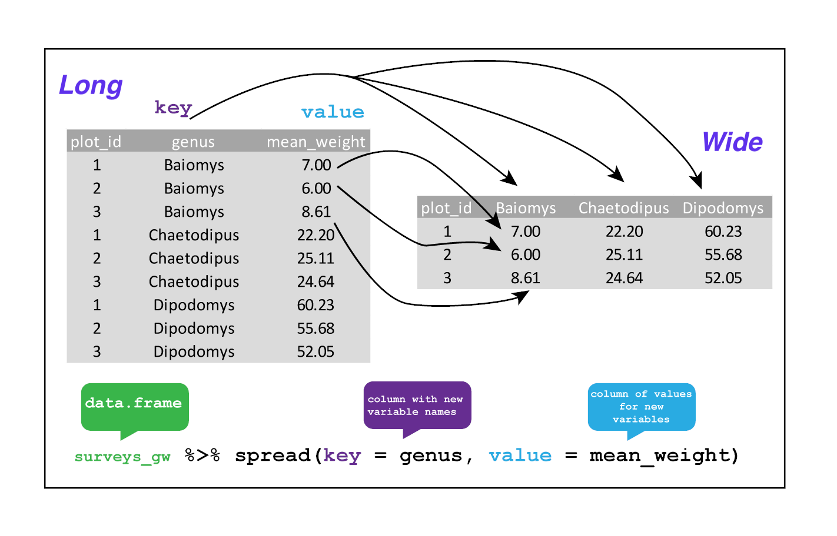

# 4 Data Visualization with R

“The simple graph has brought more information to the data analyst’s mind than any other device.” — John Tukey

This chapter will show you how to use ggplot2 to visualize your data. There are various graphing systems in R, but ggplot2 is one of the most attractive and versatile. ggplot2 implements graphics language, a unified method for describing and creating graphs. By learning one system and using it in multiple locations, you can accomplish more in less time with ggplot2.

## 4.1 Basics of ggplot2

The tidyverse’s main member, ggplot2, is the subject of this chapter. Load the tidyverse with this code to get access to the datasets, help pages, and functions:

library(tidyverse) # it has ggplot2 package  
library(cowplot) # it allows you to save figures in .png file

That one line of code loads the fundamental tidyverse packages, which are used in practically every data analysis. It also shows you which tidyverse functions clash with base R functions (or from other packages you might have loaded).

If the error message “there is no package called ‘tidyverse’” appears when you execute this code, you must first install it before running **library()** again.

install.packages("tidyverse")  
library(tidyverse)

A package only needs to be installed once, but it must be reloaded every time you start a new session.

### 4.1.1 Importing data

R can read data from a variety of sources, including text files, spreadsheets, statistical packages, and database management systems. We’ll use the mpg dataset to demonstrate these strategies. This dataset comprises data from the US Environmental Protection Agency on 38 different car models.

#### 4.1.1.1 Text files

The readr package provides functions for importing delimited text files into R data frames.

library(readr) # read dataset from file  
options(readr.show_col_types = FALSE)  
# CSV  
mpg_csv <- read_csv("data/mpg.csv")   
  
# TSV  
mpg_tsv <- read_tsv("data/mpg.tsv")

These functions assume that the variable names are on the first line of data, that values are separated by commas or tabs, and that missing data is represented by blanks.

#### 4.1.1.2 Excel spreadsheets

Data from Excel workbooks can be imported using the readxl program. The formats xls and xlsx are both supported.

library(readxl) # excel  
#Excel  
mpg_excel <- read_excel("data/mpg.xlsx", sheet='mpg')  
head(mpg_excel)

## # A tibble: 6 × 12  
## ...1 manufacturer model displ year cyl trans drv cty hwy fl class  
## <dbl> <chr> <chr> <chr> <dbl> <dbl> <chr> <chr> <dbl> <dbl> <chr> <chr>  
## 1 1 audi a4 1,8 1999 4 auto… f 18 29 p comp…  
## 2 2 audi a4 1,8 1999 4 manu… f 21 29 p comp…  
## 3 3 audi a4 2,0 2008 4 manu… f 20 31 p comp…  
## 4 4 audi a4 2,0 2008 4 auto… f 21 30 p comp…  
## 5 5 audi a4 2,8 1999 6 auto… f 16 26 p comp…  
## 6 6 audi a4 2,8 1999 6 manu… f 18 26 p comp…

#### 4.1.1.3 Statistical packages

The haven package contains functions for importing data from many statistical programs such as SAS, SPSS and Stata.

library(haven) # excel  
# SAS  
mtcars_sas <- read_sas("data/mtcars.sas7bdat")  
# SPSS  
mtcars_spss <- read_sav("data/mtcars.sav")  
# Stata  
mtcars_stata <- read_dta("data/mtcars.dta")  
head(mtcars_spss)

## # A tibble: 6 × 11  
## mpg cyl disp hp drat wt qsec vs am gear carb  
## <dbl> <dbl> <dbl> <dbl> <dbl> <dbl> <dbl> <dbl> <dbl> <dbl> <dbl>  
## 1 21 6 160 110 3.9 2.62 16.5 0 1 4 4  
## 2 21 6 160 110 3.9 2.88 17.0 0 1 4 4  
## 3 22.8 4 108 93 3.85 2.32 18.6 1 1 4 1  
## 4 21.4 6 258 110 3.08 3.22 19.4 1 0 3 1  
## 5 18.7 8 360 175 3.15 3.44 17.0 0 0 3 2  
## 6 18.1 6 225 105 2.76 3.46 20.2 1 0 3 1

### 4.1.2 Scatter plot

The first function in building a graph is the ggplot function. It specifies the

* data frame containing the data to be plotted
* the mapping of the variables to visual properties of the graph. The mappings are placed within the aes function (where aes stands for aesthetics).

library(tidyverse)  
library(ggplot2)  
library(readr)   
  
# df  
df <- read_csv("data/mpg.csv")   
ggplot(data = df) +   
 geom_point(mapping = aes(x = displ, y = hwy))

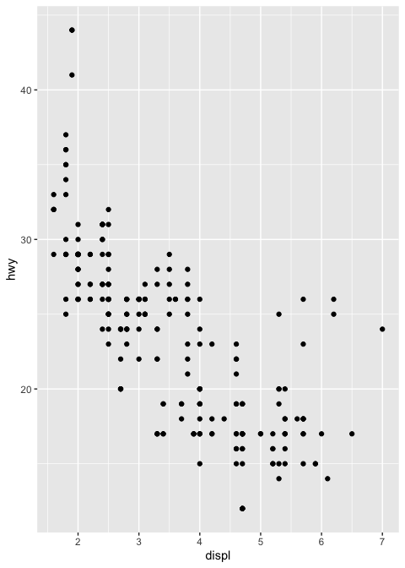

The graph demonstrates that engine size (displ) and fuel efficiency have a negative relationship (hwy). To put it another way, cars with large engines consume more fuel. Does this support or disprove your hypothesis concerning engine size and fuel efficiency?

The function ggplot2 is used to start a plot in ggplot2(). ggplot() builds a coordinate system to which layers can be added. The dataset to utilize in the graph is the first parameter to ggplot(). So ggplot(data = mpg_csv) produces an empty graph, which I won’t show here because it’s not that interesting.

By matching the aesthetics of your plot to the variables in your dataset, you may convey information about your data. You can, for example, link the colors of your points to the class variable to reveal each car’s class.

library(tidyverse)  
library(ggplot2)  
library(readr) # read dataset from file  
  
# df  
df <- read_csv("data/mpg.csv")   
ggplot(data = df) +   
 geom_point(mapping = aes(x = displ, y = hwy, color=class))

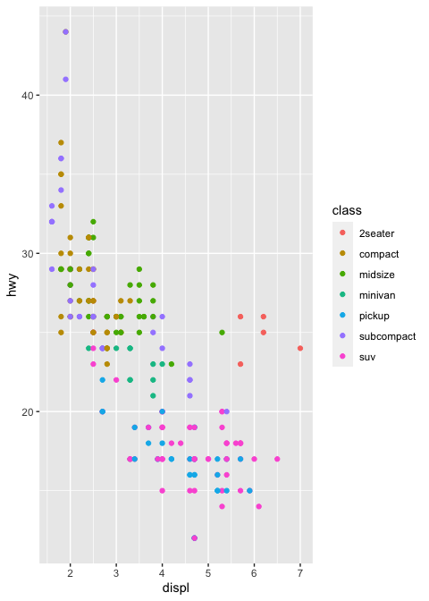

You can also set the aesthetic properties of your geom manually. For example, we can make all of the points in our plot blue:

library(tidyverse)  
library(ggplot2)  
library(readr) # read dataset from file  
# df  
df <- read_csv("data/mpg.csv")   
ggplot(data = df) +   
 geom_point(mapping = aes(x = displ, y = hwy), color="blue")

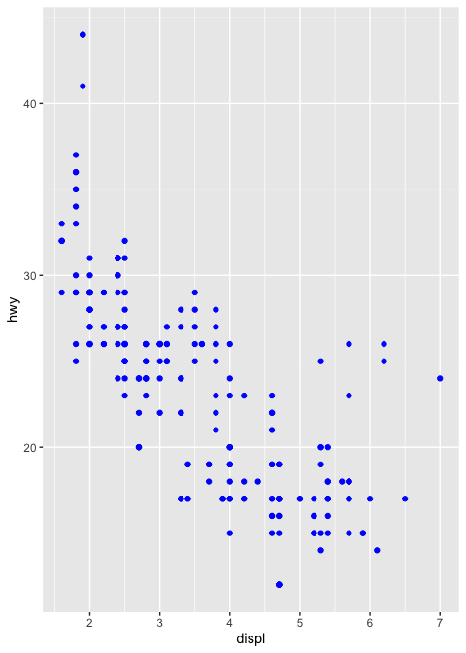

The color modifies the appearance of the plot rather than conveying information about a variable. Set the aesthetic by name as an argument of your geom function to manually set an aesthetic; i.e. it goes outside of aes(). You’ll need to choose a level that fits that aesthetic:

* The name of a color as a character string.
* The size of a point in mm.
* The shape of a point as a number

***Facets in ggplot2:***

Splitting your plot into facets, or subplots that each display one subset of the data, is another option, especially for categorical variables. Use facet_wrap() to facet your plot by a single variable. facet_wrap() expects a formula as the first input, followed by a variable name (note that “formula” is the name of a data structure in R, not a synonym for “equation”). facet_wrap() expects a discrete variable as a parameter.

library(tidyverse)  
library(ggplot2)  
library(readr)   
# df  
df <- read_csv("data/mpg.csv")   
ggplot(data = df) +   
 geom_point(mapping = aes(x = displ, y = hwy, color=class))+  
 facet_wrap(~ manufacturer, nrow = 3)

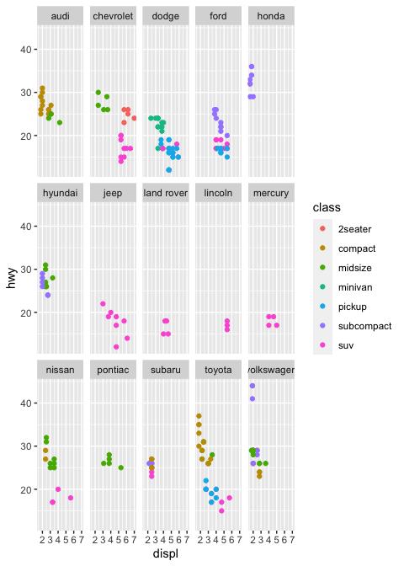

Add facet_grid() to your plot call to facet your plot on the combination of two variables. Facet grid(first )’s parameter is likewise a formula. The formula should now have two variable names separated by a comma.

library(tidyverse)  
library(ggplot2)  
library(readr) # read dataset from file  
library(ggpubr)  
# df  
df <- read_csv("data/mpg.csv")   
ggplot(data = df) +   
 geom_point(mapping = aes(x = displ, y = hwy, color=class))+  
 facet_grid( drv ~ cyl)

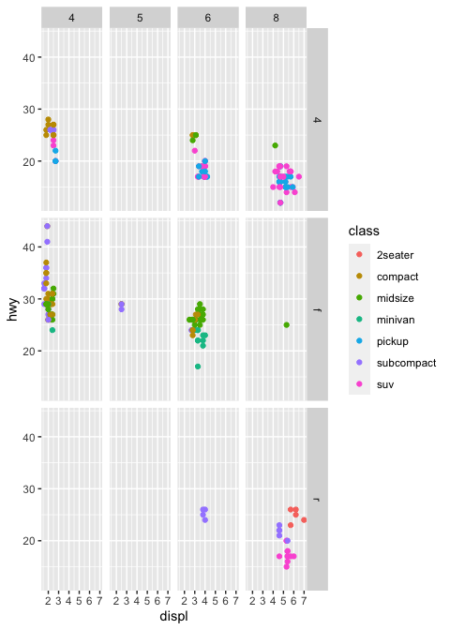

Note: Use a . instead of a variable name if you don’t want to facet in the rows or columns dimension, e.g. + facet grid(. ~ cyl).

library(tidyverse)  
library(ggplot2)  
library(readr) # read dataset from file  
# df  
df <- read_csv("data/mpg.csv")   
ggplot(data = df) +   
 geom_point(mapping = aes(x = displ, y = hwy, color=class))+  
 facet_grid(. ~ cyl)

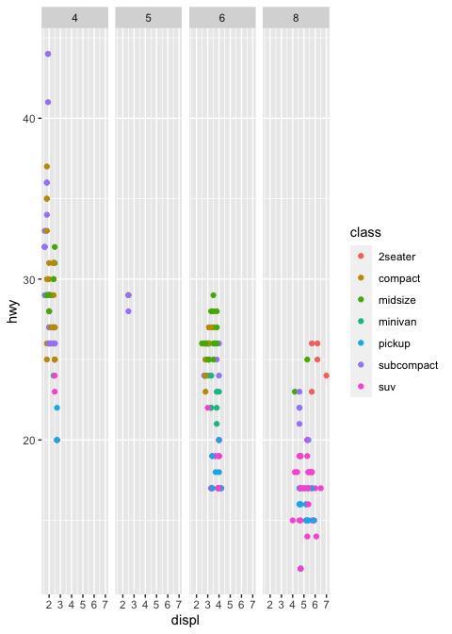 **Geometric objects:**_

A geom is a geometrical object used to represent data in a plot. Plots are frequently described by the sort of geom they employ. Bar charts, for example, use bar geoms, line charts use line geoms, and boxplots use boxplot geoms. *Scatterplots* use the point geom to break the trend. As we’ve seen, different __geoms_ can be used to plot the same data. The point geom is used for scatter plot, and the smooth geom, a smooth line suited to the data.To display multiple geoms in the same plot, add multiple geom functions to ggplot() as shown blow:

library(tidyverse)  
library(readr) # read dataset from file  
library(ggpubr)  
# df  
df <- read_csv("data/mpg.csv")   
  
ggplot(data = df, mapping = aes(x = displ, y = hwy)) +   
 geom_point(mapping = aes(color = class)) +   
 geom_smooth()+  
 labs(title = "Relationship between displacment and highway of 38 different car models",  
 subtitle = "Feul economy data from 1999 to 2008",  
 caption = "source: https://fueleconomy.gov/",  
 x = "Engine displacement in liters",  
 y = "Highway mileage",  
 color = "vehicle class")+  
 theme_pubr()+  
 grids(linetype = "dashed")+  
 theme(axis.text.x = element_text(colour = "grey20", size = 8, angle = 45, hjust = 0.5, vjust = 0.5),  
 axis.text.y = element_text(colour = "grey20", size = 12),  
 strip.text = element_text(face = "italic"),  
 text = element_text(size = 12))

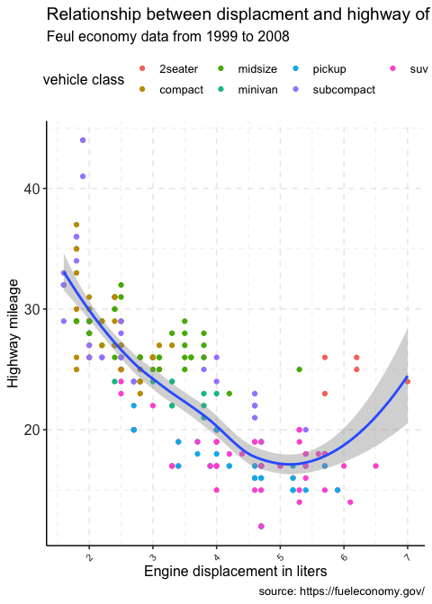

**Exercise**

# add facet wrap using manufacturer variable  
library(tidyverse)  
library(ggplot2)  
library(readr) # read dataset from file  
# df  
df <- read_csv("data/mpg.csv")   
  
ggplot(data = df, mapping = aes(x = displ, y = hwy)) +   
 geom_point(mapping = aes(color = class)) +   
 geom_smooth(method = 'loess')+  
 labs(title = "Relationship between displacment and highway of 38 different car models",  
 subtitle = "Feul economy data from 1999 to 2008",  
 caption = "source: https://fueleconomy.gov/",  
 x = "Engine displacement in liters",  
 y = "Highway mileage",  
 color = "vehicle class")+  
 theme_pubr()+  
 grids(linetype = "dashed")+  
 theme(axis.text.x = element_text(colour = "grey20", size = 8, angle = 45, hjust = 0.5, vjust = 0.5),  
 axis.text.y = element_text(colour = "grey20", size = 12),  
 strip.text = element_text(face = "italic"),  
 text = element_text(size = 12))

library(tidyverse)  
library(ggplot2)  
library(readr) # read dataset from file  
# df  
df <- read_csv("data/mpg.csv")   
  
ggplot(data = df, mapping = aes(x = displ, y = hwy)) +   
 geom_point(mapping = aes(color = class)) +   
 geom_smooth(method = 'loess')+  
 facet_wrap(~manufacturer)+  
 labs(title = "Relationship between displacment and highway of 38 different car models",  
 subtitle = "Feul economy data from 1999 to 2008",  
 caption = "source: https://fueleconomy.gov/",  
 x = "Engine displacement in liters",  
 y = "Highway mileage",  
 color = "vehicle class")+  
 theme_pubr()+  
 grids(linetype = "dashed")+  
 theme(axis.text.x = element_text(colour = "grey20", size = 8, angle = 45, hjust = 0.5, vjust = 0.5),  
 axis.text.y = element_text(colour = "grey20", size = 12),  
 strip.text = element_text(face = "italic"),  
 text = element_text(size = 12))

### 4.1.3 Bar Plot

Stacked, clustered, or segmented bar charts are commonly used to show the relationship between two categorical variables.

#### 4.1.3.1 Stacked bar chart

For the autos in the Fuel economy dataset, plot the association between automotive class and drive type (front-wheel, rear-wheel, or 4-wheel drive).

library(tidyverse)  
library(ggplot2)  
library(readr) # read dataset from file  
# df  
df <- read_csv("data/mpg.csv")   
  
ggplot(data = df, mapping = aes(x = class, fill=drv)) +   
 geom_bar(position = "stack") +   
 labs(title = "Vehicle class frequency by drive type for 38 different automobile models",  
 subtitle = "Feul economy data from 1999 to 2008",  
 caption = "source: https://fueleconomy.gov/",  
 x = "vehicle class",  
 y = "Count")+  
 theme_pubclean()+  
 grids(linetype = "dashed")+  
 guides(fill=guide_legend("Drive Type"))+  
 theme(axis.text.x = element_text(colour = "grey20", size = 8, angle = 45, hjust = 0.5, vjust = 0.5),  
 axis.text.y = element_text(colour = "grey20", size = 12),  
 strip.text = element_text(face = "italic"),  
 text = element_text(size = 12))

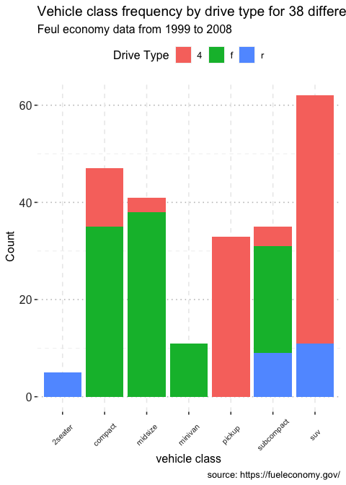

#### 4.1.3.2 Grouped bar chart

library(tidyverse)  
library(ggplot2)  
library(readr) # read dataset from file  
# df  
df <- read_csv("data/mpg.csv")   
  
ggplot(data = df, mapping = aes(x = class, fill=drv)) +   
 geom_bar(position = "dodge") +   
 labs(title = "Vehicle class frequency by drive type for 38 different automobile models",  
 subtitle = "Feul economy data from 1999 to 2008",  
 caption = "source: https://fueleconomy.gov/",  
 x = "vehicle class",  
 y = "Count")+  
 theme_pubclean()+  
 grids(linetype = "dashed")+  
 guides(fill=guide_legend("Drive Type"))+  
 theme(axis.text.x = element_text(colour = "grey20", size = 8, angle = 45, hjust = 0.5, vjust = 0.5),  
 axis.text.y = element_text(colour = "grey20", size = 12),  
 strip.text = element_text(face = "italic"),  
 text = element_text(size = 12))

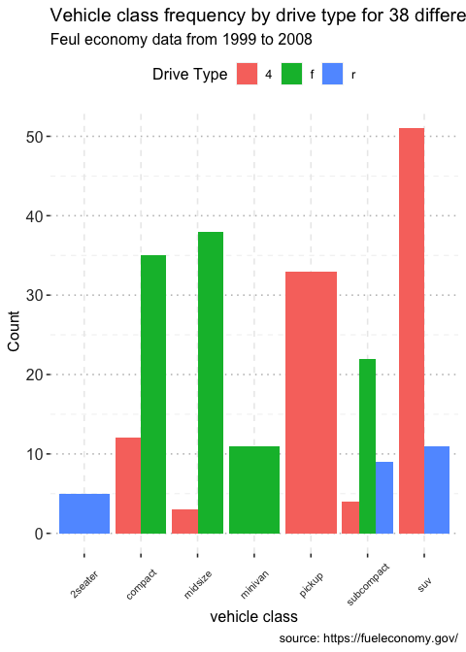

Notice that front-wheel drive is standard on all Minivans. Zero count bars are removed by default, and the remaining bars are made broader. This may not be the desired behavior. The position = position dodge(preserve = "single") option can be used to change this.

library(tidyverse)  
library(ggplot2)  
library(readr) # read dataset from file  
library(ggthemes)  
library(ggpubr)  
# df  
df <- read_csv("data/mpg.csv")   
  
ggplot(data = df, mapping = aes(x = class, fill=drv)) +   
 geom_bar(position = position_dodge(preserve = "single")) +   
 labs(title = "Vehicle class frequency by drive type for 38 different automobile models",  
 subtitle = "Feul economy data from 1999 to 2008",  
 caption = "source: https://fueleconomy.gov/",  
 x = "vehicle class",  
 y = "Count",  
 fill="Drive type")+  
 theme_pubclean()+  
 grids(linetype = "dashed")+  
 theme(axis.text.x = element_text(colour = "grey20", size = 8, angle = 90, hjust = 0.5, vjust = 0.5),  
 axis.text.y = element_text(colour = "grey20", size = 12),  
 strip.text = element_text(face = "italic"),  
 text = element_text(size = 12))

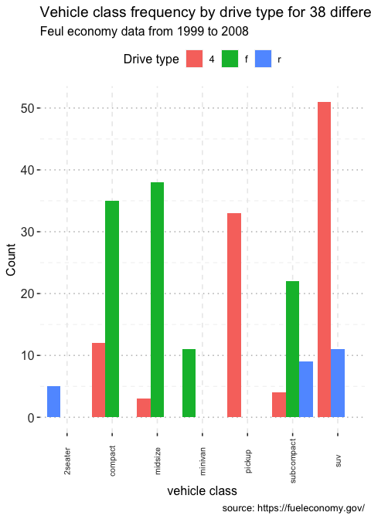

## 4.2 Boxplots

A boxplot displays the ${25}^{th}$ percentile, median, and ${75}^{th}$ percentile of a distribution. The whiskers (vertical lines) capture roughly 99% of a normal distribution, and observations outside this range are plotted as points representing outliers (see the figure below).

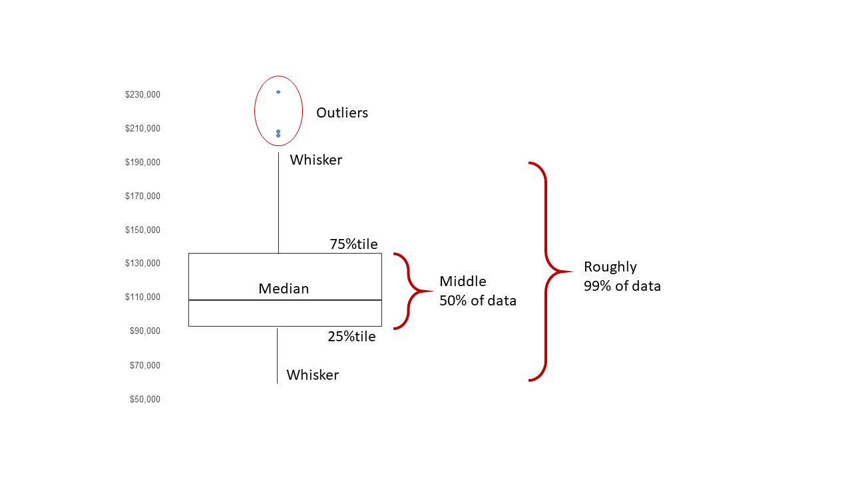

Boxplot schematics

We can use boxplots to visualize the distribution of weight within each species:

library(tidyverse)  
#read the visual treatment for patients dataset  
df_vt <- read_csv("./data/visual_treatment.csv")  
ggplot(data = df_vt,   
 mapping = aes(x = Day, y = Value, color=Day)) +  
 geom_boxplot(alpha=0.5)+  
 ggtitle('Visual improvement after treatment')

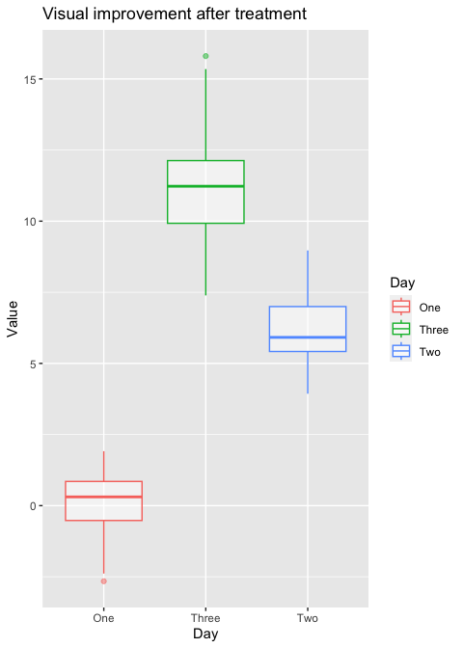

* R appears to be unaware that the order should be **One -> Two -> Three**. Because the column Day is shown as **chr>**, which indicates character, R chose to follow the alphabetical order.
* When you want to display characters in a non-alphabetical order, factors are crucial. Factors are variables with a small number of possible values.
* Individual data can sometimes be plotted on top of the boxplot. This can be accomplished in a variety of ways.
* Using *geom jitter()*, here is a simple solution. For more information, type ?geom_jitter.

library(tidyverse)  
library(ggthemes)  
library(ggpubr)  
  
#read the visual treatment for patients dataset  
df_vt <- read_csv("./data/visual_treatment.csv")  
# ordering the treatment  
df_vt$Day <- factor(df_vt$Day, levels=c("One","Two","Three"))  
  
  
ggplot(data = df_vt,   
 mapping = aes(x = Day, y = Value, color=Day)) +  
 geom_boxplot(alpha=0.5)+  
 geom_jitter(width=0.15)+ # show individual data  
 theme_pubclean()+ # change theme  
 grids(linetype = "dashed")+ # modify grids type  
 ggtitle('Visual improvement after treatment')+ # add title   
 theme(axis.text.x = element_text(colour = "grey20", size = 8, angle = 0, hjust = 0.5, vjust = 0.5),  
 axis.text.y = element_text(colour = "grey20", size = 12),  
 strip.text = element_text(face = "italic"),  
 text = element_text(size = 12))

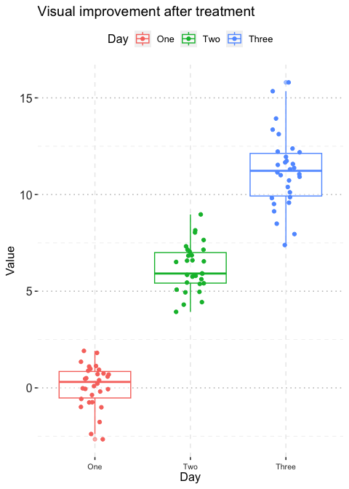

## 4.3 Plotting time series data

Let’s calculate number of counts per year for each genus. First we need to group the data and count records within each group:

## 4.4 Line Plot

data(country.map, package = "choroplethrMaps")  
head(unique(country.map$region), 30)

## [1] "afghanistan" "angola" "azerbaijan" "moldova" "madagascar"   
## [6] "mexico" "macedonia" "mali" "myanmar" "montenegro"   
## [11] "mongolia" "mozambique" "mauritania" "burundi" "malawi"   
## [16] "malaysia" "namibia" "france" "niger" "nigeria"   
## [21] "nicaragua" "netherlands" "norway" "nepal" "belgium"   
## [26] "new zealand" "oman" "pakistan" "panama" "peru"

library(readr)  
library(tidyverse)  
  
gap <- read_csv("data/gapminder.csv")  
  
# Select US cases  
library(dplyr)  
plotdata <- filter(gap,   
 country == "Ethiopia")  
  
# simple line plot  
ggplot(plotdata,   
 aes(x = year,   
 y = lifeExp)) +  
 geom_line()+  
 theme_pubr()+  
 grids(linetype = "dashed")

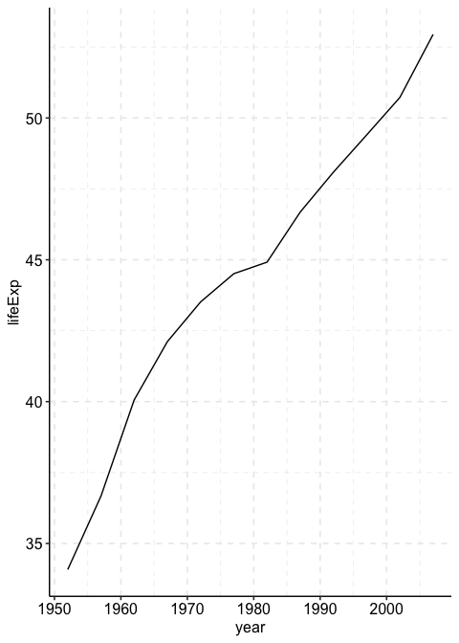

library(ggplot2)  
library(ggthemes)  
gap <- read_csv("data/gapminder.csv")  
# line plot with points  
# and improved labeling  
ggplot(plotdata,   
 aes(x = year,   
 y = lifeExp)) +  
 geom_line(size = 1.5,   
 color = "lightgrey") +  
 geom_point(size = 3,   
 color = "steelblue") +  
 labs(y = "Life Expectancy (years)",   
 x = "Year",  
 title = "Life expectancy changes over time",  
 subtitle = "Ethiopia (1952-2007)",  
 caption = "Source: http://www.gapminder.org/data/")+  
 theme_pubclean()+  
 grids(linetype = "dashed")

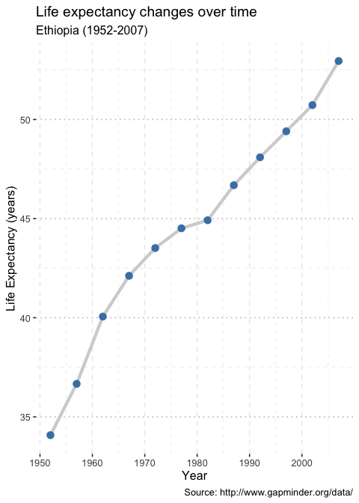

# prepare dataset  
data(gapminder, package = "gapminder")  
plotdata <- gapminder %>%  
 filter(year == 2007) %>%  
 rename(region = country,  
 value = lifeExp) %>%  
 mutate(region = tolower(region)) %>%  
 mutate(region = recode(region,  
 "united states" = "united states of america",  
 "congo, dem. rep." = "democratic republic of the congo",  
 "congo, rep." = "republic of congo",  
 "korea, dem. rep." = "south korea",  
 "korea. rep." = "north korea",  
 "tanzania" = "united republic of tanzania",  
 "serbia" = "republic of serbia",  
 "slovak republic" = "slovakia",  
 "ethiopia" = "democratic republic of ethiopia",  
 "yemen, rep." = "yemen"))

Now lets create the map

## 4.5 Histograpm

Marriage <- read_csv("data/marriage.csv")  
# plot the histogram with a binwidth of 5  
ggplot(Marriage, aes(x = age)) +  
 geom_histogram(fill = "cornflowerblue",   
 color = "white",   
 binwidth = 5) +   
 labs(title="Participants by age",   
 subtitle = "binwidth = 5 years",  
 x = "Age")

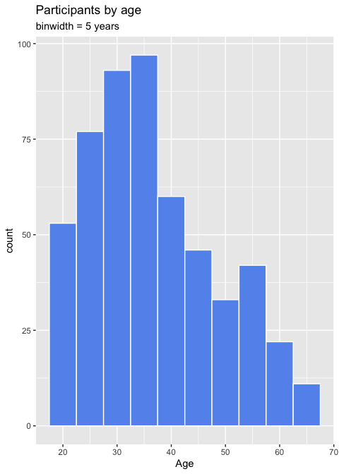

data(gapminder, package="gapminder")  
  
# subset Asian countries in 2007  
library(dplyr)  
plotdata <- gapminder %>%  
 filter(continent == "Africa" &   
 year == 2007)  
  
# Sorted Cleveland plot  
ggplot(plotdata,   
 aes(x=lifeExp,   
 y=reorder(country, lifeExp))) +  
 geom_point(color="blue",   
 size = 2) +  
 geom_segment(aes(x = 40,   
 xend = lifeExp,   
 y = reorder(country, lifeExp),   
 yend = reorder(country, lifeExp)),  
 color = "lightgrey") +  
 labs (x = "Life Expectancy (years)",  
 y = "",  
 title = "Life Expectancy by Country",  
 subtitle = "GapMinder data for Africa - 2007") +  
 theme_minimal() +   
 theme(panel.grid.major = element_blank(),  
 panel.grid.minor = element_blank())

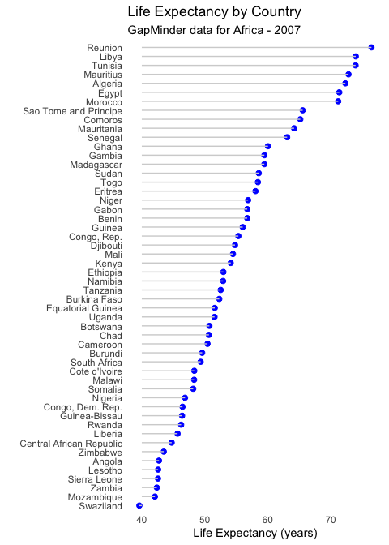

* Reunion clearly has the highest life expectancy, while Afghanistan has the lowest by far. This last plot is also called a lollipop graph (you can see why).

## 4.6 Map

In R the sf package deals with vector data (points, lines and polygons), and the raster package deals with raster data.

# for vector data handling  
library(sf)   
# for raster data handling  
library(raster)   
# example spatial data for Africa  
library(afrilearndata)  
# for mapping  
library(tmap)  
tm_shape(africountries) +  
 tm_polygons()

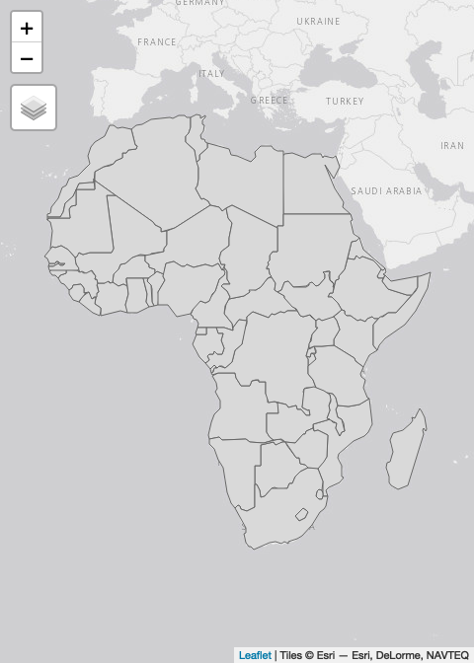

It can be displayed with tm_shape([object_name]) & tm_raster. Here we specify the breaks or cutoffs to the different colour bands.

In this example, if you use the default breaks by not specifying any arguments with tm_raster() (see the hint) the map looks entirely one colour. This is because there are few very high density cells and a majority of cells with very low values. This is a common issue with population data. The default (equal-interval) classification doesn’t work well; most of the map falls in the lowest category. If you look very closely you can see a few very high value cells e.g. in Lagos & Cairo.

tm_shape(afripop2020) +  
 tm_raster(breaks=c(0,2,20,200,2000,25000))

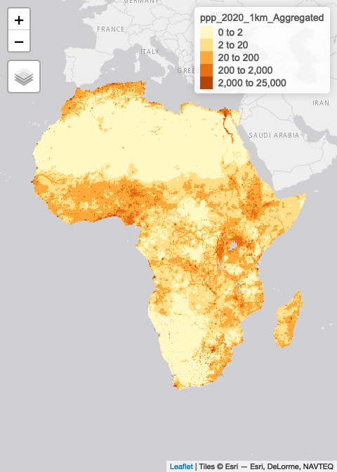

**Mapping multiple ‘layers’**

In the previous section we showed how to make maps of individual data objects. Those sections of code can be combined to create multiple ‘layer’ maps as shown in the example below.

tmap::tm_shape(afripop2020) +  
 tm_raster(palette = rev(viridisLite::magma(5)), breaks=c(0,2,20,200,2000,25000)) +  
tm_shape(africountries) +  
 tm_borders("white", lwd = .5) +  
 #tm_text("iso_a3", size = "AREA") +  
tm_shape(afrihighway) +  
 tm_lines(col = "red") +   
tm_shape(africapitals) +  
 tm_symbols(col = "blue", alpha=0.4, scale = .6 ) +  
tm_legend(show = FALSE)

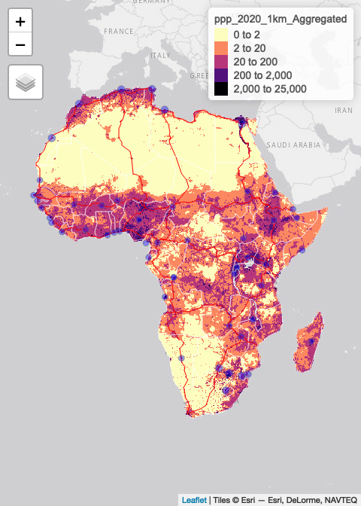

Interactive maps

The maps created so far have been static. There are also great options for creating interactive maps, which are useful for web pages or reports where readers can zoom, pan and enable/disable layers.

tmap_mode('view')   
  
tmap::tm_shape(afripop2020) +  
 tm_raster(palette = rev(viridisLite::magma(5)), breaks=c(0,2,20,200,2000,25000)) +  
tm_shape(africountries) +  
 tm_borders("white", lwd = .5) +  
 #tm_text("iso_a3", size = "AREA") +  
tm_shape(afrihighway) +  
 tm_lines(col = "red") +   
tm_shape(africapitals) +  
 tm_symbols(col = "blue", alpha=0.4, scale = .6 )+  
tm_legend(show = FALSE)



***Read spatial data from files***

Spatial data can be read into R using sf::st_read() for vector data (points, lines and polygons) and the raster & rgdal packages for gridded data.

library(sf)  
filename1 <- system.file("extdata","africountries.shp", package="afrilearndata", mustWork=TRUE)  
myobject1 <- sf::st_read(filename1)

## Reading layer `africountries' from data source   
## `/Library/Frameworks/R.framework/Versions/4.2/Resources/library/afrilearndata/extdata/africountries.shp'   
## using driver `ESRI Shapefile'  
## Simple feature collection with 51 features and 11 fields  
## Geometry type: MULTIPOLYGON  
## Dimension: XY  
## Bounding box: xmin: -17.62504 ymin: -34.81917 xmax: 51.13387 ymax: 37.34999  
## Geodetic CRS: WGS 84

library(raster)  
library(rgdal)   
filename2 <- system.file("extdata","afripop2020.tif", package="afrilearndata", mustWork=TRUE)  
myobject2 <- raster::raster(filename2)

There are other packages too but we don’t need those for now.

First, let us start with creating a base map of the world using ggplot2. This base map will then be extended with different map elements, as well as zoomed in to an area of interest. We can check that the world map was properly retrieved and converted into an sf object, and plot it with ggplot2:

library(sf)  
library(tidyverse)  
library(rnaturalearth)  
library(rnaturalearthdata)  
  
world <- ne_countries(scale = "medium", returnclass = "sf")  
class(world)

## [1] "sf" "data.frame"

ggplot(data = world) +  
 geom_sf()

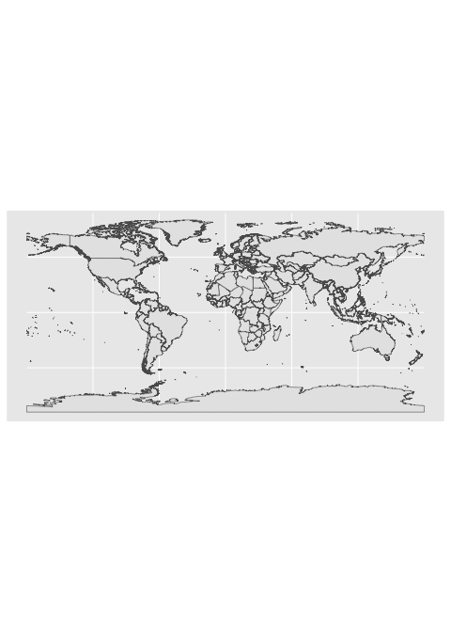

A title and a subtitle can be added to the map using the function ggtitle, passing any valid character string (e.g. with quotation marks) as arguments. Axis names are absent by default on a map, but can be changed to something more suitable (e.g. “Longitude” and “Latitude”), depending on the map:

library(sf)  
library(tidyverse)  
library(rnaturalearth)  
library(rnaturalearthdata)  
  
world <- ne_countries(scale = "medium", returnclass = "sf")  
class(world)

## [1] "sf" "data.frame"

ggplot(data = world) +  
 geom_sf()+  
 ggtitle("World map", subtitle = paste0("(", length(unique(world$NAME)), " countries)"))

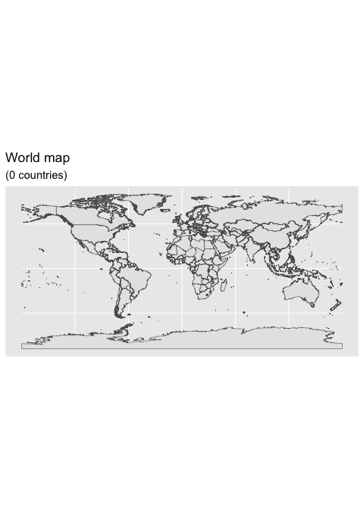

### 4.6.1 Map color

In many ways, sf geometries are no different than regular geometries, and can be displayed with the same level of control on their attributes. Here is an example with the polygons of the countries filled with a green color (argument fill), using black for the outline of the countries (argument color):

library(sf)  
library(tidyverse)  
library(rnaturalearth)  
library(rnaturalearthdata)  
  
world <- ne_countries(scale = "medium", returnclass = "sf")  
class(world)

## [1] "sf" "data.frame"

ggplot(data = world) +  
 geom_sf(color = "black", fill = "lightgreen")

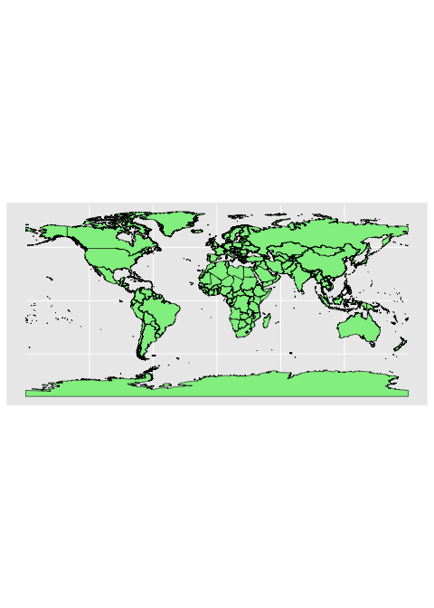

The package ggplot2 allows the use of more complex color schemes, such as a gradient on one variable of the data. Here is another example that shows the population of each country. In this example, we use the “viridis” colorblind-friendly palette for the color gradient (with option = “plasma” for the plasma variant), using the square root of the population (which is stored in the variable POP_EST of the world object):

library(sf)  
library(tidyverse)  
library(rnaturalearth)  
library(rnaturalearthdata)  
  
world <- ne_countries(scale = "medium", returnclass = "sf")  
class(world)

## [1] "sf" "data.frame"

ggplot(data = world) +  
 geom_sf(aes(fill = pop_est)) +  
 scale_fill_viridis_c(option = "plasma", trans = "sqrt")

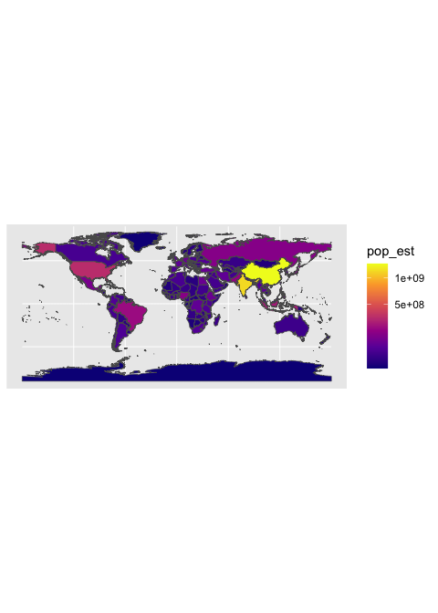

ggplot(data = world) +  
 geom_sf() +  
 coord_sf(xlim = c(22, 50), ylim = c(-5, 21), expand = FALSE)

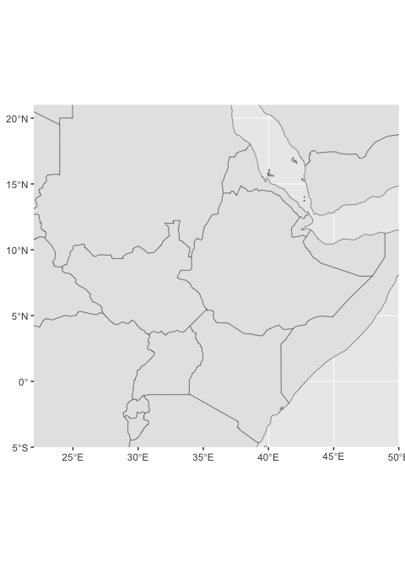

library("ggspatial")  
ggplot(data = world) +  
 geom_sf() +  
 annotation_scale(location = "br", width_hint = 0.5) +  
 annotation_north_arrow(location = "bl", which_north = "true",   
 pad_x = unit(3.75, "in"), pad_y = unit(0.5, "in"),  
 style = north_arrow_fancy_orienteering) +  
 coord_sf(xlim = c(22, 50), ylim = c(-5, 21))

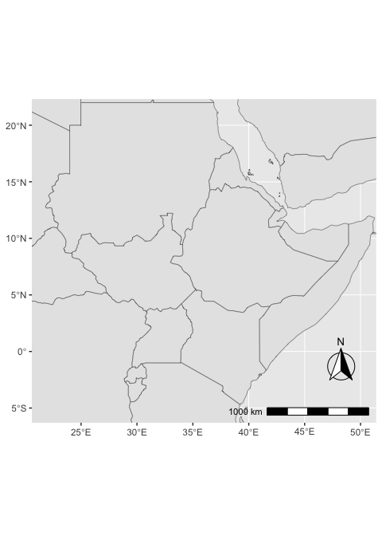

It can be difficult to work with maps. The sf package includes ggplot2-compatible utilities like geom_sf_(). High-quality mapping coordinates are provided by the rnaturalearth package.

library(sf) # for mapping geoms  
library(rnaturalearth) # for map data  
  
# get and bind country data  
eth_sf <- ne_states(country = "Ethiopia", returnclass = "sf")  
eri_sf <- ne_states(country = "Eritrea", returnclass = "sf")  
dji_sf <- ne_states(country = "Djibouti", returnclass = "sf")  
kenya_sf <- ne_states(country = "Kenya", returnclass = "sf")  
#ssudan_sf <- ne_states(country = "South Sudan", returnclass = "sf")  
somal_sf <- ne_states(country = "Somalia" , returnclass = "sf")   
somald_sf <- ne_states(country = "Somaliland" , returnclass = "sf")   
sudan_sf <- ne_states(country = "Sudan", returnclass = "sf")  
lands <- bind_rows(eth_sf, eri_sf, dji_sf, kenya_sf,   
 sudan_sf,somal_sf,somald_sf) %>%  
 filter(!is.na(geonunit))  
  
#df <- ne_countries(continent = "Africa", returnclass = "sf")  
#df$admin  
  
  
# set colours  
country_colours <- c("Eritrea" = "#0962BA",  
 "Djibouti" = "#00AC48",  
 "Ethiopia" = "#FF0000",  
 "Somalia" = "#FFCD2C",  
 "Somaliland"= "#FFCD2C",  
 "Puntland" = "#FFCD2C",  
 "Sudan" = "#F77613",  
 "Kenya" = "#00008B")  
  
ggplot() +   
 geom_sf(data = lands,  
 mapping = aes(fill = geonunit),  
 colour = NA,  
 alpha = 0.75) +  
 coord_sf(crs = sf::st_crs(4326),  
 xlim = c(22, 50),   
 ylim = c(-5, 21)) +  
 scale_fill_manual(name = "Country",   
 values = country_colours)

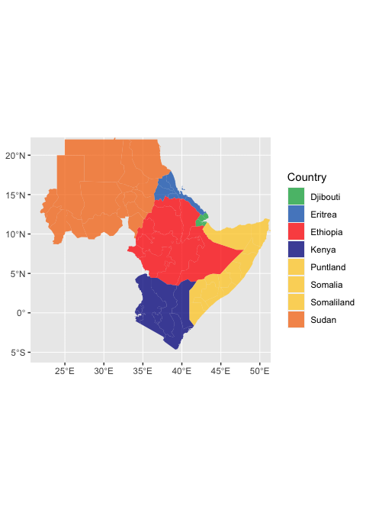

## 4.7 Exploratory data analysis

In his 1977 book “Exploratory Data Analysis,” statistician John Tukey popularized exploratory data analysis (EDA). The overall goal of EDA is to assist us in formulating and refining hypotheses that will lead to useful analyses or additional data collecting. EDA’s main goals are as follows:

* to suggest hypotheses about the causes of observed phenomena,
* to guide the selection of appropriate statistical tools and techniques,
* to assess the assumptions on which statistical analysis will be based,
* to provide a foundation for further data collection.

EDA employs a combination of numerical and visual analytic techniques. Statistical approaches are occasionally used to enhance EDA, although their primary goal is to aid comprehension before moving on to formal statistical modeling.

### 4.7.1 Statistical variables and data

Statistical variables can be described in a variety of ways depending on how they might be analyzed, quantified, or presented. While it may not be the most fascinating topic, knowing what kind of variables we’re dealing with is critical since it defines how we should visualize the data and, later, how we might analyze it statistically. Statisticians have given considerable effort to how variables should be classified. Although the distinctions can be subtle, we’ll only look at two simple classification approaches.

#### 4.7.1.1 Numeric vs. categorical variables

The values of **numeric variables** are numbers that describe a measurable amount, such as ‘how many’ or ‘how much.’ Quantitative variables are also known as numeric variables, and the data obtained with numeric variables is referred to as quantitative data. Numeric variables can also be classified as continuous or discrete:

* **Continuous numeric variable**: Observations can take any value between a certain set of real numbers, i.e. numbers represented with decimals. This set is typically either “every possible number”.
* Discrete numeric variable: Observations can take a value based on a count from a set of whole values; e.g. 1, 2, 3, 4, 5, and so on. A discrete variable cannot take the value of a fraction between one value and the next closest value.

**Categorical variables** have values that describe a data unit’s characteristic, such as ‘what type’ or ‘which category.’ Mutually exclusive (in one category or another) and exhaustive (containing all conceivable alternatives) categories exist for categorical variables. As a result, categorical variables are qualitative variables with a non-numeric representation. The information gathered for a category variable is qualitative. Ordinal and nominal variables are two types of categorical variables:

* **Ordinal variable**: Observations can take a value that can be logically ordered or ranked. The categories associated with ordinal variables can be ranked higher or lower than another, but do not necessarily establish a numeric difference between each category.
* **Nominal variable**: Observations can take a value that is not able to be organised in a logical sequence. Examples of nominal categorical variables include sex, business type, eye colour, religion and brand.

### 4.7.2 Understanding numerical variables

To explain the key concepts, we’ll use wind and pressure variables using the storms data from the nasaweather package (remember to load and attach the package), we’ll review some basic descriptive statistics and visualisations that are appropriate for numeric variables.

Atmospheric pressure and wind speed are also numerical variables. We have a little more to say. Because zero truly is zero, they are both numeric variables that are measured on a ratio scale: it makes sense to state that 20 mph is twice as fast as 10 mph, and 1000 mbar exerts twice as much pressure on objects as 500 mbar. Are these variables continuous or discrete? Consider the range of possibilities for wind speed and air pressure. Wind speeds of 40.52 mph and atmospheric pressure of 1000.23 mbar are both completely realistic numbers, therefore these are basically continuous variables.

# first 100 values of atmospheric pressure  
storms$pressure[1:100]

## [1] 1005 1004 1003 1001 997 995 987 988 988 990 990 993 993 994 995  
## [16] 995 992 990 988 984 982 984 989 993 995 996 997 1000 997 990  
## [31] 992 992 993 1019 1019 1018 1017 1016 1013 1011 1009 1007 1004 1001 997  
## [46] 997 997 997 996 995 993 991 990 989 1012 1012 1012 1011 1011 1011  
## [61] 1010 1010 1006 1008 1009 1010 1009 1006 1006 1005 1004 999 999 997 991  
## [76] 995 997 995 994 994 995 996 997 997 998 998 999 999 1000 1000  
## [91] 1001 1002 1003 1005 1005 1009 1008 1008 1008 1007

# first 100 values of atmospheric pressure  
storms$wind[1:100]

## [1] 30 30 35 40 50 60 65 65 65 60 60 45 30 35 35 40 40 45 45 45 50 50 50 45 40  
## [26] 40 40 40 40 40 40 35 35 20 20 20 25 25 30 30 30 35 40 60 60 55 50 50 50 50  
## [51] 50 50 45 40 25 25 25 30 30 30 30 30 35 35 35 40 40 45 45 45 45 50 50 55 60  
## [76] 60 60 55 55 55 50 50 50 50 50 50 50 50 50 50 50 50 50 50 50 25 30 30 30 30

Notice that even though pressure is continuous variables it looks like a discrete variable because it has only been measured to the nearest whole millibar. Similarly, wind is only measured to the nearest 5 mph. These differences reflect the limitations of the methodology used to measure each variable, e.g. measuring wind speed is hard because it varies so much in space and time.

We set the properties of the geom_histogram to tweak this kind of thing—the binwidth argument adjusts the width of the bins used. Let’s construct the histogram again with 7 mbar wide bins, as well as adjust the colour scheme and axis labels a bit:

library(nasaweather)  
ggplot(storms, aes(x = pressure)) +   
 geom_histogram(binwidth = 7, fill = "steelblue", colour="darkgrey", alpha = 0.8) +   
 xlab("Atmospheric Pressure (mbar)") + ylab("Count")

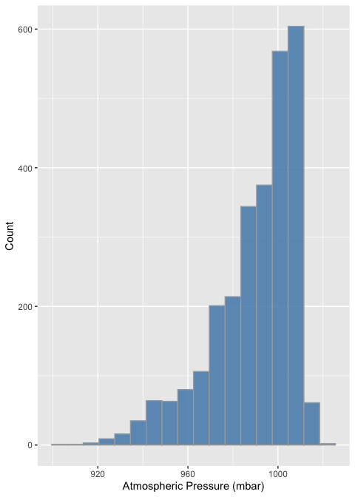

ggplot(storms, aes(x = wind)) +   
 geom_histogram(binwidth = 10, fill = "steelblue", colour="darkgrey", alpha = 0.8) +  
 xlab("Wind Speed (mph)") + ylab("Count")

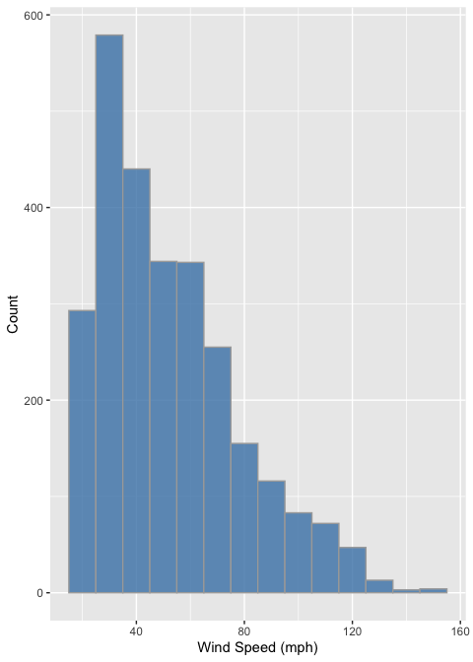

The only things that changed in this example were the aesthetic mapping and the bin width, which we set to 10. It reveals that the wind speed during a storm tends to be about 40 mph, though the range of wind speeds is about 100 mph and the shape of the distribution is asymmetric.

We have to choose the bin widths carefully. Remember that wind speed is measured to the nearest 5 mph. This means we should choose a bin width that is a multiple of 5 to produce a meaningful histogram. Look what happens if we set the bin width to 3:

ggplot(storms, aes(x = wind)) +   
 geom_histogram(binwidth = 5, fill = "steelblue", colour="darkgrey", alpha = 0.8) +   
 xlab("Wind Speed (mph)") + ylab("Count")

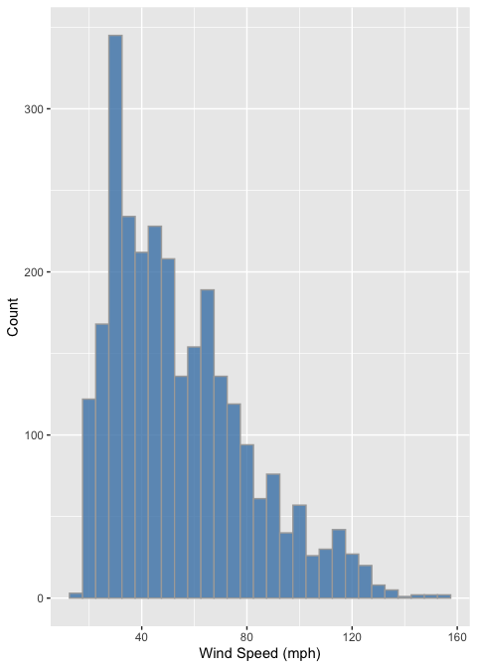

We end up with gaps in the histogram because some intervals do not include multiples of 5. This is not a good histogram because it fails to reliably summarise the distribution. Similar problems would occur if we chose a bin width that is greater than, but not a multiple of 5, because different bins would cover a different number of values that make up the wind variable. The take home message is that we have to know our data in order to produce meaningful summaries of it.

Histograms are good for visualising sample distributions when we have a reasonable sample size (at least dozens, and ideally, hundreds of observations). They aren’t very effective when the sample is quite small. In this ‘small data’ situation it’s better to use something called a dot plot

Let’s use dplyr to extract a small(ish) subset of the storms data:

storms_small <-   
 storms %>%   
 filter(year == 1998, type == "Hurricane")

This just extracts the subset of hurricane observations from 1998. The ggplot2 code to make a dot plot with these data is very similar to the histogram case:

ggplot(storms_small, aes(x = pressure,fill='red')) +   
 geom_dotplot(binwidth = 2, color='blue') +   
 xlab("Atmospheric Pressure (mbar)") + ylab("Count")

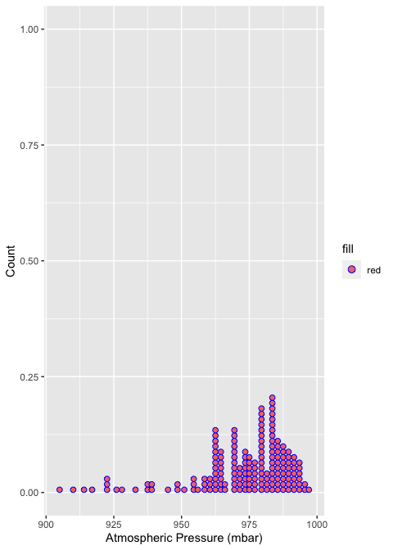 Here, each observation in the data adds one dot, and dots that fall into the same bin are stacked up on top of one another. The resulting plot displays the same information about a sample distribution as a histogram, but it tends to be more informative when there are relatively few observations.

### 4.7.3 Understanding categorical variables

Exploring categorical variables is generally simpler than working with numeric variables because we have fewer options, or at least life is simpler if we only require basic summaries. We’ll work with the year and type variables in storms to illustrate the key ideas.

Which kind of categorical variable is type? There are four storm categories in type. We can use the unique function to print these for us:

unique(storms$type)

## [1] "Tropical Depression" "Tropical Storm" "Hurricane"   
## [4] "Extratropical"

When we calculate summaries of categorical variables we are aiming to describe the sample distribution of the variable, just as with numeric variables. The general question we need to address is, ‘what are the relative frequencies of different categories?’ We need to understand which categories are common and which are rare. Since a categorical variable takes a finite number of possible values, the simplest thing to do is tabulate the number of occurrences of each type. We’ve seen how the table function is used to do this:

table(storms$type)

##   
## Extratropical Hurricane Tropical Depression Tropical Storm   
## 412 896 513 926

This shows that the number of observations associated with hurricanes and tropical storms are about equal, that the number of observations associated with extratropical and tropical systems is similar, and the former pair of categories are more common than the latter. This indicates that in general, storm systems in Central America spend relatively more time in the more severe classes.

Raw frequencies give us information about the rates of occurance of different categories in a dataset. However, it’s difficult to compare raw counts across different data sets if the sample sizes vary (which they usually do). This is why we often convert counts to proportions. To do this, we have to divide each count by the total count across all categories. This is easy to do in R because it’s vectorised:

type_counts <- table(storms$type)  
type_counts / sum(type_counts)

##   
## Extratropical Hurricane Tropical Depression Tropical Storm   
## 0.1499818 0.3261740 0.1867492 0.3370950

So about 2/3 of observations are associated with hurricanes and tropical storms, with a roughly equal split, and the remaining 1/3 associated with less severe storms.

ggplot(storms, aes(x = type,fill=type)) +   
 geom_bar(color = "orange", width = 0.7, show.legend = F) +   
 xlab("Storm Type") + ylab("Number of Observations")

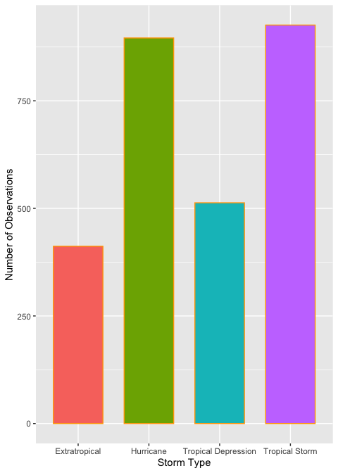

This is the same summary information we produced using the table function, only now it’s presented in graphical form. We can customized the bar graph with functions like xlab and ylab, and by setting various properties inside geom_bar.

The categories of type have quite long names, meaning the axis labels are all bunched together. One way to fix this is to make the labels smaller or rotate them via the ‘themes’ system. Here’s an alternative solution: just flip the x and y axes to make a horizontal bar chart. We can do this with the coord_flip function (this is new):

ords <- c("Tropical Depression", "Extratropical", "Tropical Storm", "Hurricane")  
ggplot(storms, aes(x = type,fill=type)) +   
 geom_bar(color = "orange", width = 0.7, show.legend = F) +   
 scale_x_discrete(limits = ords) +  
 coord_flip() +   
 xlab("Storm Type") + ylab("Number of Observations")

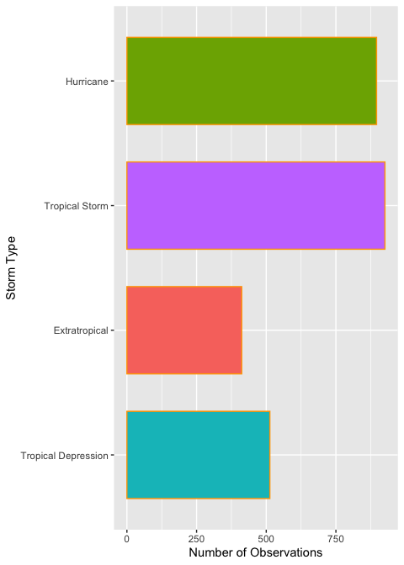

ggplot(data=storms, aes(x=type,fill=type))+  
 geom_bar(color='orange',width = 0.7,show.legend = F)+  
 coord_polar()+  
 labs(x=NULL, y= NULL)

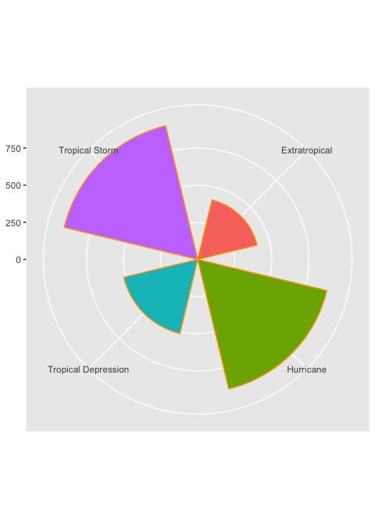

## 4.8 Regression with R

### 4.8.1 Hypotheses and null hypotheses

* Stages in the scientific process are:
  + Observation :- *information, or impression, about events or objects*.
  + Question :— *what it is that you want to know; the scope of your investigation*.
  + Hypothesis:— *an explanation proposed to account for observed facts*.
  + Prediction:— *what you would expect to see if the hypothesis was true*.
* The null hypothesis, denoted H0, is the statement about the population parameter that is assumed to be true unless there is convincing evidence to the contrary.
* The alternative hypothesis, denoted Ha, is a statement about the population parameter that is contradictory to the null hypothesis, and is accepted as true only if there is convincing evidence in favor of it.
* The null hypothesis corresponds to the idea that an observed difference is due to chance. The alternative hypothesis corresponds to the idea that the observed difference is real.
* We’ll be able to collect data to evaluate our ideas once we’ve finalized our hypotheses and predictions. We will either accept or reject our various hypotheses based on these data. The most important thing to remember about hypothesis testing is that hypotheses are either rejected or not rejected in science, but they are rarely established, even in the most trivial instances.
* After analyzing the evidence showing our hypothesis’ predictions are correct, we can either accept it as the best current explanation for the observations or reject it and look for new hypotheses. For these hypotheses, the same approach must be followed.
* It’s vital to remember that when explaining science, we don’t report null hypotheses. The null hypothesis is merely a tool for constructing a frequentist statistical test. In and of itself, it is neither entertaining nor beneficial. Again, for the sake of clarity. In a report or a presentation, there is no need to state the null hypothesis for each and every test.
* R will typically display p-values from a statistical significance test to six decimal places (e.g. p = 0.003672). However, when we write about them, the results from tests are usually presented as one of the following four categories:
  + $p>0.05$, for results which are not statistically significant (sometimes also written as ‘NS’),
  + $p<0.05$, for results where $0.01<p<0.05$,
  + $p<0.01$, for results where $0.001<p<0.01$,
  + $p<0.001$ for results where $p<0.001$,
* It is common to see ranges of probabilities coded with asterisks in tables and figures:
  + *for $p=0.05⋯0.01$,
  + ** for $p=0.01⋯0.001$,
  + *** for $p<0.001$.

This is common in tables and figures as it is a more compact and visually obvious representation than numbers. Never use the asterisks convention in the text of a report.

* We use a chi-square test for independence when we want to formally test whether or not there is a statistically significant association between two categorical variables.
* The hypotheses of the test are as follows:
  + Null hypothesis (H0): There is no significant association between the two variables.
  + Alternative hypothesis: (Ha): There is a significant association between the two variables.

### 4.8.2 Linear Regression

Linear regression allows us to explore the relationship between a quantitative response variable and an explanatory variable while other variables are held constant.

In a linear model, given a vector of inputs, $X^{T}=\left(X_{1},X_{2},...,X_{p}\right)$, we predict the output $Y$ via the model:

$$\hat{Y}={\hat{β}}_{0}+\sum_{j=1}^{p}{X_{j}}{\hat{β}}_{j}$$

The term ${\hat{β}}_{0}$ is the intercept, also known as the *bias* in machine learning. Often it is convenient to include the constant variable $1$ in $X$, include $β_{0}$ in the vector of coefficients $\hat{β}$, and then write the linear model in vector form as an inner product,

$$\hat{Y}=X^{T}\hat{β},$$

where $X^{T}$ denotes the transpose of the design matrix.

**Ordinary Least Squares (OLS)**

There are many different methods to fitting a linear model, but the most simple and popular method is [Ordinary Least Squares](https://en.wikipedia.org/wiki/Ordinary_least_squares) (OLS). The OLS method minimizes the [residual sum of squares](https://en.wikipedia.org/wiki/Residual_sum_of_squares) (RSS), and leads to a closed-form expression for the estimated value of the unknown parameter $β$.

$$RSS\left(β\right)=\sum_{i=1}^{n}{{\left(y_{i}−x_{i}^{T}β\right)}^{2}}$$

$RSS\left(β\right)$ is a quadradic function of the parameters, and hence its minimum always exists, but may not be unique. The solution is easiest to characterize in matrix notation:

$$RSS\left(β\right)={\left(y−Xβ\right)}^{T}\left(y−Xβ\right)$$

where $X$ is an $n×p$ matrix with each row an input vector, and $y$ is a vector of length $n$ representing the response in the training set. Differentiating with respect to $β$, we get the *normal equations*,

$$X^{T}\left(y−Xβ\right)=0$$

Consider predicting property values based on lot size (square feet), age (years), land value (thousands of dollars), living area (square feet), number of bedrooms and bathrooms, and whether or not the home is on the waterfront.

The basic method of performing a linear regression in R is to the use the lm() function.

To see the parameter estimates alone, you can just call the lm() function. But much more results are available if you save the results to a regression output object, which can then be accessed using the summary() function.

library(tidyverse)  
library(readr)  
  
houses <- read_csv("data/houses.csv")  
  
houses_lm <- lm(price ~ lotSize + age + landValue +  
 livingArea + bedrooms + bathrooms +  
 waterfront,   
 data = houses)  
summary(houses_lm)

##   
## Call:  
## lm(formula = price ~ lotSize + age + landValue + livingArea +   
## bedrooms + bathrooms + waterfront, data = houses)  
##   
## Residuals:  
## Min 1Q Median 3Q Max   
## -220208 -35416 -5443 27570 464320   
##   
## Coefficients:  
## Estimate Std. Error t value Pr(>|t|)   
## (Intercept) 1.915e+04 6.428e+03 2.980 0.002927 **   
## lotSize 7.501e+03 2.075e+03 3.615 0.000309 ***  
## age -1.360e+02 5.416e+01 -2.512 0.012099 *   
## landValue 9.093e-01 4.583e-02 19.841 < 2e-16 ***  
## livingArea 7.518e+01 4.158e+00 18.080 < 2e-16 ***  
## bedrooms -5.767e+03 2.388e+03 -2.414 0.015863 *   
## bathrooms 2.455e+04 3.332e+03 7.366 2.71e-13 ***  
## waterfrontYes 1.207e+05 1.560e+04 7.738 1.70e-14 ***  
## ---  
## Signif. codes: 0 '***' 0.001 '**' 0.01 '*' 0.05 '.' 0.1 ' ' 1  
##   
## Residual standard error: 59370 on 1720 degrees of freedom  
## Multiple R-squared: 0.6378, Adjusted R-squared: 0.6363   
## F-statistic: 432.6 on 7 and 1720 DF, p-value: < 2.2e-16

#### 4.8.2.1 Formatting regression output: tidyr

With the tidy() function from the broom package, you can easily create standard regression output tables.

library(broom)  
tidy(houses_lm)

## # A tibble: 8 × 5  
## term estimate std.error statistic p.value  
## <chr> <dbl> <dbl> <dbl> <dbl>  
## 1 (Intercept) 19152. 6428. 2.98 2.93e- 3  
## 2 lotSize 7501. 2075. 3.61 3.09e- 4  
## 3 age -136. 54.2 -2.51 1.21e- 2  
## 4 landValue 0.909 0.0458 19.8 4.72e-79  
## 5 livingArea 75.2 4.16 18.1 4.95e-67  
## 6 bedrooms -5767. 2388. -2.41 1.59e- 2  
## 7 bathrooms 24547. 3332. 7.37 2.71e-13  
## 8 waterfrontYes 120727. 15601. 7.74 1.70e-14

#### 4.8.2.2 Regression Visualization

The visreg function takes (1) the model and (2) the variable of interest and plots the conditional relationship, controlling for the other variables. A ggplot2 graph is created with the argument **gg = TRUE**.

# conditional plot of price vs. living area  
library(ggplot2)  
library(visreg)  
library(readr)  
houses <- read_csv("data/houses.csv")  
  
houses_lm <- lm(price ~ lotSize + age + landValue +  
 livingArea + bedrooms + bathrooms +  
 waterfront,   
 data = houses)  
visreg(houses_lm, "livingArea", gg = TRUE)+  
 scale_y_continuous(label = scales::dollar) +  
 labs(title = "Relationship between price and location",  
 subtitle = "controlling for lot size, age, land value, bedrooms and bathrooms",  
 caption = "source: Saratoga Housing Data (2006)",  
 y = "Home Price",  
 x = "Waterfront")

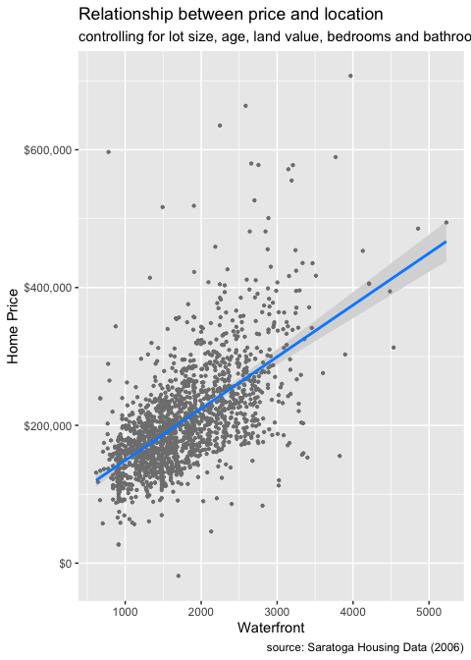

### 4.8.3 Generalized Linear Model(GLM)

The generalized linear model (GLM) is a variant of ordinary linear regression that allows for response variables with error distribution models other than a normal distribution, such as the Gaussian distribution.

GLMs are fit with function glm(). Like linear models (lm()s), glm()s have formulas and data as inputs, but also have a family input. Generalized Linear Model Syntax:

glm( y ~ x, data=df, family ="gaussian")

##   
## Call: glm(formula = y ~ x, family = "gaussian", data = df)  
##   
## Coefficients:  
## (Intercept) x   
## 4 1   
##   
## Degrees of Freedom: 3 Total (i.e. Null); 2 Residual  
## Null Deviance: 5   
## Residual Deviance: 0 AIC: -Inf

The Gaussian family is how R refers to the normal distribution and is the default for a **glm()**. If the family is Gaussian then a GLM is the same as an LM. Non-normal errors or distributions can occur in generalized linear models.However, the possible distributions are constrained. You can, for example, use the Poisson family for count data or the binomial family for binomial data.

### 4.8.4 Logistic Regression

While other variables are kept constant, logistic regression can be used to investigate the relationship between a binary response variable and an explanatory variable. There are two levels to binary response variables (yes/no, lived/died, pass/fail, malignant/benign). The visreg package, like linear regression, may be used to illustrate these relationships.

library(tidyverse)  
library(visreg)  
library(ggplot2)  
  
marriage <- read_csv("data/marriage.csv")  
  
# convert variable from character to factor  
marriage$sex <- factor(marriage$sex)  
marriage$race <- factor(marriage$race)  
marriage$sector <- factor(marriage$sector)  
marriage$married <- factor(marriage$married)  
#LR  
married_glm <- glm(married ~ sex + age + race + sector,   
 family="binomial",   
 data=marriage)  
  
# plot regression  
  
visreg(married_glm, "age",  
 by = "sex",  
 line=list(col="red"),  
 gg = TRUE,   
 scale="response") +  
 labs(y = "Prob(Married)",   
 x = "Age",  
 title = "Relationship of age and marital status",  
 subtitle = "controlling for race and job sector",  
 caption = "source: Current Population Survey 1985")

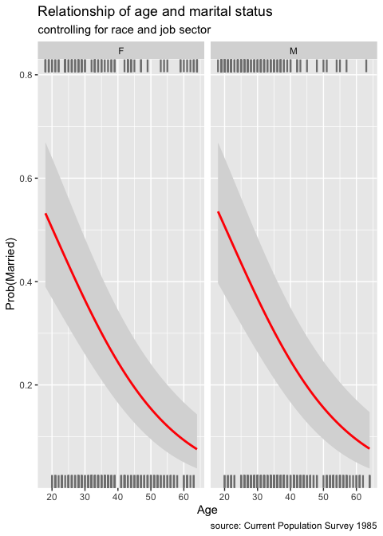

## 4.9 Anova with R

ANOVA is one of the most often used statistical techniques in the field of ecological and environmental studies. It is also widely used in many social science areas, including as sociology, psychology, communication, and media studies.

Let’s review a few key definitions in order to better understand ANOVA.

* Categorical variables have a limited number of categories or groupings, such as treatments, material type, and payment method.
* Continuous variables, such as time and height, have an endless number of values between any two values.
* An explanatory variable (also known as a **independent variable, factor, treatment, or predictor variable**) in an experiment is a variable that is changed to examine how it impacts a response variable (also called dependent variable or outcome variable).

**The explanatory variable is the CAUSE and the response variable is the EFFECT.**

The analysis of variance (ANOVA) is used to determine how a continuous dependent variable (y) varies across levels of one or more categorical independent variables (x). As explained above, the latter are often referred to as “factors”. Within each factor, there may be different categories called levels.

You probably guessed it by now: ANOVA = Analysis of Variance!

library(tidyverse)  
mpg <- read_csv("data/mpg.csv")  
mpg$class <- as.factor(mpg$class)  
mpg$cyl <- as.factor(mpg$cyl)  
mpg$drv <- as.factor(mpg$drv)  
  
mpg %>%   
 ggplot(aes(x=class, y=displ, color=class))+  
 geom_boxplot(show.legend = F)+  
 coord_flip()+  
 labs(x="Class Type", y="Displacement")

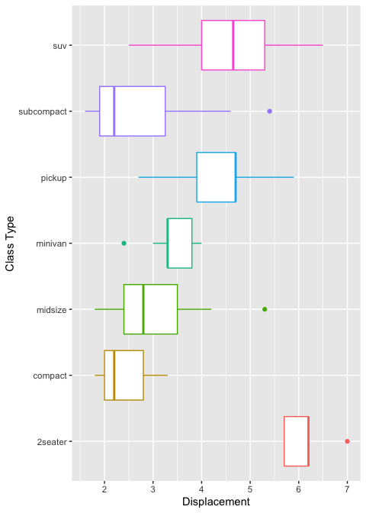

# Test outliers  
mpg %>%  
 group_by(class) %>%   
 identify_outliers(displ)

## # A tibble: 4 × 14  
## class ...1 manuf…¹ model displ year cyl trans drv cty hwy fl   
## <fct> <dbl> <chr> <chr> <dbl> <dbl> <fct> <chr> <fct> <dbl> <dbl> <chr>  
## 1 2seater 28 chevro… corv… 7 2008 8 manu… r 15 24 p   
## 2 midsize 159 pontiac gran… 5.3 2008 8 auto… f 16 25 p   
## 3 minivan 38 dodge cara… 2.4 1999 4 auto… f 18 24 r   
## 4 subcompact 99 ford must… 5.4 2008 8 manu… r 14 20 p   
## # … with 2 more variables: is.outlier <lgl>, is.extreme <lgl>, and abbreviated  
## # variable name ¹​manufacturer

## get summary stat  
library(rstatix)  
mpg %>%  
 group_by(class) %>%   
 get_summary_stats(displ, type = "mean_sd")

## # A tibble: 7 × 5  
## class variable n mean sd  
## <fct> <chr> <dbl> <dbl> <dbl>  
## 1 2seater displ 5 6.16 0.532  
## 2 compact displ 47 2.33 0.452  
## 3 midsize displ 41 2.92 0.719  
## 4 minivan displ 11 3.39 0.453  
## 5 pickup displ 33 4.42 0.829  
## 6 subcompact displ 35 2.66 1.10   
## 7 suv displ 62 4.46 1.07

# Step 1: Setup Null Hypothesis and Alternate Hypothesis  
# H0 = mu = mu01 = mu02(There is no difference  
# between average displacement for different class)  
# H1 = Not all means are equal  
# Step 2: Calculate test statistics using aov function  
mpg_aov1 <- aov(mpg$displ~ mpg$class+mpg$cyl)  
summary(mpg_aov1)

## Df Sum Sq Mean Sq F value Pr(>F)   
## mpg$class 6 223.09 37.18 249.0 <2e-16 ***  
## mpg$cyl 3 132.37 44.12 295.4 <2e-16 ***  
## Residuals 224 33.45 0.15   
## ---  
## Signif. codes: 0 '***' 0.001 '**' 0.01 '*' 0.05 '.' 0.1 ' ' 1

capture.output(summary(mpg_aov1), file = "data/mpg_anova1.doc")

# Step 1: Setup Null Hypothesis and Alternate Hypothesis  
# H0 = mu = mu01 = mu02(There is no difference  
# between average displacement for different class)  
# H1 = Not all means are equal  
mpg$class <- as.factor(mpg$class)  
mpg$cyl <- as.factor(mpg$cyl)  
# Step 2: Calculate test statistics using aov function with interaction  
mpg_aov2 <- aov(mpg$displ~ mpg$class+mpg$cyl:mpg$class)  
summary(mpg_aov2)

## Df Sum Sq Mean Sq F value Pr(>F)   
## mpg$class 6 223.09 37.18 255.76 <2e-16 ***  
## mpg$class:mpg$cyl 12 134.57 11.21 77.14 <2e-16 ***  
## Residuals 215 31.26 0.15   
## ---  
## Signif. codes: 0 '***' 0.001 '**' 0.01 '*' 0.05 '.' 0.1 ' ' 1

capture.output(summary(mpg_aov2), file = "data/mpg_anova2.doc")

* Quantile-Quantile Plots (or QQ-Plots) compare the quantiles between two distributions - typically the observed distribution and an assumed distribution like the normal distribution. If the points fall on the diagonal line, then the distributions match. If the points differ from the diagonal line, then the distributions differ.

qq_mpg <- mpg %>%   
 ggplot(aes(sample=displ)) +  
 geom_qq(color='blue')+  
 geom_qq_line(color='red', size=1)+  
 xlab("Theoretial Quantities")+  
 ylab("Standard Residuals")+  
 ggtitle("Normal Q-Q")+  
 theme(plot.title = element_text(hjust = 0.5))

mpg_residuals <- as.data.frame(mpg_aov1$residuals)  
names(mpg_residuals) <- c("residuals")  
mpg_residuals

## residuals  
## 1 -0.2038584618  
## 2 -0.2038584618  
## 3 -0.0038584618  
## 4 -0.0038584618  
## 5 -0.2948653396  
## 6 -0.2948653396  
## 7 0.0051346604  
## 8 -0.2038584618  
## 9 -0.2038584618  
## 10 -0.0038584618  
## 11 -0.0038584618  
## 12 -0.2948653396  
## 13 -0.2948653396  
## 14 0.0051346604  
## 15 0.0051346604  
## 16 -0.4798846195  
## 17 -0.1798846195  
## 18 -0.4703049429  
## 19 0.1645460841  
## 20 0.1645460841  
## 21 0.1645460841  
## 22 0.5645460841  
## 23 0.8645460841  
## 24 -0.4600000000  
## 25 -0.4600000000  
## 26 0.0400000000  
## 27 0.0400000000  
## 28 0.8400000000  
## 29 0.1645460841  
## 30 0.1645460841  
## 31 0.5645460841  
## 32 1.3645460841  
## 33 0.2111222583  
## 34 0.2111222583  
## 35 -0.1798846195  
## 36 0.2201153805  
## 37 0.3201153805  
## 38 0.0009153434  
## 39 -0.4900915343  
## 40 -0.1900915343  
## 41 -0.1900915343  
## 42 -0.1900915343  
## 43 -0.1900915343  
## 44 -0.1900915343  
## 45 0.3099084657  
## 46 0.3099084657  
## 47 0.3099084657  
## 48 0.5099084657  
## 49 0.0253147223  
## 50 0.0253147223  
## 51 0.2253147223  
## 52 0.2253147223  
## 53 -0.3651056012  
## 54 -0.3651056012  
## 55 -0.3651056012  
## 56 0.1348943988  
## 57 0.1348943988  
## 58 0.1549664076  
## 59 -0.4354539159  
## 60 -0.4354539159  
## 61 -0.4354539159  
## 62 0.0645460841  
## 63 0.5645460841  
## 64 0.7645460841  
## 65 -0.3651056012  
## 66 -0.3651056012  
## 67 -0.3651056012  
## 68 -0.3651056012  
## 69 -0.3651056012  
## 70 -0.3651056012  
## 71 0.1348943988  
## 72 0.1348943988  
## 73 0.6348943988  
## 74 0.8348943988  
## 75 -0.5354539159  
## 76 0.2645460841  
## 77 0.2645460841  
## 78 0.2549664076  
## 79 0.2549664076  
## 80 0.2549664076  
## 81 0.2549664076  
## 82 -0.5354539159  
## 83 -0.1354539159  
## 84 0.5253147223  
## 85 0.5253147223  
## 86 -0.4651056012  
## 87 -0.4651056012  
## 88 -0.4651056012  
## 89 0.3348943988  
## 90 0.3348943988  
## 91 0.6484144660  
## 92 0.6484144660  
## 93 0.8484144660  
## 94 0.8484144660  
## 95 0.0579941426  
## 96 0.0579941426  
## 97 0.0579941426  
## 98 0.0579941426  
## 99 0.8579941426  
## 100 -0.4605786562  
## 101 -0.4605786562  
## 102 -0.4605786562  
## 103 -0.4605786562  
## 104 -0.4605786562  
## 105 -0.2605786562  
## 106 -0.2605786562  
## 107 -0.2605786562  
## 108 -0.0605786562  
## 109 0.2111222583  
## 110 0.2111222583  
## 111 0.2111222583  
## 112 0.2111222583  
## 113 -0.7798846195  
## 114 -0.7798846195  
## 115 0.0201153805  
## 116 -0.0605786562  
## 117 -0.0605786562  
## 118 -0.0605786562  
## 119 -0.0605786562  
## 120 -0.4515855340  
## 121 -0.4515855340  
## 122 -0.4515855340  
## 123 -0.7450335924  
## 124 -0.0450335924  
## 125 0.2549664076  
## 126 -0.4354539159  
## 127 -0.4354539159  
## 128 -0.4354539159  
## 129 0.5645460841  
## 130 0.9645460841  
## 131 -1.1354539159  
## 132 -0.9354539159  
## 133 -0.7354539159  
## 134 -0.5354539159  
## 135 0.2645460841  
## 136 0.2645460841  
## 137 0.2645460841  
## 138 0.2549664076  
## 139 0.2549664076  
## 140 -0.5354539159  
## 141 -0.1354539159  
## 142 0.3961415382  
## 143 0.3961415382  
## 144 0.3111222583  
## 145 0.3111222583  
## 146 0.2201153805  
## 147 0.2201153805  
## 148 -0.2798846195  
## 149 -0.2798846195  
## 150 0.2201153805  
## 151 -0.4450335924  
## 152 -0.4450335924  
## 153 0.2549664076  
## 154 0.4645460841  
## 155 -0.1798846195  
## 156 0.5201153805  
## 157 0.5201153805  
## 158 0.5201153805  
## 159 0.6296950571  
## 160 -0.1540267147  
## 161 -0.1540267147  
## 162 -0.1540267147  
## 163 -0.1540267147  
## 164 -0.1540267147  
## 165 -0.1540267147  
## 166 0.1394213438  
## 167 0.1394213438  
## 168 0.4394213438  
## 169 0.4394213438  
## 170 0.4961415382  
## 171 0.4961415382  
## 172 0.4961415382  
## 173 0.4961415382  
## 174 0.0459732853  
## 175 0.0459732853  
## 176 -0.3450335924  
## 177 -0.3450335924  
## 178 0.2549664076  
## 179 -0.4354539159  
## 180 0.0111222583  
## 181 0.0111222583  
## 182 0.2111222583  
## 183 0.2111222583  
## 184 -0.2798846195  
## 185 -0.2798846195  
## 186 0.2201153805  
## 187 0.1961415382  
## 188 0.1961415382  
## 189 0.3961415382  
## 190 0.3961415382  
## 191 -0.0948653396  
## 192 -0.0948653396  
## 193 0.2051346604  
## 194 -0.2038584618  
## 195 -0.2038584618  
## 196 -0.2038584618  
## 197 -0.2038584618  
## 198 -0.2038584618  
## 199 -0.4354539159  
## 200 0.5645460841  
## 201 0.1163216001  
## 202 0.1163216001  
## 203 0.1163216001  
## 204 -0.2746852777  
## 205 -0.2746852777  
## 206 0.3253147223  
## 207 0.3253147223  
## 208 -0.0038584618  
## 209 -0.0038584618  
## 210 -0.0038584618  
## 211 -0.0038584618  
## 212 -0.2948653396  
## 213 -0.1038584618  
## 214 -0.0038584618  
## 215 -0.0038584618  
## 216 -0.0038584618  
## 217 -0.0038584618  
## 218 0.0283600972  
## 219 0.0283600972  
## 220 -0.2948653396  
## 221 -0.2948653396  
## 222 -0.1605786562  
## 223 -0.1605786562  
## 224 -0.0605786562  
## 225 -0.0605786562  
## 226 -0.0283600972  
## 227 -0.0283600972  
## 228 -0.3888777417  
## 229 -0.3888777417  
## 230 -0.1888777417  
## 231 -0.1888777417  
## 232 -0.4798846195  
## 233 -0.4798846195  
## 234 0.3201153805

hist_mpg <- ggplot(data=mpg_residuals, aes(x=residuals)) +   
 geom_histogram(breaks=seq(-3, 3, by=1),   
 col="red",   
 fill="blue",   
 alpha = .2) +   
 labs(title="Histogram for anova residuals", x="Residuals", y="Frequency")+   
 theme(plot.title = element_text(hjust = 0.5))

# Condition of Linear Regression(LINE)  
# L: Linear  
# I : The errors e_i are independent  
# N : the errors are normally distributed   
# E : the errors have equal variance  
# Create grid  
mpg_out <- ggpubr::ggarrange(hist_mpg, qq_mpg, # list of plots  
 labels=c("(a)", "(b)"), # labels  
 common.legend = F, # COMMON LEGEND  
 legend = "bottom", # legend position  
 align = "hv", # Align them both, horizontal and vertical  
 nrow = 1, ncol = 2, # number of rows  
 label.x = 0, label.y=.99,  
 font.label = list(color='blue',size=14)  
)   
  
mpg_out

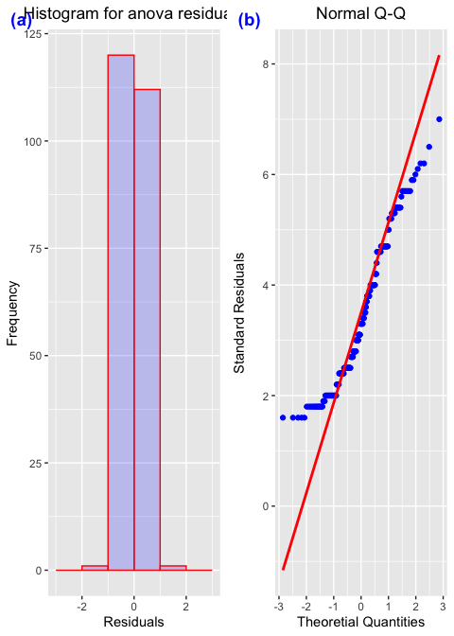

ggsave('fig/pfgplot8.png', mpg_out,width=10, dpi=300)

# 5 Scientific Publishing with Quarto in R

## 5.1 Publishing with Quarto

[Yihui Xie](https://twitter.com/xieyihui), who has written several of the most essential packages in this space, including knitr, first introduced R Markdown in 2012. Xie presents R Markdown as “an authoring framework for data science” in his book [R Markdown: The Definitive Guide](https://bookdown.org/yihui/rmarkdown/). The .Rmd file is used to automatically “save and execute code, as well as generate high-quality reports.” Documents and presentations in **HTML, PDF, Word, Markdown, Powerpoint, LaTeX**, and more formats are all supported. Homework assignments, journal articles, full-length books, formal reports, presentations, web pages, and interactive dashboards are just a few of the possibilities he offers, with examples of each. It is an understatement to suggest that it is a flexible and dynamic environment.

Quarto is the next generation of RMarkdown for publishing, including dynamic and static documents and multi-lingual programming language support. With Quarto you can create documents, books, presentations, blogs or other online resources.

## 5.2 Markdown Basics

Quarto is based on Pandoc and uses its variation of markdown as its underlying document syntax. Pandoc markdown is an extended and slightly revised version of John Gruber’s [Markdown](https://daringfireball.net/projects/markdown/) syntax.

## 5.3 R Markdown Syntax

R Markdown files consist of the following elements:

* A metadata header that uses the YAML syntax to configure multiple output choices.
* Markdown-formatted content in the body
* Three backticks separate code chunks, which are separated by a curly braced block that identifies the language and sets chunk settings.

R Markdown also allows users to embed code expressions in the prose by enclosing them in single backticks. A minimal .Rmd example is included below. This is based on the Xie’s sample, which I’ve modified to demonstrate all of the elements mentioned above.

---  
02: title: "Hello Dinsho"  
03: author: "Mesfin Diro"  
04: output: html_document  
05: ---  
06:  
07: This is a paragraph in an _R Markdown_ document.  
08: Below is a code chunk:  
09:  
10: ```{r fit-plot, echo=TRUE}  
11: fit = lm(dist ~ speed, data = cars)  
12: b = coef(fit)  
13: plot(cars)  
14: abline(fit)  
15: ```  
16:  
17: The slope of the regression is `r round(b[2], digits = 3)`.

* R Markdown provides an authoring framework for data science. You can use a single R Markdown file to both
  + save and execute code
  + generate high quality reports that can be shared with an audience
* R Markdown documents are fully reproducible and support dozens of static and dynamic output formats. This is an R Markdown file, a plain text file that has the extension .Rmd.

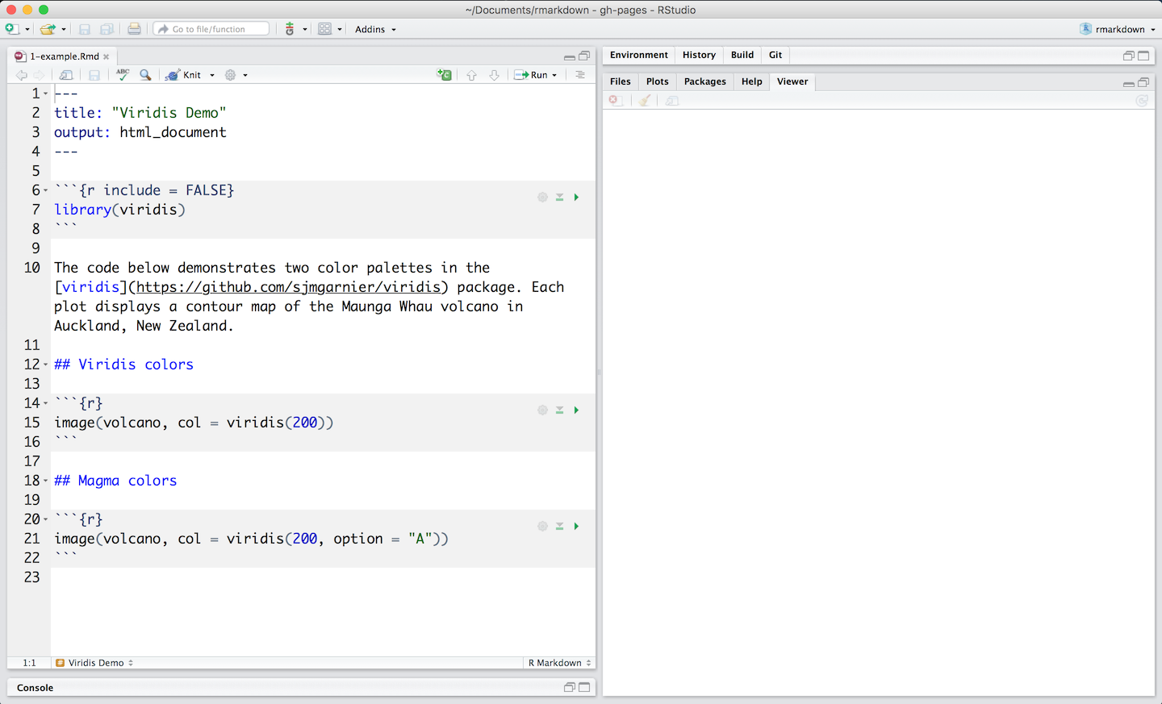 - The file contains three types of content: 1. An (optional) YAML header surrounded by ---s 2. R code chunks surrounded by ```s 3. text mixed with simple text formatting

## 5.4 Rendering output

* To generate a report from the file, run the render command:

library(rmarkdown)  
render("example_1.Rmd)

* Better still, use the **“Knit”** button in the RStudio IDE to render the file and preview the output with a single click or keyboard shortcut.r

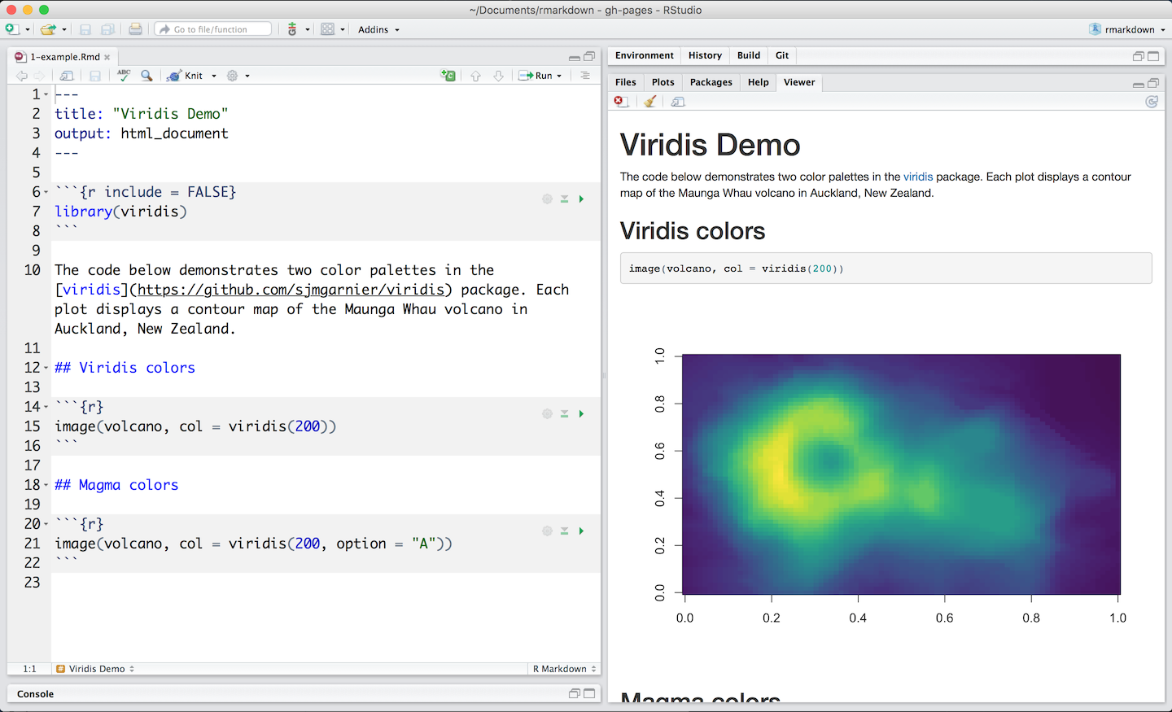

R Markdown with Knit button in RStudio

* R Markdown generates a new file that contains selected text, code, and results from the .Rmd file. The new file can be a finished **web page, PDF, MS Word document, slide show, notebook, handout, book, dashboard, package vignette** or other **format**.

## 5.5 How it works



R Markdown with Knit button in RStudio

* When you run render, R Markdown sends the .Rmd file to knitr, which runs all of the code chunks and generates a new markdown (.md) document with the code and its output.
* **Knitr** generates a markdown file, which is then processed by pandoc, which generates the final format.
* While this may appear hard, R Markdown simplifies the process by combining all of the above processing into a single render function.

## 5.6 Code Chunks

* The R Markdown file below contains three code chunks:

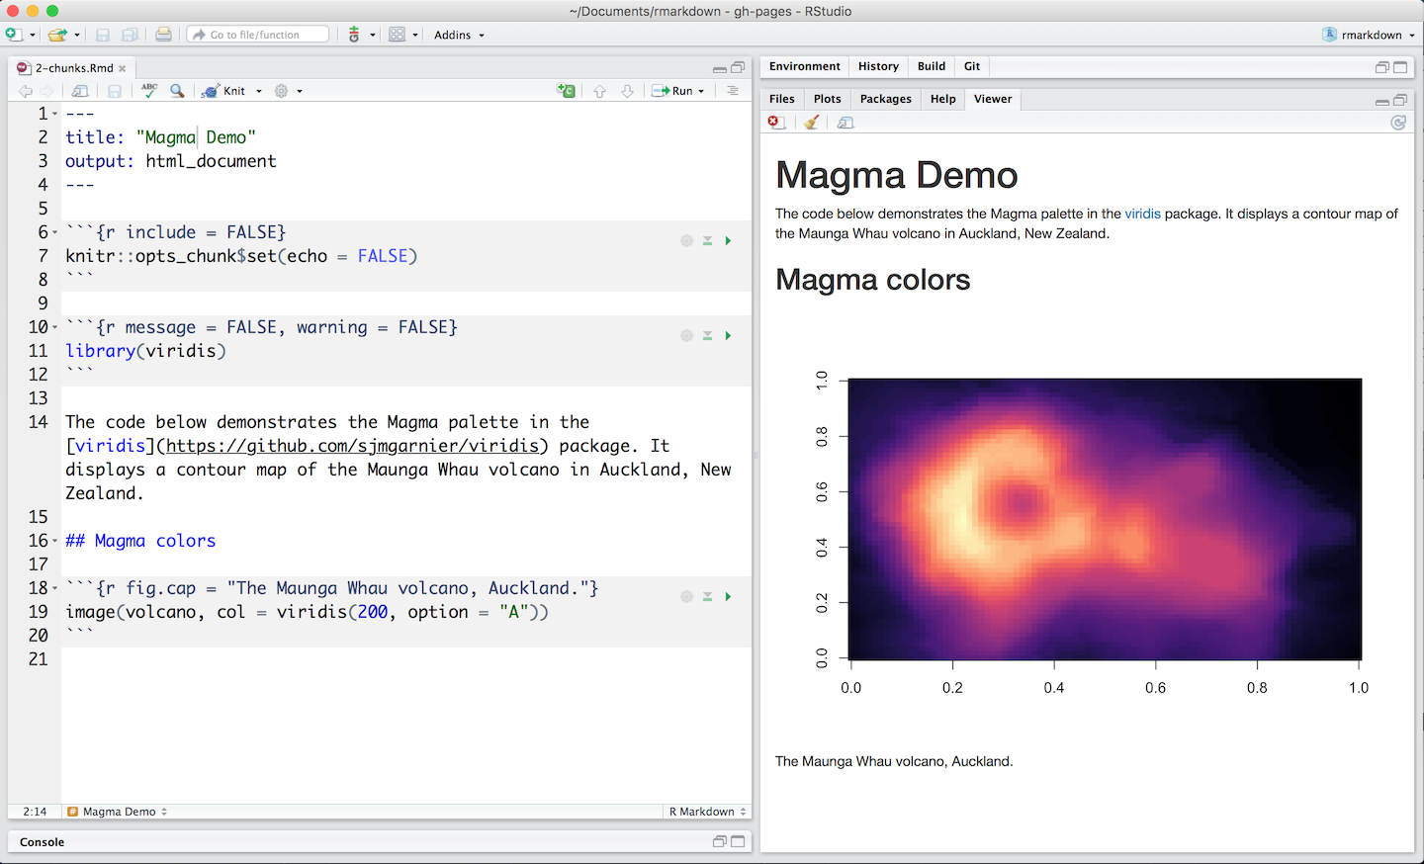

R Markdown with Knit button in RStudio

* You can quickly insert chunks like these into your file with
  + the keyboard shortcut **Ctrl + Alt + I** (OS X: **Cmd + Option + I**)
  + the Add Chunk  command in the editor toolbar or or by typing the chunk delimiters **{r}__ and __**.
* When you render your .Rmd file, R Markdown will run each code chunk and embed the results beneath the code chunk in your final report.

## 5.7 Inline Code

* Code results can be inserted directly into the text of a .Rmd file by enclosing the code with `r`. The file below uses `r` twice to call **colorFunc**, which returns “heat.colors”.

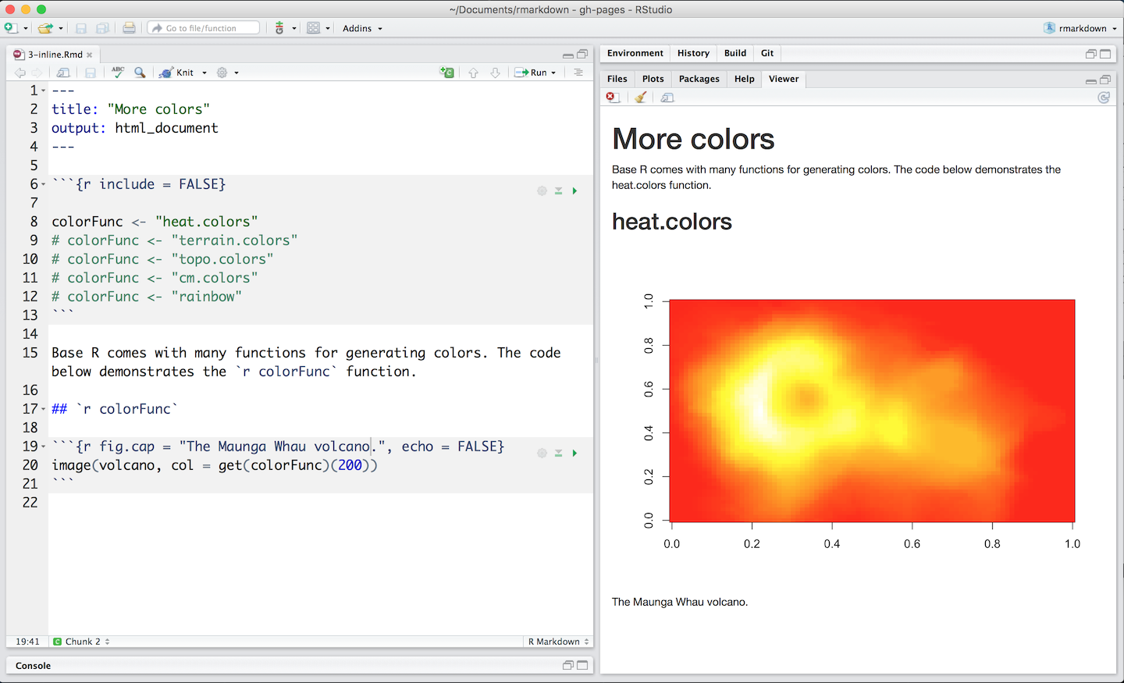

* Using `r` makes it easy to update the report to refer to another function.

## 5.8 Code Languages

* knitr can execute code in many languages besides R. Some of the available language engines include:
  + Python
  + SQL
  + Bash
  + Rcpp
  + Stan
  + JavaScript
  + CSS
* To process a code chunk using an alternate language engine, replace the r at the start of your chunk declaration with the name of the language:

{bash}

## 5.9 Academic Journals

Academic publications frequently have severe formatting requirements for submitted articles. Few journals support R Markdown submissions directly at the moment, however several do support the LaTeX format. While you can convert R Markdown to LaTeX, different journals have different typesetting requirements and LaTeX styles, so it may be time-consuming and frustrating for all authors who want to use R Markdown to figure out the technical details of how to properly convert a R Markdown-based paper to a LaTeX document that meets the journal requirements.

The rticles package is designed to simplify the creation of documents that conform to submission standards. A suite of custom R Markdown templates for popular journals is provided by the package

### 5.9.1 Get started

You can install and use rticles from CRAN as follows:

# Install from CRAN  
install.packages("rticles")  
  
# Or install development version from GitHub  
devtools::install_github("rstudio/rticles")

The development version of the package from GitHub is recommended because it has the most recent versions as well as various new templates.

If you’re using RStudio, go to File -> New File -> R Markdown to access the templates. This will bring up a dialog window where you may choose from a number of different templates.

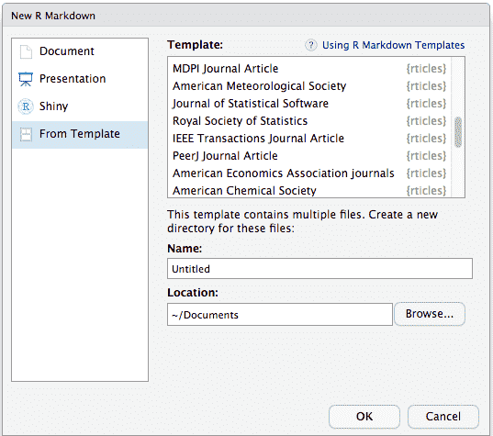

The R Markdown template window in RStudio showing available rticles templates

If you are using the command line, you can use the rmarkdown::draft() function, which requires you to specify a template using the journal short name, e.g.,

rmarkdown::draft(  
 "JSSArticle.Rmd", template = "jss", package = "rticles"  
)

### 5.9.2 rticles templates

The rticles package provides templates for various journals and publishers, including:

* R Journal articles
* CTeX documents
* JSS articles (Journal of Statistical Software)
* ACM articles (Association of Computing Machinery)
* ACS articles (American Chemical Society)
* AMS articles (American Meteorological Society)
* PeerJ articles
* Elsevier journal submissions
* AEA journal submissions (American Economic Association)
* IEEE Transaction journal submissions
* Statistics in Medicine journal submissions
* Royal Society Open Science journal submissions
* MDPI journal submissions
* Springer journal submissions

The full list is available within the R Markdown templates window in RStudio, or through the function rticles::journals():

library(rticles)  
rticles::journals()

## [1] "acm" "acs" "aea" "agu"   
## [5] "ajs" "amq" "ams" "arxiv"   
## [9] "asa" "bioinformatics" "biometrics" "copernicus"   
## [13] "ctex" "elsevier" "frontiers" "glossa"   
## [17] "ieee" "ims" "informs" "iop"   
## [21] "isba" "jasa" "jedm" "joss"   
## [25] "jss" "lipics" "lncs" "mdpi"   
## [29] "mnras" "oup_v0" "oup_v1" "peerj"   
## [33] "pihph" "plos" "pnas" "rjournal"   
## [37] "rsos" "rss" "sage" "sim"   
## [41] "springer" "tf" "trb" "wellcomeor"

## 5.10 Essential commands with Quarto

Quarto is a multi-language, next-generation version of R Markdown from RStudio, and includes dozens of new features and capabilities while at the same being able to render most existing Rmd files without modification. Like R Markdown, Quatro uses a variation of Markdown as its underlying syntax. Essential markdown commands include those for emphasis, headers, lists, links, and images. A reminder of these is included in RStudio (“Help” -> “Markdown Quick Reference”). It is your choice as to whether you want to use the visual or source editor. But either way, it is good to understand these essentials because it will not always be possible to use a visual editor, for instance if you are quickly looking at a Quarto document in GitHub. Also RStudio is sometimes laggy and it can be useful to use a text editor, such as Sublime Text, or VS Code

The following is a Quarto document with the extension .qmd (on the left) along with its rendered version as HTML (on the right). You could also choose to render it into other formats like PDF, MS Word, etc.

### 5.10.1 Rendering

Use the Render button in the RStudio IDE to render the file and preview the output with a single click Note that documents can also be rendered from the R console via the quarto package:

install.packages("quarto")  
quarto::quarto_render("hello.qmd")

When rendering, Quarto generates a new file that contains selected text, code, and results from the .qmd file. The new file can be an HTML, PDF, MS Word document, presentation, website, book, interactive document, or other format.

### 5.10.2 Authoring

In the image below we can see the same document in the two modes of the RStudio editor: visual (on the left) and source (on the right). RStudio’s visual editor offers an WYSIWYM authoring experience for markdown. For formatting (e.g. bolding text) you can use the toolbar, or the markdown construct (**bold**). The plain text source code underlying the document is written for you and you can view/edit it at any point by switching to source mode for editing. You can toggle back and forth these two modes by clicking on Source and Visual in the editor toolbar

# Appendix

# Appendex 1

## 5.11 Installing R and Rstudio

* R is free
* Often, less codes are needed in R to plot an elegant graph
* for/while loops (basic concepts in programming) are not necessary in R to make a production-quality graph
* R is the best software for statistical analysis

### 5.11.1 installing R

1. You can download R from the Comprehensive R Archive Network (CRAN). Search for CRAN on your browser:

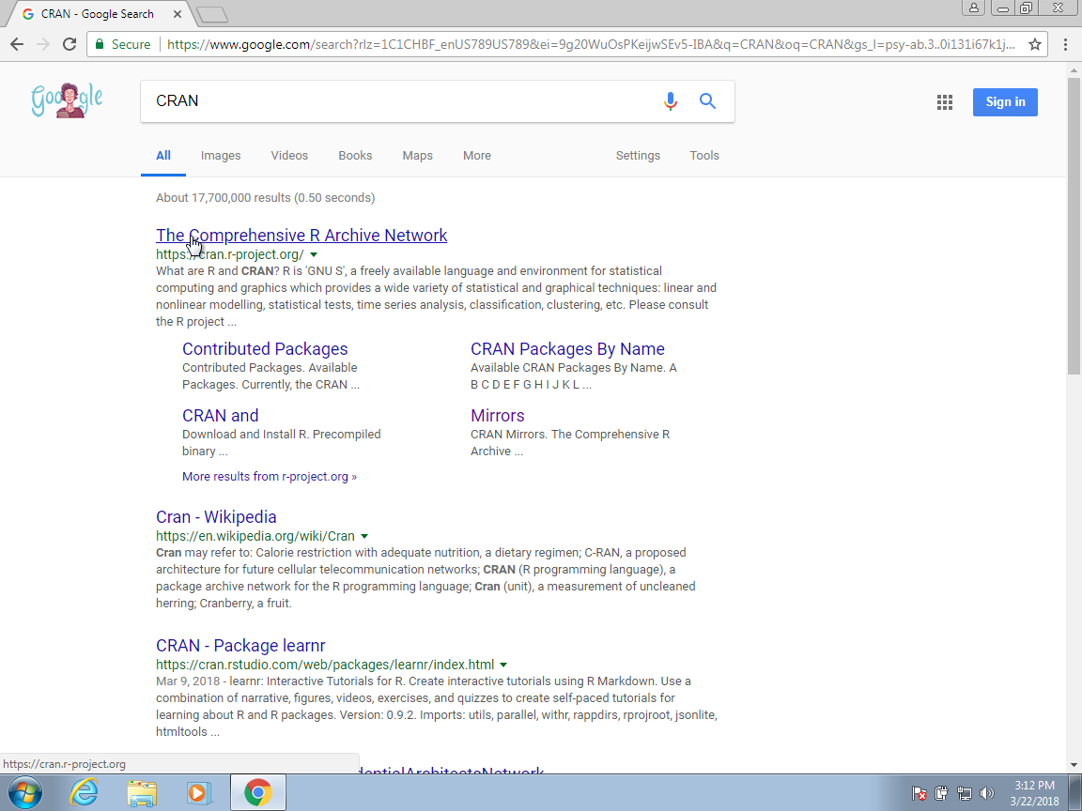

Comprehensive R Archive Network

1. Select the version for your operating system from the CRAN page: Linux, Mac OS X, or Windows.

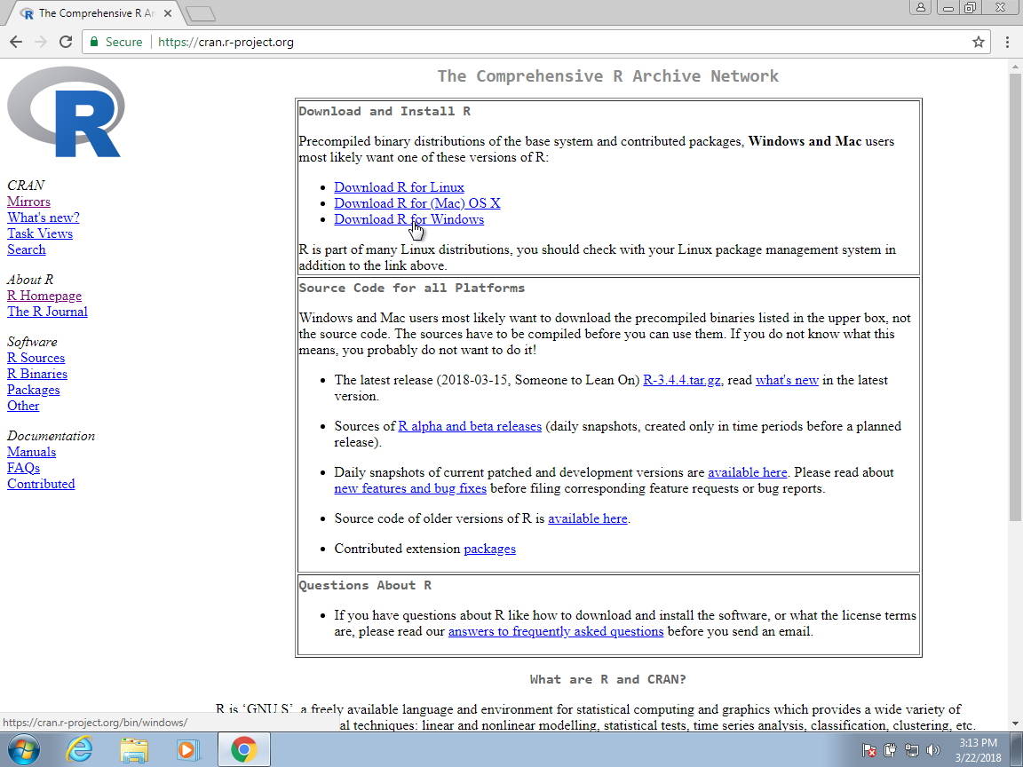

R Version for Linux, Mac OS X or Windows

1. You have numerous options once you get at the CRAN download page. The base subfolder is what you want to install. This sets up the foundational packages you’ll need to get started. Instead of using this URL, we’ll learn how to install additional required programs from within R.

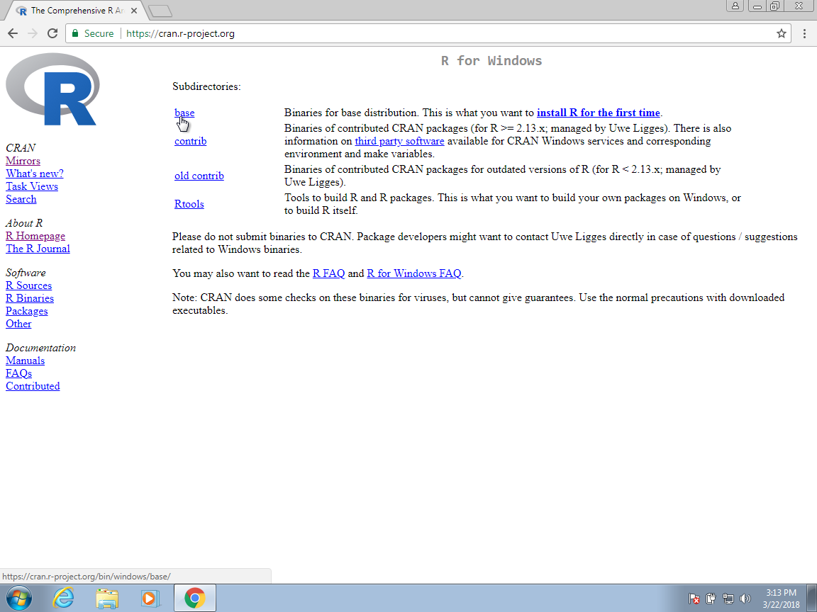

R Version for Linux, Mac OS X or Windows

1. To begin the download, click the link for the most **latest version**.

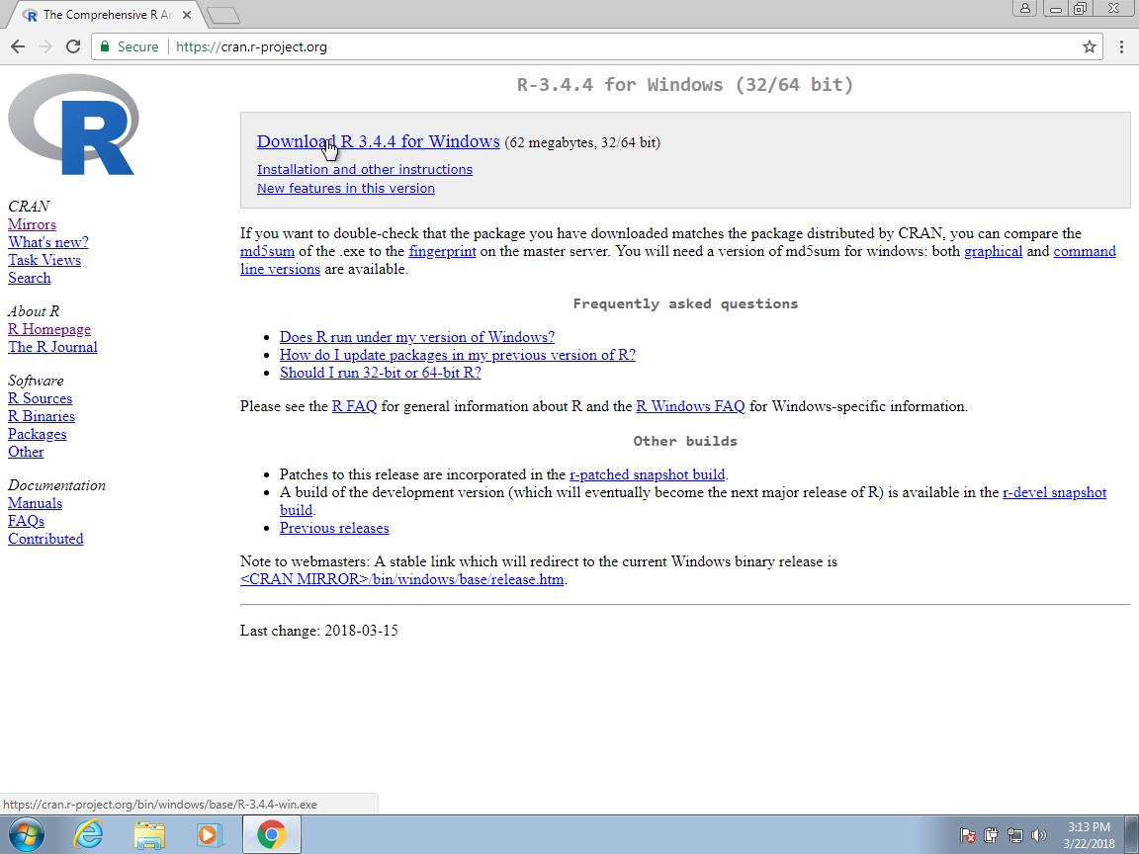

R Version for Linux, Mac OS X or Windows

1. When the installer file has finished downloading, click that tab to begin the installation process. As a result, you’ll need to locate where they store downloaded files and click on them to begin the process.

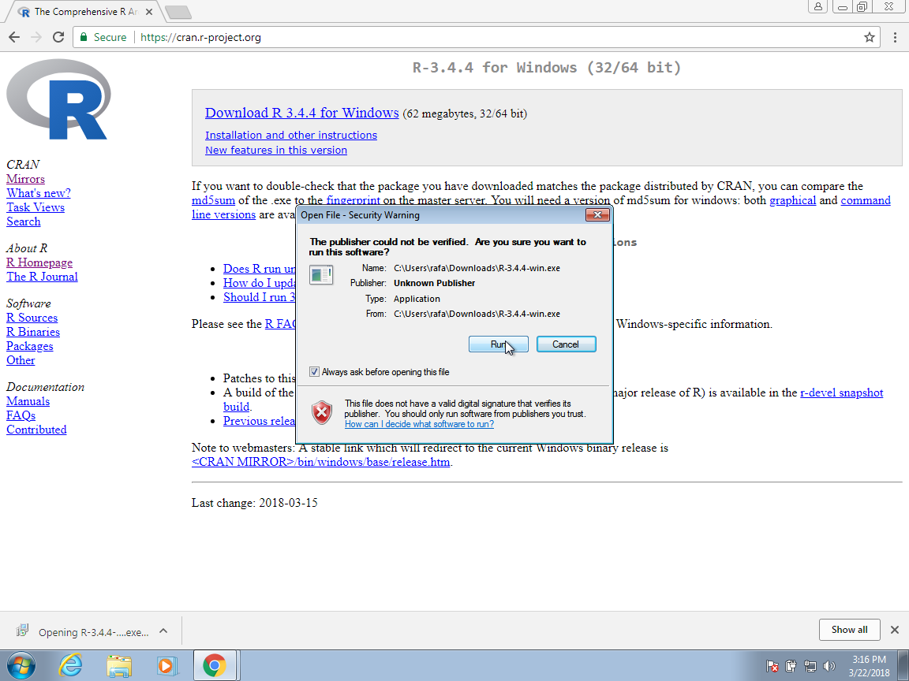

R Version for Linux, Mac OS X or Windows

1. To complete the installation, navigate through the various options. All of the default options are recommended.



R installation startup

1. Select the default even when you get an ominous warning.

 8. When selecting the language, consider that it will be easier to follow this book if you select English

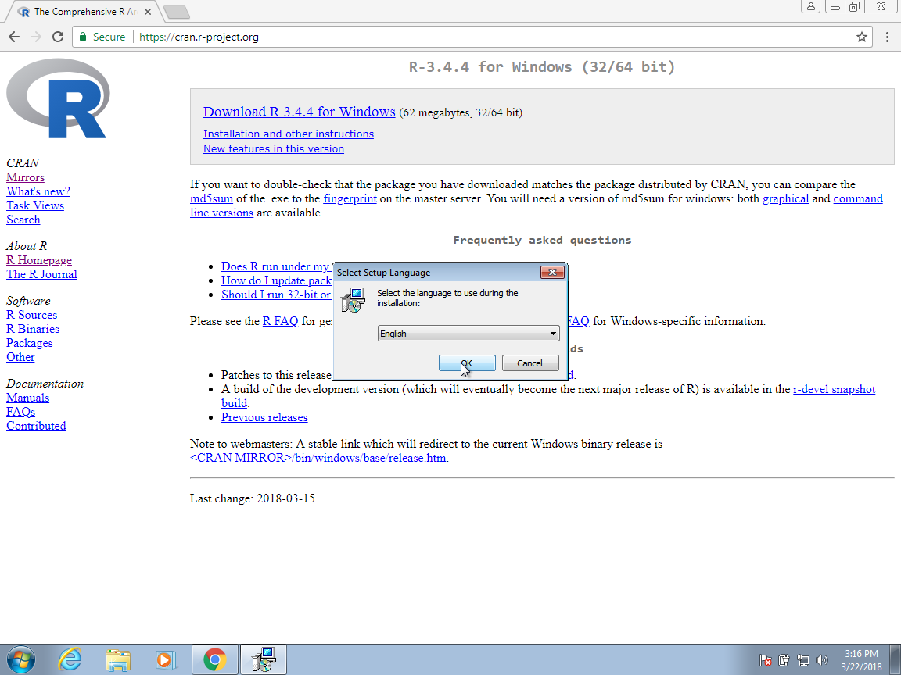

R Installation language selection

1. Continue to select all the defaults:

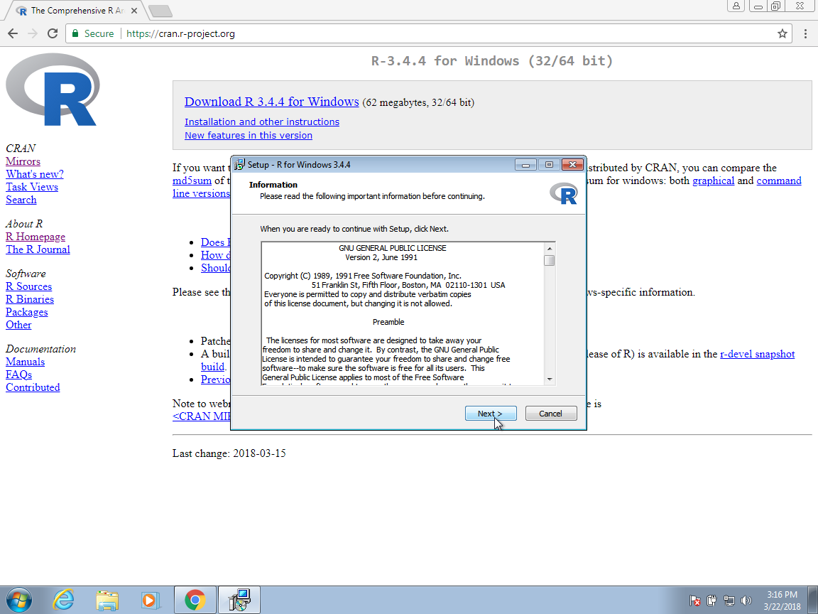

R Installation defaults

### 5.11.2 Installing RStudio

RStudio is an interactive desktop environment, but it is not R, and when you download and install it, it does not include R. As a result, before we can utilize RStudio, we must first install R.

**Download requirements for RStudio**

* Download R: <http://cran.r-project.org/>
* RStudio: <http://www.rstudio.org/>
* For Mac users only : XQuartz: <https://www.xquartz.org/>

### 5.11.3 Open RStudio

When you start RStudio for the first time, you will see three panes. The left pane shows the R console. On the right, the top pane includes tabs such as Environment and History, while the bottom pane shows five tabs: File, Plots, Packages, Help, and Viewer (these tabs may change in new versions). You can click on each tab to move across the different features.

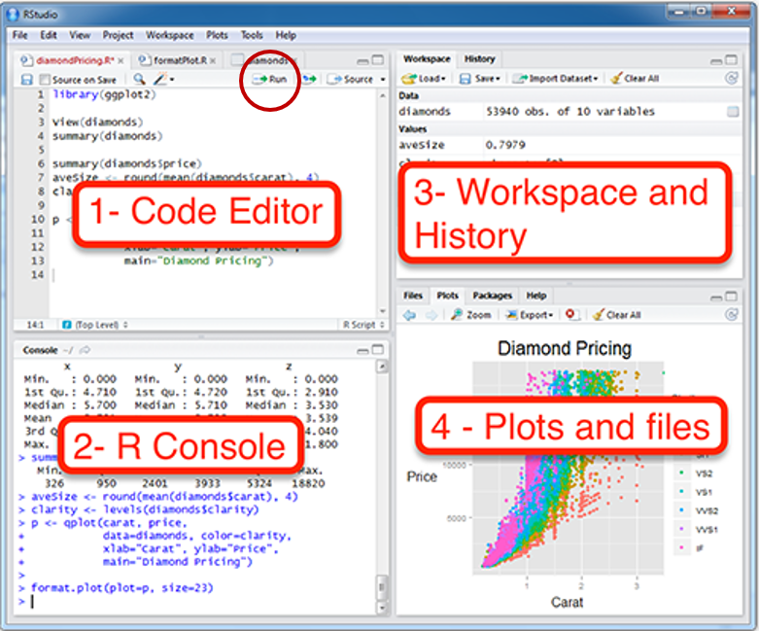

Rstudio layout

To start a new script, you can click on **file**, then **New File**, then **R Script**

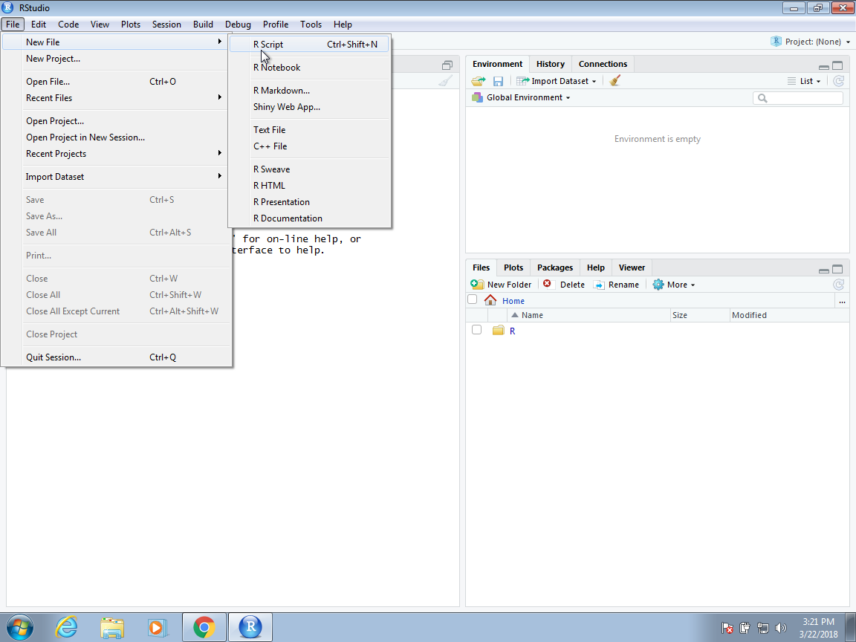

Setting your working directory

* Rstudio is where people do R programming. You can type codes (commands) into the console (bottom-left panel).
  + > means that the console is ready to receive more code.
  + + means your code is not complete.
* You can also write (longer) codes in the script within the code editor (top-left panel).
  + The code editor will run the script into the console.
  + A new script can be opened by clicking: **File -> New -> R Script**.
* You can run a script by clicking **“Run”** with the green arrow or by typing **ctrl + enter**. It is labeled with the red circle.
  + Or you can just type your codes directly into the console.

**How to set working directory**

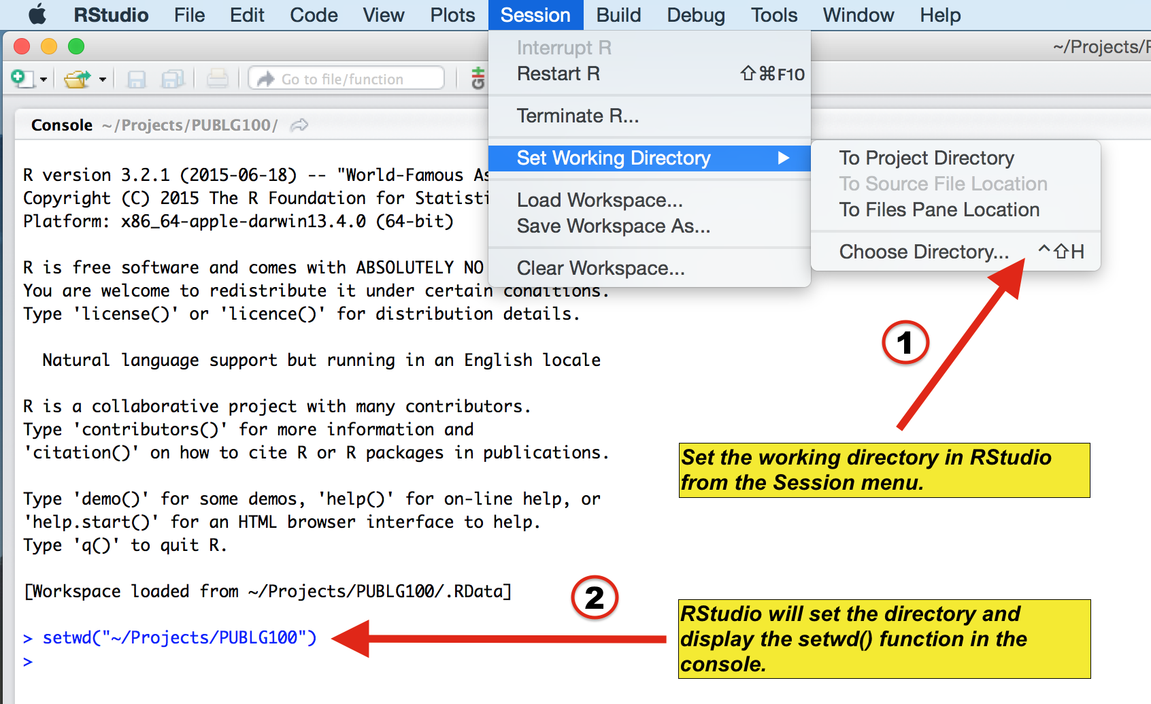

Setting your working directory

### 5.11.4 Installing R packages

A fresh install of R only provides a small portion of the capability available. In reality, what you get after your initial setup is referred to as base R. Developer-created add-ons provide the additional capabilities. Hundreds of these are presently available through CRAN, with many more provided via other sources such as GitHub. R, on the other hand, makes distinct components available via packages because not everyone requires all of the available capabilities. R makes installing packages from within R very simple. To install the **tidyverse** package, for example, which we use to share datasets and code for this book, type:

install.packages("tidyverse")

Navigate to the Tools menu in RStudio and click Install Packages. We can then use the **library** function to load the package into our R sessions:

library(tidyverse)

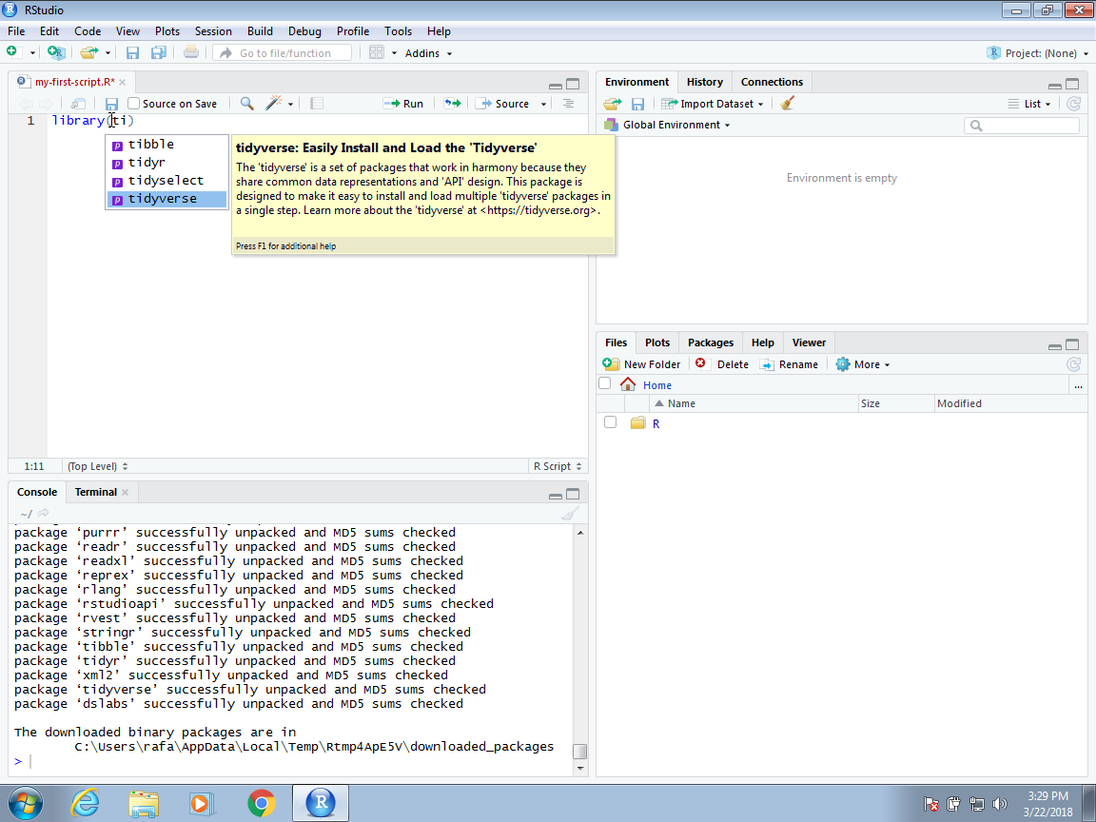

Setting your working directory

Until we exit the R session, the package remains loaded. If you encounter an error when trying to load a package, it implies you need to install it first. By passing a character vector to this function, we can also install multiple packages at once:

install.packages(c("tidyverse","ggpubr"))

It’s worth noting that tidyverse installs multiple packages. When a package contains dependencies or uses functions from other packages, this happens frequently. When you use library to load a package, you also load its dependencies.

# Appendex 2

## 5.12 Installing OpenRefine

The core functions of OpenRefine do not require internet access. It runs as a small web server on your own computer when you download and install it, and you access it using your browser. To import data from the online, reconcile data using a web service, or export data to the web, all you need is an internet connection.

To run OpenRefine, you’ll need three things on your computer:

### 5.12.1 Compatible operating system

* OpenRefine is designed to work with Windows, Mac, and Linux operating systems

### 5.12.2 Java

* To run OpenRefine, you must have Java installed and configured on your machine. The Mac version of OpenRefine contains Java, while a Windows package with Java was added in OpenRefine 3.4.
* If you install and run OpenRefine on a Windows computer without Java, it will open a browser window with instructions for downloading Java.
* Before installing OpenRefine, we recommend that you first download and install Java. Please keep in mind that OpenRefine 3.5 supports Java 8 through Java 17.

### 5.12.3 Compatible browser

* OpenRefine works well with Webkit-based browsers, such as:
  + Chromium Google Chrome
  + Opera
  + Edge by Microsoft
* Other browsers, such as Firefox, have some minor rendering and performance difficulties. **Internet Explorer is not supported**.

# References

Allaire, JJ, Yihui Xie, Jonathan McPherson, Javier Luraschi, Kevin Ushey, Aron Atkins, Hadley Wickham, Joe Cheng, Winston Chang, and Richard Iannone. 2020. *Rmarkdown: Dynamic Documents for r*. <https://CRAN.R-project.org/package=rmarkdown>.

Allam, O., R. Kuramshin, Z. Stoichev, B. W. Cho, S. W. Lee, and S. S. Jang. 2020. “Molecular Structureredox Potential Relationship for Organic Electrode Materials: Density Functional Theorymachine Learning Approach.” *Materials Today Energy* 17 (September): 100482. <https://doi.org/10.1016/j.mtener.2020.100482>.

Arnold, Jeffrey B. 2019. *Ggthemes: Extra Themes, Scales and Geoms for ’Ggplot2’*. <https://CRAN.R-project.org/package=ggthemes>.

Attali, Dean, and Christopher Baker. 2019. *ggExtra: Add Marginal Histograms to ’Ggplot2’, and More ’Ggplot2’ Enhancements*. <https://CRAN.R-project.org/package=ggExtra>.

Auguie, Baptiste. 2017. *gridExtra: Miscellaneous Functions for "Grid" Graphics*. <https://CRAN.R-project.org/package=gridExtra>.

Barbera, Pablo. 2018. *streamR: Access to Twitter Streaming API via r*. <https://CRAN.R-project.org/package=streamR>.

Becke, Axel D. 2014. “Perspective: Fifty Years of Density-Functional Theory in Chemical Physics.” *The Journal of Chemical Physics* 140 (18): 18A301. <https://doi.org/gfgqd9>.

Blum, Lorenz C., and Jean-Louis Reymond. 2009. “970 Million Druglike Small Molecules for Virtual Screening in the Chemical Universe Database GDB-13.” *Journal of the American Chemical Society* 131 (25): 8732–33. <https://doi.org/10.1021/ja902302h>.

Chamberlain, Scott. 2020. *Rorcid: Interface to the ’Orcid.org’ API*. <https://CRAN.R-project.org/package=rorcid>.

Chen, Ruiyong. 2020. “Redox Flow Batteries for Energy Storage: Recent Advances in Using Organic Active Materials.” *Current Opinion in Electrochemistry* 21 (June): 40–45. <https://doi.org/10.1016/j.coelec.2020.01.003>.

Cheng, Joe, Bhaskar Karambelkar, and Yihui Xie. 2019. *Leaflet: Create Interactive Web Maps with the JavaScript Leaflet Library*. <https://CRAN.R-project.org/package=leaflet>.

Couture-Beil, Alex. 2018. *Rjson: JSON for r*. <https://CRAN.R-project.org/package=rjson>.

“Derivatives of Naphthoquinone as Potential Electroactive Species for Redox FLOW Batteries.” 2018. *ECS Meeting Abstracts*. <https://doi.org/10.1149/ma2018-02/2/124>.

“Developing New Chemistries for Redox Flow Batteries.” 2019. *ECS Meeting Abstracts*. <https://doi.org/10.1149/ma2019-02/1/4>.

Fert, A. 2008. “The Origin, Development and Future of Spintronics.” *Phys. Usp.* 51 (12): 1336. <https://ufn.ru/en/articles/2008/12/n/>.

Fert, Albert. 2008. “Nobel Lecture: Origin, Development, and Future of Spintronics.” *Rev. Mod. Phys.* 80 (December): 1517–30. <https://doi.org/10.1103/RevModPhys.80.1517>.

Fink, Tobias, and Jean-Louis Reymond. 2007. “Virtual Exploration of the Chemical Universe up to 11 Atoms of C, N, O, F: Assembly of 26.4 Million Structures (110.9 Million Stereoisomers) and Analysis for New Ring Systems, Stereochemistry, Physicochemical Properties, Compound Classes, and Drug Discovery.” *Journal of Chemical Information and Modeling* 47 (2): 342–53. <https://doi.org/d8q5xw>.

“Flexible Ceramic Membranes for Redox Flow Batteries.” 2018. *ECS Meeting Abstracts*. <https://doi.org/10.1149/ma2018-01/41/2373>.

G’omez-Bombarelli, Rafael, and Al’an Aspuru-Guzik. 2018. “Machine Learning and Big-Data in Computational Chemistry.” *Handbook of Materials Modeling*, 1–24. <https://doi.org/gjprg7>.

G’omez-Bombarelli, Rafael, Jennifer N. Wei, David Duvenaud, Jos’e Miguel Hern’andez-Lobato, Benjam’ın S’anchez-Lengeling, Dennis Sheberla, Jorge Aguilera-Iparraguirre, Timothy D. Hirzel, Ryan P. Adams, and Al’an Aspuru-Guzik. 2018. “Automatic Chemical Design Using a Data-Driven Continuous Representation of Molecules.” *ACS Central Science* 4 (2): 268–76. <https://doi.org/ch82>.

Goodfellow, Ian J., Jean Pouget-Abadie, Mehdi Mirza, Bing Xu, David Warde-Farley, Sherjil Ozair, Aaron Courville, and Yoshua Bengio. 2014. “Generative Adversarial Networks.” June 10, 2014. <http://arxiv.org/abs/1406.2661>.

Henry, Lionel, and Hadley Wickham. 2020. *Purrr: Functional Programming Tools*. <https://CRAN.R-project.org/package=purrr>.

“Highly Stable Active Materials for Nonaqueous Redox Flow Batteries.” 2018. *ECS Meeting Abstracts*. <https://doi.org/10.1149/ma2018-02/1/68>.

“Hybrid Organic and Inorganic Redox Active Components for Non-Aqueous Redox Flow Batteries.” 2014. *ECS Meeting Abstracts*. <https://doi.org/10.1149/ma2014-01/4/396>.

“(Invited) Computational Discovery of Metal-Organic Frameworks for Hydrogen Storage: Combining High-Throughput Screening, Machine Learning, and Experimental Demonstration.” 2019. *ECS Meeting Abstracts*. <https://doi.org/10.1149/ma2019-02/42/1995>.

“(Invited) High-Energy-Density Redox-Flow Batteries: Fundamental Redox Processes and Materials Design Strategies.” 2019. *ECS Meeting Abstracts*. <https://doi.org/10.1149/ma2019-01/3/424>.

“(Invited) Organic Molecules for Redox Flow Batteries.” 2018. *ECS Meeting Abstracts*. <https://doi.org/10.1149/ma2018-03/4/234>.

“(Invited) Redox-Active Organic Electrode Materials for Safe Energy Storage.” 2018. *ECS Meeting Abstracts*. <https://doi.org/10.1149/ma2018-02/55/1969>.

“Ionic Liquids-Promoted Utilization of Redox-Active Organic Materials for Flow Batteries.” 2019. *ECS Meeting Abstracts*. <https://doi.org/10.1149/ma2019-04/5/242>.

Jang, Seung Soon. 2020. “(Invited) Density Functional Theory Modeling - Machine Learning Approach for Redox Potential of Organic Electrode Materials.” *ECS Meeting Abstracts* MA2020-02 (2): 199–99. <https://doi.org/10.1149/ma2020-022199mtgabs>.

“(Keynote) Redox-Active Organic Species for Rechargeable Batteries, and Beyond!” 2018. *ECS Meeting Abstracts*. <https://doi.org/10.1149/ma2018-02/2/89>.

Lewis, Nathan S. 2007. “Powering the Planet.” *MRS Bulletin* 32 (10): 808–20. <https://doi.org/10.1557/mrs2007.168>.

Mahapatra, Sovesh, Prathul Nath, Manisha Chatterjee, Neeladrisingha Das, Deepjyoti Kalita, Partha Roy, and Soumitra Satapathi. 2020. “Repurposing Therapeutics for COVID-19: Rapid Prediction of Commercially Available Drugs Through Machine Learning and Docking.” *medRxiv*. <https://doi.org/10.1101/2020.04.05.20054254>.

Müller, Kirill, and Hadley Wickham. 2020. *Tibble: Simple Data Frames*. <https://CRAN.R-project.org/package=tibble>.

“Multi-Redox Molecule for High-Energy Redox Flow Batteries.” 2018. *ECS Meeting Abstracts*. <https://doi.org/10.1149/ma2018-02/5/375>.

“Organic Active Species for Nonaqueous Redox Flow Batteries.” 2015. *ECS Meeting Abstracts*. <https://doi.org/10.1149/ma2015-03/3/685>.

“Organic Anolyte Species for Aqueous Redox Flow Batteries.” 2017. *ECS Meeting Abstracts*. <https://doi.org/10.1149/ma2017-02/1/16>.

“Organic Redox Active Molecular Engineer for Non-Aqueous Redox Flow Battery.” 2014. *ECS Meeting Abstracts*. <https://doi.org/10.1149/ma2014-03/2/7>.

Pan, Feng, and Qing Wang. 2015. “Redox Species of Redox Flow Batteries: A Review.” *Molecules* 20 (11): 20499–517. <https://doi.org/10.3390/molecules201119711>.

“Phenothiazine-Based Redox Polymers as Cathode-Active Materials in Li/Organic Batteries.” 2019. *ECS Meeting Abstracts*. <https://doi.org/10.1149/ma2019-04/6/349>.

“Properties of Redox Couples for Use in Organic Redox Flow Batteries.” 2015. *ECS Meeting Abstracts*. <https://doi.org/10.1149/ma2015-01/3/704>.

“Redox-Active Organic Electrodes for Pseudocapacitor Applications.” 2017. *ECS Meeting Abstracts*. <https://doi.org/10.1149/ma2017-01/1/98>.

“Redox-Active Organic Molecules for Non-Aqueous Flow Batteries.” 2012. *ECS Meeting Abstracts*. <https://doi.org/10.1149/ma2012-02/5/410>.

Ruddigkeit, Lars, Lorenz C. Blum, and Jean-Louis Reymond. 2013. “Visualization and Virtual Screening of the Chemical Universe Database GDB-17.” *Journal of Chemical Information and Modeling* 53 (1): 56–65. <https://doi.org/10.1021/ci300535x>.

Ruddigkeit, Lars, Ruud van Deursen, Lorenz C. Blum, and Jean-Louis Reymond. 2012. “Enumeration of 166 Billion Organic Small Molecules in the Chemical Universe Database GDB-17.” *Journal of Chemical Information and Modeling* 52 (11): 2864–75. <https://doi.org/10.1021/ci300415d>.

Rudis, Bob, Niels Lohmann, Deepak Bandyopadhyay, and Lutz Kettner. 2019. *Ndjson: Wicked-Fast Streaming ’JSON’ (’Ndjson’) Reader*. <https://CRAN.R-project.org/package=ndjson>.

Team, R Core. 2020. *R: A Language and Environment for Statistical Computing*. Vienna, Austria: R Foundation for Statistical Computing. <https://www.R-project.org/>.

Temple Lang, Duncan. 2020. *RCurl: General Network (HTTP/FTP/...) Client Interface for r*. <https://CRAN.R-project.org/package=RCurl>.

Urbanek, Simon. 2013. *Png: Read and Write PNG Images*. <https://CRAN.R-project.org/package=png>.

———. 2019. *Jpeg: Read and Write JPEG Images*. <https://CRAN.R-project.org/package=jpeg>.

Ushey, Kevin, JJ Allaire, and Yuan Tang. 2020. *Reticulate: Interface to ’Python’*. <https://CRAN.R-project.org/package=reticulate>.

Wang, Shaoyang, Fei Li, Alexandra D. Easley, and Jodie L. Lutkenhaus. 2018. “Real-Time Insight into the Doping Mechanism of Redox-Active Organic Radical Polymers.” *Nature Materials* 18 (1): 69–75. <https://doi.org/10.1038/s41563-018-0215-1>.

Wang, Xiao, Jingchao Chai, and Jianbing “Jimmy” Jiang. 2021. “Redox Flow Batteries Based on Insoluble Redox-Active Materials. A Review.” *Nano Materials Science* 3 (1): 17–24. <https://doi.org/10.1016/j.nanoms.2020.06.003>.

Weininger, David. 1988. “SMILES, a Chemical Language and Information System. 1. Introduction to Methodology and Encoding Rules.” *Journal of Chemical Information and Computer Sciences* 28 (1): 31–36. <https://doi.org/fg6q5f>.

Wickham, Hadley. 2016. *Ggplot2: Elegant Graphics for Data Analysis*. Springer-Verlag New York. <https://ggplot2.tidyverse.org>.

———. 2019a. *Stringr: Simple, Consistent Wrappers for Common String Operations*. <https://CRAN.R-project.org/package=stringr>.

———. 2019b. *Tidyverse: Easily Install and Load the ’Tidyverse’*. <https://CRAN.R-project.org/package=tidyverse>.

———. 2020. *Forcats: Tools for Working with Categorical Variables (Factors)*. <https://CRAN.R-project.org/package=forcats>.

Wickham, Hadley, Mara Averick, Jennifer Bryan, Winston Chang, Lucy D’Agostino McGowan, Romain François, Garrett Grolemund, et al. 2019. “Welcome to the tidyverse.” *Journal of Open Source Software* 4 (43): 1686. <https://doi.org/10.21105/joss.01686>.

Wickham, Hadley, Winston Chang, Lionel Henry, Thomas Lin Pedersen, Kohske Takahashi, Claus Wilke, Kara Woo, Hiroaki Yutani, and Dewey Dunnington. 2020. *Ggplot2: Create Elegant Data Visualisations Using the Grammar of Graphics*. <https://CRAN.R-project.org/package=ggplot2>.

Wickham, Hadley, Romain François, Lionel Henry, and Kirill Müller. 2020. *Dplyr: A Grammar of Data Manipulation*. <https://CRAN.R-project.org/package=dplyr>.

Wickham, Hadley, and Lionel Henry. 2020. *Tidyr: Tidy Messy Data*. <https://CRAN.R-project.org/package=tidyr>.

Wickham, Hadley, Jim Hester, and Romain Francois. 2018. *Readr: Read Rectangular Text Data*. <https://CRAN.R-project.org/package=readr>.

Wynants, Laure, Ben Van Calster, Marc M J Bonten, Gary S Collins, Thomas P A Debray, Maarten De Vos, Maria C Haller, et al. 2020. “Prediction Models for Diagnosis and Prognosis of Covid-19 Infection: Systematic Review and Critical Appraisal.” *BMJ* 369. <https://doi.org/10.1136/bmj.m1328>.

Xie, Yihui. 2014. “Knitr: A Comprehensive Tool for Reproducible Research in R.” In *Implementing Reproducible Computational Research*, edited by Victoria Stodden, Friedrich Leisch, and Roger D. Peng. Chapman; Hall/CRC. <http://www.crcpress.com/product/isbn/9781466561595>.

———. 2015b. *Dynamic Documents with R and Knitr*. 2nd ed. Boca Raton, Florida: Chapman; Hall/CRC. <https://yihui.org/knitr/>.

———. 2015a. *Dynamic Documents with R and Knitr*. 2nd ed. Boca Raton, Florida: Chapman; Hall/CRC. <http://yihui.name/knitr/>.

———. 2016. *Bookdown: Authoring Books and Technical Documents with R Markdown*. Boca Raton, Florida: Chapman; Hall/CRC. <https://github.com/rstudio/bookdown>.

———. 2020a. *Bookdown: Authoring Books and Technical Documents with r Markdown*. <https://github.com/rstudio/bookdown>.

———. 2020b. *Knitr: A General-Purpose Package for Dynamic Report Generation in r*. <https://CRAN.R-project.org/package=knitr>.

Xie, Yihui, J. J. Allaire, and Garrett Grolemund. 2018. *R Markdown: The Definitive Guide*. Boca Raton, Florida: Chapman; Hall/CRC. <https://bookdown.org/yihui/rmarkdown>.

Zhu, Hao. 2019. *kableExtra: Construct Complex Table with ’Kable’ and Pipe Syntax*. <https://CRAN.R-project.org/package=kableExtra>.